Jehnny Beth - ‘Look At Me ft. Mike Patton’
The New Album ‘You Heartbreaker, You’ Out Now
UK & EU Tour On Sale
Tufnell Park Dome Headline on Wed 18th March
Starring in Broken English - Documentary Film On Marianne Faithfull’s Life & Career
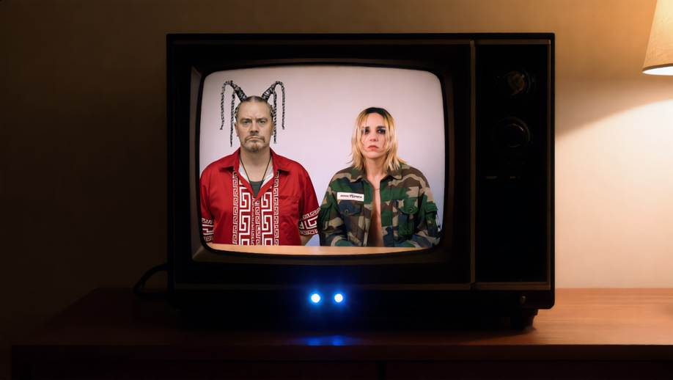
still taken from the Scorsese inspired self-directed music video | Download Here

WATCH VIDEO FOR LOOK AT ME FT MIKE PATTON
PRIVATE VIEWING LINK
Jehnny Beth teams up with Mike Patton (Faith No More) on her new single ‘Look At Me’. Patton was a huge influence on Jehnny Beth during the recording of her latest album 'You Heartbreaker, You'. Specifically, his ability to switch between high pitch crooning and soft atmospheric whispering. "When Johnny [Hostile] and I wrote ‘Look At Me’, we had this idea of a song in two parts" - it became clear from the start that Patton was the ideal fit. "When Mike sent his vocals it was like choosing candy in a candy store, he had a million ideas, it was mind blowing!"
Reflecting on the track’s origins, Jehnny reveals that "it’s about the modern sellers of truth, who share their opinion online on how to ‘better oneself’, giving an illusion of control - but all they really want is to be the centre of attention.” ‘Look At Me’ is a song about deceivers and the effect they have on those susceptible to the sinister luring of misleading ideology.
These ideas all set the tone for the Taxi Driver inspired ‘Look At Me’ music video. "I represent De Niro's character who embodies this lonely outcast who doesn't have a place in the world", Jehnny explains. "Mike is the preacher who changes my outlook on the world, and our two characters merge together towards the end."
Combining the hyper-real photo-aesthetic of Martin Parr with Gregg Araki filmography, Jehnny explores the underbelly of humanity via the lens of characters "who say a big fuck off to the world."
Jehnny Beth UK Tour Dates:
17th March, Brighton, Patterns
18th March, London, Tufnell Park Dome
19th March, Manchester, Yes Pink Room
21st March, Leeds, Boom
22nd March, Glasgow, King Tuts
The new album ‘You Heartbreaker, You’ is out now on Fiction Records
Receiving acclaim across the board, MOJO called the record “a sensuous pile-driving mix”, with Pitchfork exclaiming “she knows what she wants and she just—does it”. Rolling Stone UK continued the praise by calling the LP “her most fully realised album as a solo artist, as well as her most visceral.”
Capturing the feeling of being broken in a broken world, where love still operates on a prehistoric level, ‘You Heartbreaker, You’ is a radical work that cuts straight to the core.
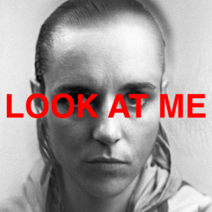
Single Art / Download

Discover Jehnny Beth:
Website / Instagram / YouTube / Facebook / X

For more info contact Warren Higgins
warren@chuffmedia.com

