JORJA SMITH AND NIA ARCHIVES JOIN FORCES FOR ‘LITTLE THINGS’ REMIX
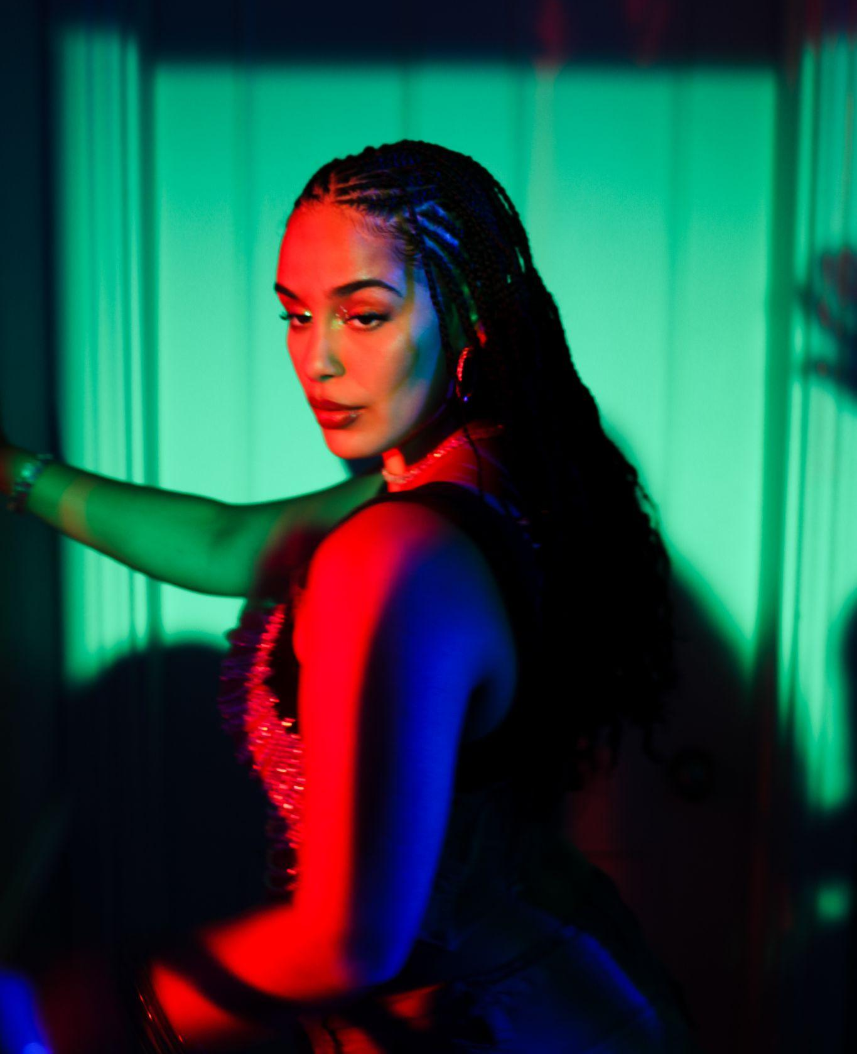
Shot by Romany Francesca

LISTEN HERE / WATCH ACCOMPANYING VISUALISER HERE
PRESS SHOT HERE / ARTWORK HERE

May 16th 2023 - Further to steadily climbing the charts with her latest summer offering ‘Little Things’, Jorja Smith has tapped BRIT Nominated artist, Nia Archives for a brand new remix of the single, with Nia adding a sprinkle of the brilliant Jungle essence for which she’s best known for.

“Little Things is a big summer tune!! As soon as i heard it i had to flip it into a little jungle riddim in my sets! I’ve been playing it out the past few weeks and it’s going offfff - all tha girlies have been luvin it which is cute.” - Nia says of remixing the single.

Since its release last month, ‘Little Things’ has dominated a plethora of global charts and last week surpassed 10.5 million global streams; breaking in to the UK Top #40 at number #28 and currently sitting at #19 in the UK midweeks.

Of the many British voices in music today, Jorja is among the most commanding, writing at a pitch of intensity and urgency that few can match. Over the past five and half years, since the release of her critically acclaimed debut album ‘Lost & Found’, she has been celebrated unanimously across the world for her evocative song-writing, powerful delivery, pure emotion and unbridled talent as a young woman navigating her way through life and in 2021 was the year Jorja’s hiatus from music was broken. Enter ‘Be Right Back’, the holding space between the sensation that was ‘Lost & Found’, and her next project. ‘Be Right Back’ was born from playing, jamming, freestyling, and sounding out what Jorja had been on the edge of expressing all her life. It was a project entirely for her fans. “Be Right Back did exactly what I wanted it to do. It was a little waiting room so people knew I was coming back.”

And come back she did - entering a chapter of her return to music that’s certain to draw in and intoxicate Jorja’s fans and new listeners alike. And what has changed for her, in the five years since ‘Lost & Found’ dominated the charts and the soundscape? “I like this world that I've just come into. And I’m still figuring things out. Always figuring things out.” Jorja says. “This is the first time I’m putting stuff out there that I can connect with right now.” Over the last few years, it’s been a reflective and transformative step into her mid twenties for her. She’s been able to step into herself and evolve as a songwriter and a woman despite an ever-changing musical landscape.

While she recognises that the global pandemic has been completely devastating, she acknowledges that it allowed her to stay still, to come more into herself, and to be more in control of the person she is, and of her musical output. Like some of the legendary musicians that came before her, Jorja is looking at the chaos and disorder in the world right now with resourceful, refined eyes, and she sees the glorious opportunity and enormous responsibility that affords. Listen on to ‘Little Things’ in wonder.

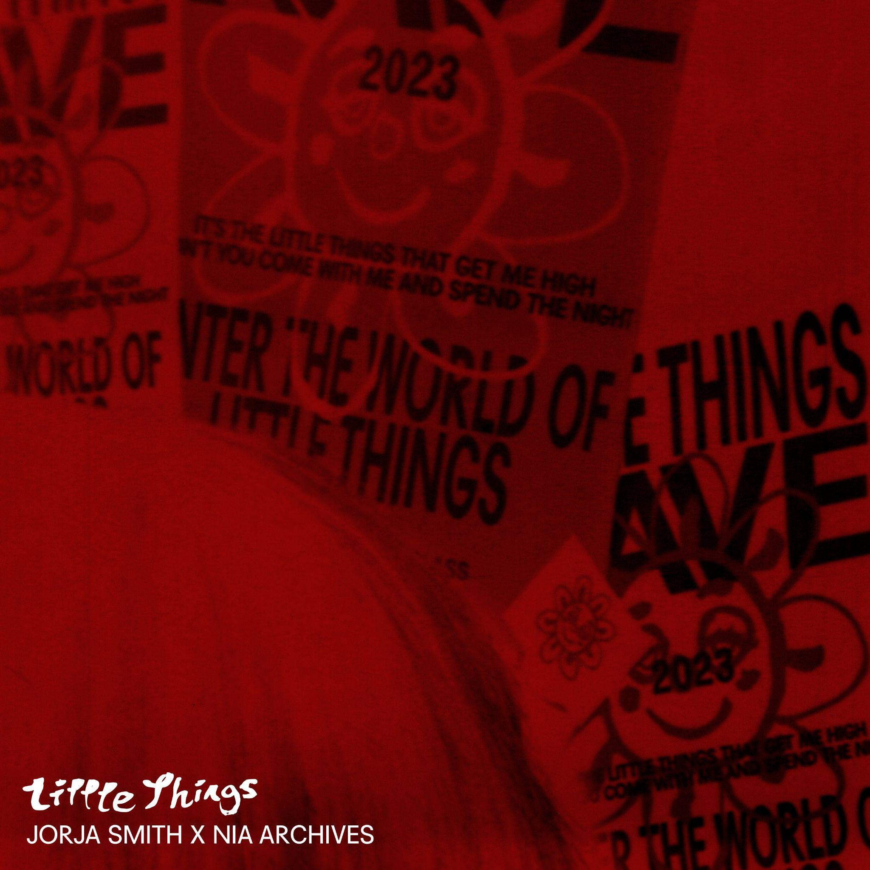

FOLLOW JORJA SMITH: INSTAGRAM / FACEBOOK / TWITTER

For more information please contact warren@chuffmedia.com on 07762 130510

