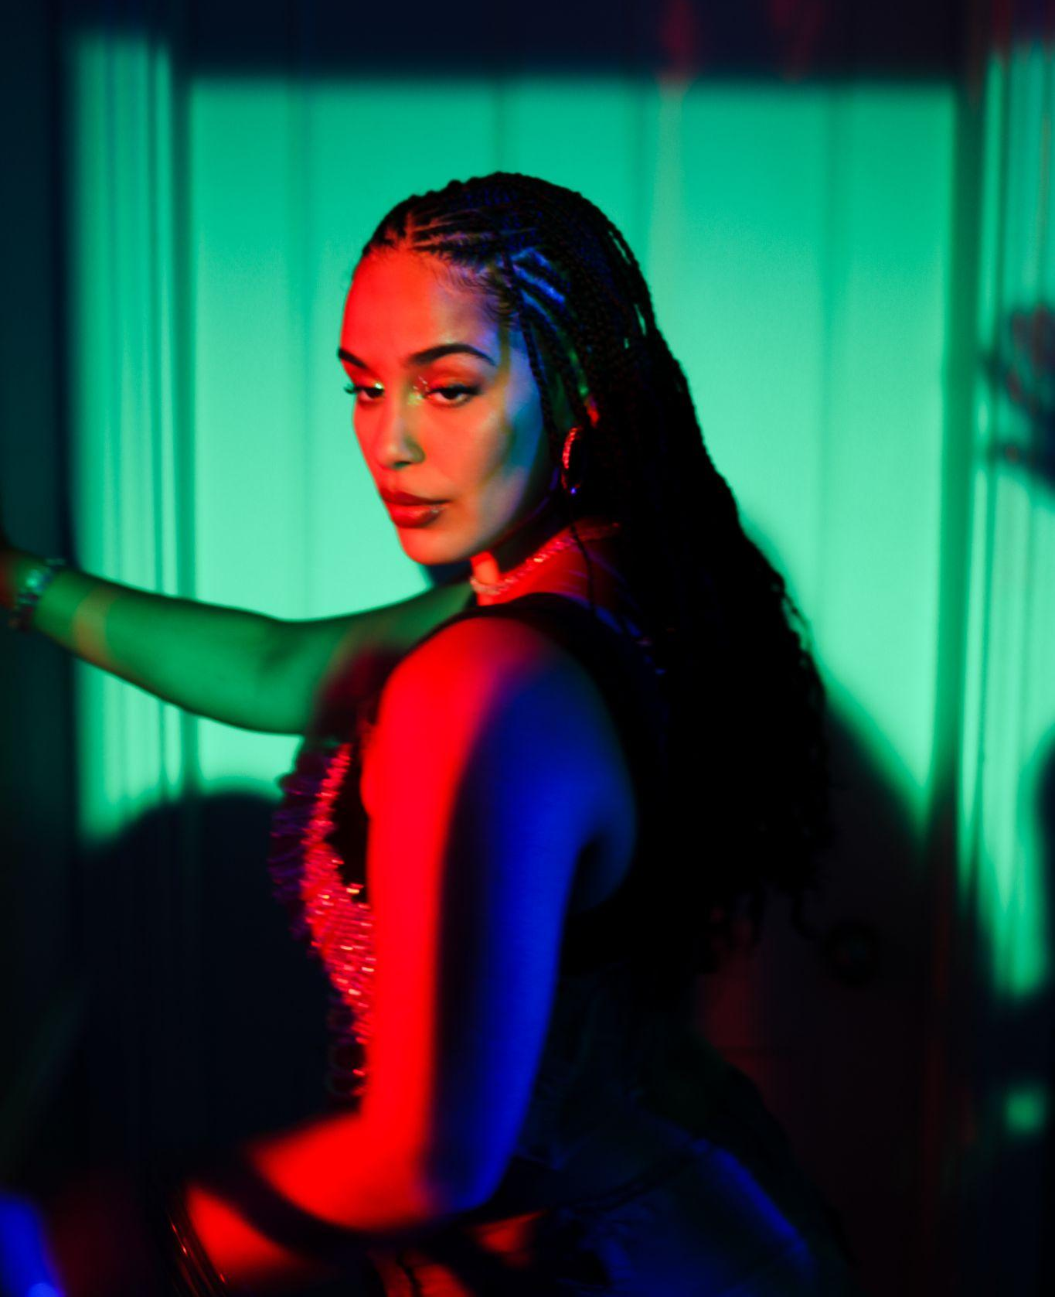
Shot by Romany Francesca

JORJA SMITH UNVEILS ‘LITTLE THINGS x GYPSY WOMAN’ REMIX
LISTEN HERE
PRESS SHOT HERE / ARTWORK HERE

June 30th 2023 - Hot off the heels of releasing the Nia Archives remix of her latest summer single ‘Little Things’, today, Jorja Smith has unveiled a second remix in the form of DJ L Beat’s viral TikTok mash-up. The remix see’s ‘Little Things’ go head to head with Crystal Water’s 1991 hit, ‘Gypsy Woman’. Listen here.

Since its release in May, ‘Little Things’ has become 2023’s summer soundtrack; having dominated a plethora of global charts and surpassing 15 million global streams! In addition, last week the single broke in to the UK Top #20 at number #15, marking Jorja’s second top #20 record to date.

Of the many British voices in music today, Jorja is among the most commanding, writing at a pitch of intensity and urgency that few can match. Over the past five and half years, since the release of her critically acclaimed debut album ‘Lost & Found’, she has been celebrated unanimously across the world for her evocative song-writing, powerful delivery, pure emotion and unbridled talent as a young woman navigating her way through life. It was in 2021 that Jorja’s hiatus from music was broken - enter ‘Be Right Back’, the holding space between the sensation that was ‘Lost & Found’, and her next project. ‘Be Right Back’ was born from playing, jamming, freestyling, and sounding out what Jorja had been on the edge of expressing all her life. It was a project entirely for her fans. “Be Right Back did exactly what I wanted it to do. It was a little waiting room so people knew I was coming back.”

And come back she did - entering a chapter of her return to music that’s certain to draw in and intoxicate Jorja’s fans and new listeners alike. And what has changed for her, in the five years since ‘Lost & Found’ dominated the charts and the soundscape? “I like this world that I've just come into. And I’m still figuring things out. Always figuring things out.” Jorja says. “This is the first time I’m putting stuff out there that I can connect with right now.” Over the last few years, it’s been a reflective and transformative step into her mid twenties for her. She’s been able to step into herself and evolve as a songwriter and a woman despite an ever-changing musical landscape.

While she recognises that the global pandemic has been completely devastating, she acknowledges that it allowed her to stay still, to come more into herself, and to be more in control of the person she is, and of her musical output. Like some of the legendary musicians that came before her, Jorja is looking at the chaos and disorder in the world right now with resourceful, refined eyes, and she sees the glorious opportunity and enormous responsibility that affords. Grab a spritz in the sun and enjoy ‘Little Things’ below.

LISTEN HERE
PRESS SHOT HERE / ARTWORK HERE

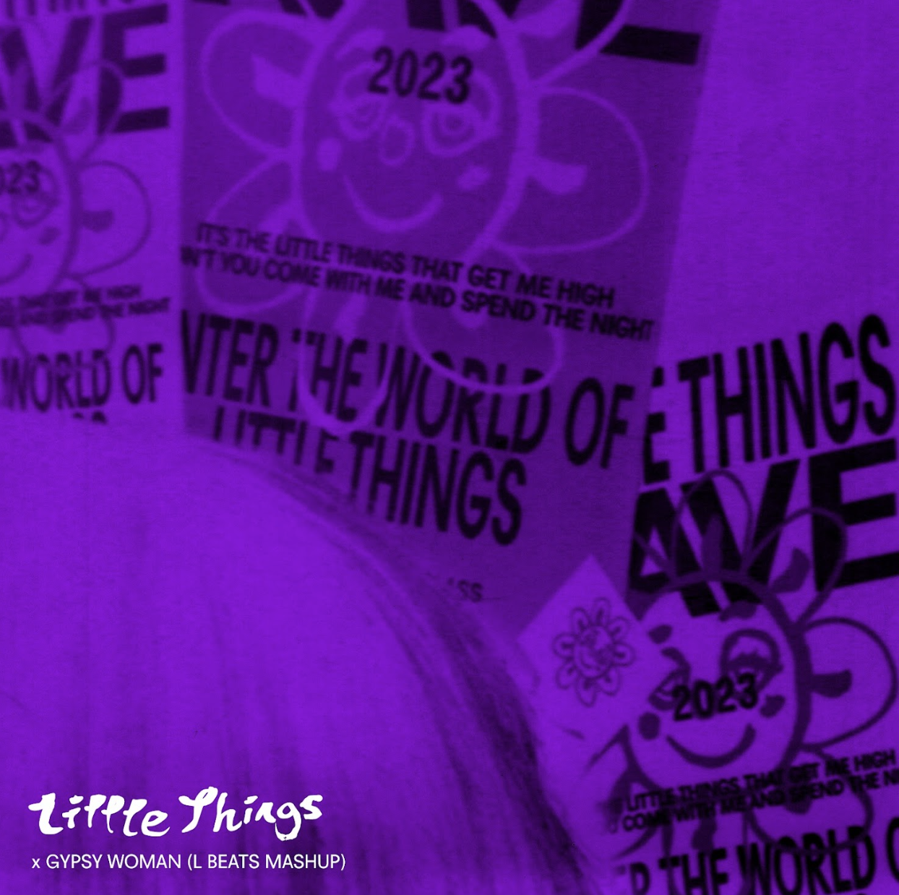

FOLLOW JORJA SMITH ONLINE:
INSTAGRAM
FACEBOOK
TWITTER

For more information please contact warren@chuffmedia.com on 07762 130510

