

**CIAN DUCROT SHARES THE NEW SINGLE ‘LITTLE DREAMING’ - LISTEN** [**HERE**](https://cianducrot.lnk.to/littledreaming)

**WATCH A TRAILER FOR THE TRACK’S OFFICIAL VIDEO COMING SOON HERE**

**FEATURING ACTORS FROM ‘SAY NOTHING’ AND ‘THE YOUNG OFFENDERS’**

**ANNOUNCES FIRST DUBLIN ARENA SHOW AND BIGGEST GIGS TO DATE IN LONDON AND PARIS**

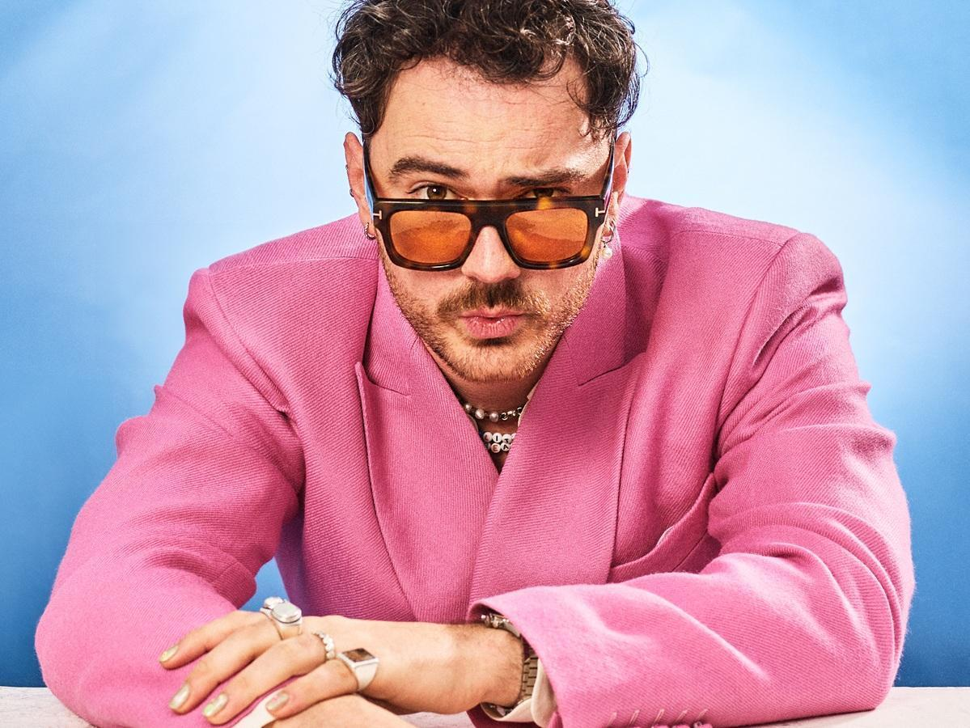

**Photo by Freddie Sinstead / Single artwork**

Following a stunning performance of **‘Who’s Making You Feel It’** as well as both national anthems at the recent **Ireland v France Six Nations** rugby match, **Cian Ducrot** now shares the new single **‘Little Dreaming’**, and also announces three headline shows: his first arena date in **Dublin** after selling **36,000** tickets to his outdoor shows in **Ireland** last summer, and his biggest venues to date in **London** and **Paris**. The announcements come off the back of **Cian Ducrot** recently winning **Best R&B Song** as co-writer on **'Saturn' by SZA**, at the **GRAMMY Awards**, and continues a rise which has seen him exceed **1.4 billion** streams to date. Listen [HERE.](https://cianducrot.lnk.to/littledreaming)

Bouncing along a bright keyboard riff, **Cian** is supported by joyous vocal harmonies as he celebrates what makes us all special and unique, especially in the face of current caustic discourse. As he sings, *“I’ve got glitter in my tears and mascara on my face / I’ve got sequins all the way from my collar to my waist / Got a wave of iridescence painted on my nails / And I like it when you look, and you look a little pale.”*

**Cian** explains, *“I love how theatrical this one turned out, it feels reflective of my personality. It’s about reconnecting with your inner child but also, as an adult, doing what you want, expressing yourself and not caring what anyone else thinks. Hopefully breaking down those boundaries of toxic masculinity in the process.”*

Today also sees **Cian** share a trailer for the track’s upcoming video, which can be seen HERE. It will feature actors from two high-profile **Irish** TV shows: **Lola Petticrew** and **Hazel Doupe** from the acclaimed **Disney+** series **‘Say Nothing’**, and **Chris Walley** from the cult comedy **‘The Young Offenders’**.

**Cian** will complete a **UK** and **European** arena tour as special guest to **Teddy Swims** in **Manchester** this **Sunday**. Tickets for his newly announced headline shows, listed below, are now available [**HERE**.](https://www.cianducrot.com/live/)

**SEPTEMBER**

**17th - London, O2 Academy Brixton**

**18th - Paris, L’Olympia**

**DECEMBER**

**20th- Dublin, 3Arena**

**Follow Cian Ducrot:**

[**Instagram**](https://www.instagram.com/cianducrot/) **|** [**TikTok**](https://www.tiktok.com/@cianducrot?lang=en) **|** [**X**](https://twitter.com/Cian_ducrot) **|** [**YouTube**](https://www.youtube.com/user/cianducrot) **|** [**Spotify**](https://open.spotify.com/artist/49jTY62Cpw3RYo4dLuG43W?si=twClLke_Q-q_5wZD9j-Tmg) **|** [**Apple Music**](https://music.apple.com/gb/artist/cian-ducrot/1117495310)



