RENEÉ RAPP RETURNS WITH BRAND NEW SINGLE
“LEAVE ME ALONE”
STREAM HERE | WATCH HERE

FROM HIGHLY ANTICIPATED SECOND STUDIO ALBUM BITE ME
RELEASING AUGUST 1ST
PRE-ORDER HERE

SET TO MAKE AWARD SHOW LIVE PERFORMANCE DEBUT AT AMERICAN MUSIC AWARDS THIS WEEKEND

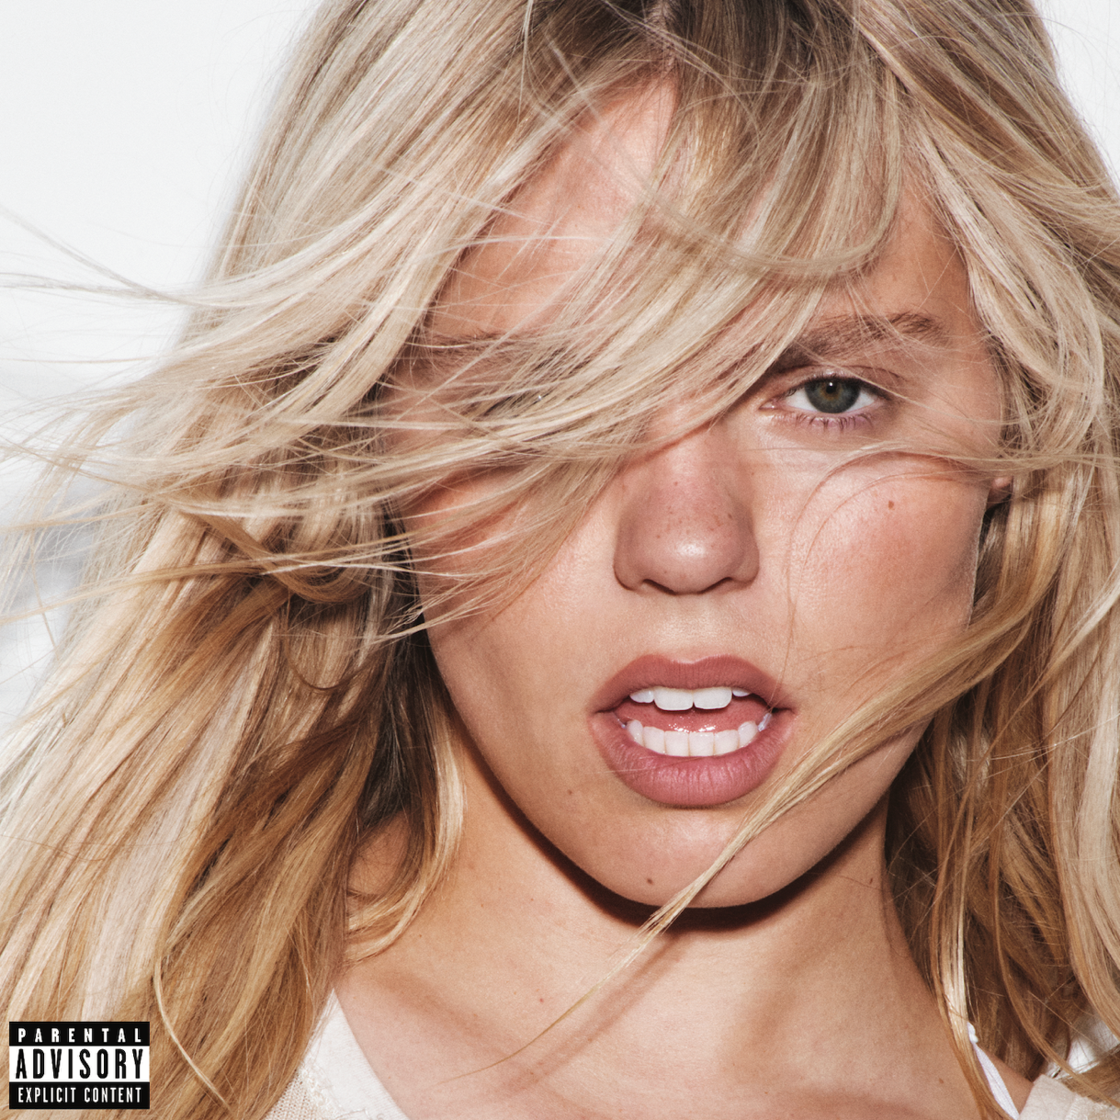
Download artwork HERE.

May 21, 2025 – Today, critically acclaimed singer-songwriter Reneé Rapp unveils brand new single “Leave Me Alone,” marking her bold entrance into a new era and simultaneously announcing long-awaited sophomore album Bite Me releasing on August 1st via Interscope Records. Stream “Leave Me Alone” HERE, pre-order Bite Me HERE.

Today’s release and announcement arrive alongside an official music video for “Leave Me Alone.” The video features Rapp accompanied by a slew of blonde doppelgängers as they progress from raunchy pillow-fight to all-out brawl. The highly stylized video ranges from chaotic and fun to thrilling and exciting, a fitting complement to the energy of the new song, and a perfect intro into Rapp’s new chapter. Watch HERE.

Rapp first began teasing her new era earlier this month with the BITE.ME website reveal, urging fans to ‘sign a hundred NDA’s’ ultimately revealing a slew of hints about the yet-to-be-announced album. In the weeks following, the internet erupted with ‘Bite Me’ related clues – from Rapp’s “Bite Me” lip tattoo to posts from the likes of Paris Hilton, Charlize Theron, Monica Lewinsky, Gabby Windey, and more. A powerful statement about reclaiming your personal narrative, “Leave Me Alone” and the Bite Me era encourages listeners to embrace every facet of their personality, the chaotic and the confident, and to find strength in being authentically, unapologetically themselves.

This exciting new chapter marks Rapp’s first music release since 2023, when she collaborated with GRAMMY® award-winning artist Megan Thee Stallion on hit record “Not My Fault” from the official soundtrack to Paramount’s feature film MEAN GIRLS (which also saw Rapp reprising her iconic role of Regina George). The song earned Rapp’s highest ever day one streams on Spotify to date, and saw a legendary performance between the two stars on Saturday Night Live. Earlier that same year, Rapp released her first studio album Snow Angel, earning her the largest first-week sales for a female artist’s debut album in the U.S. upon release. That fall, she embarked on the ‘Snow Hard Feelings Tour’ in support of the project, a sold-out headlining run met with massive demand, featuring four nights in New York and one in Los Angeles at the iconic Greek Theatre. Now, with her sophomore effort on the horizon Rapp is positioned to ascend to even higher levels of stardom in this next era.

About Reneé Rapp:

Reneé Rapp is a critically acclaimed multi-hyphenate with experience in music, film and TV acting, and Broadway. In just a few short years, Rapp has solidified her position as a dynamic force across all industries, reaching widespread critical acclaim while simultaneously cultivating her rapidly growing fan-base.

After landing her breakout role as Regina George in Mean Girls on Broadway, Rapp eventually turned her attention to her solo music career in 2022. That year saw the release of her debut EP, Everything to Everyone, which featured standout tracks “Too Well,” and “In The Kitchen.” Following the momentum of Everything to Everyone, Rapp channeled her raw talent and authentic voice into the creation of her first full-length studio album Snow Angel in 2023. The project, which earned the largest first-week sales for a female artist’s debut album in the U.S. upon release that year, showcased her powerful vocals, introspective songwriting, and ability to connect with her fans on a deeply emotional level. Snow Angel marked a significant step in Rapp’s musical journey, cementing her status as one of the most compelling and dynamic new artists in the pop landscape, now amassing over 1.4 billion streams and counting across her entire discography.

Across her career, Rapp has played to packed crowds at iconic festivals across the globe, including Coachella Valley Music & Arts Festival, Lollapalooza, Governors Ball, Boston Calling, and many more. She’s been nominated for two MTV VMA Awards, in the categories of ‘Best New Artist’ and ‘PUSH Performance of the Year,’ and held performance spots on a number of coveted television programs including Saturday Night Live, The Today Show’s Summer Concert Series, Late Night with Seth Meyers, and more. This consistent presence on major stages and recognition from tastemakers across industries firmly establishes Reneé Rapp as a burgeoning powerhouse and a vital new voice shaping the future of pop culture.

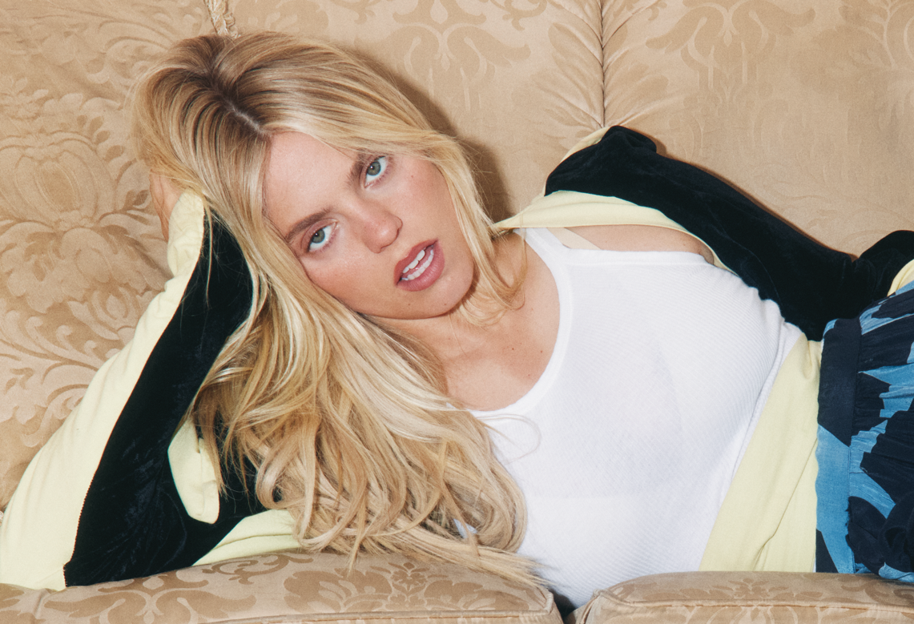
Download press photo HERE. Credit Zora Sicher.

# # #

Follow Reneé Rapp:

INSTAGRAM | TIKTOK | X

For more information and press enquiries for RENEÉ RAPP please contact

Jenny Entwistle
Jenny@chuffmedia.com

