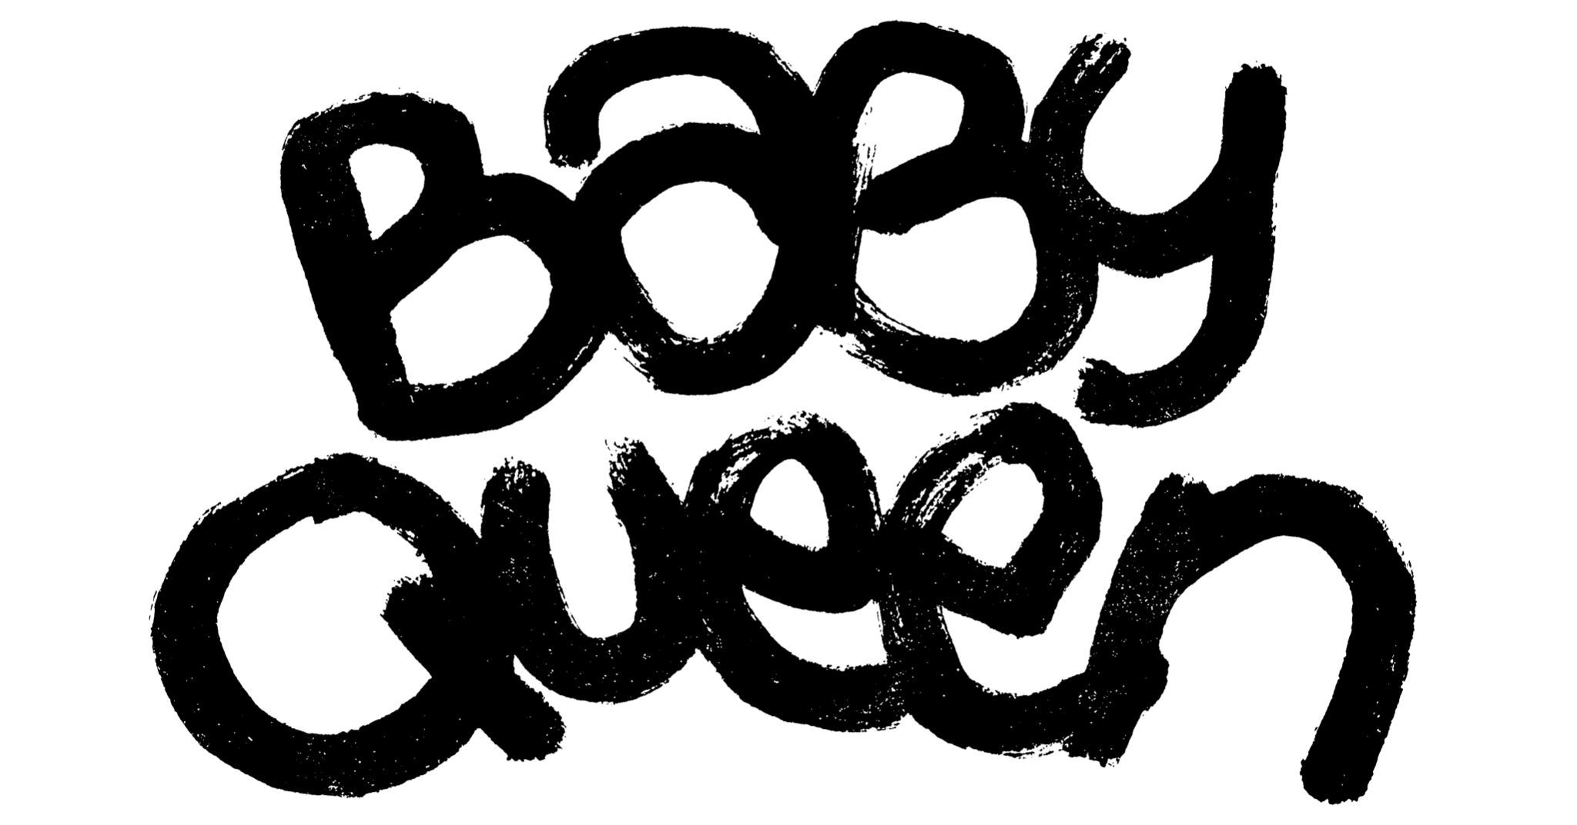
RELEASES BRAND NEW SINGLE 'LAZY’
STREAM HERE
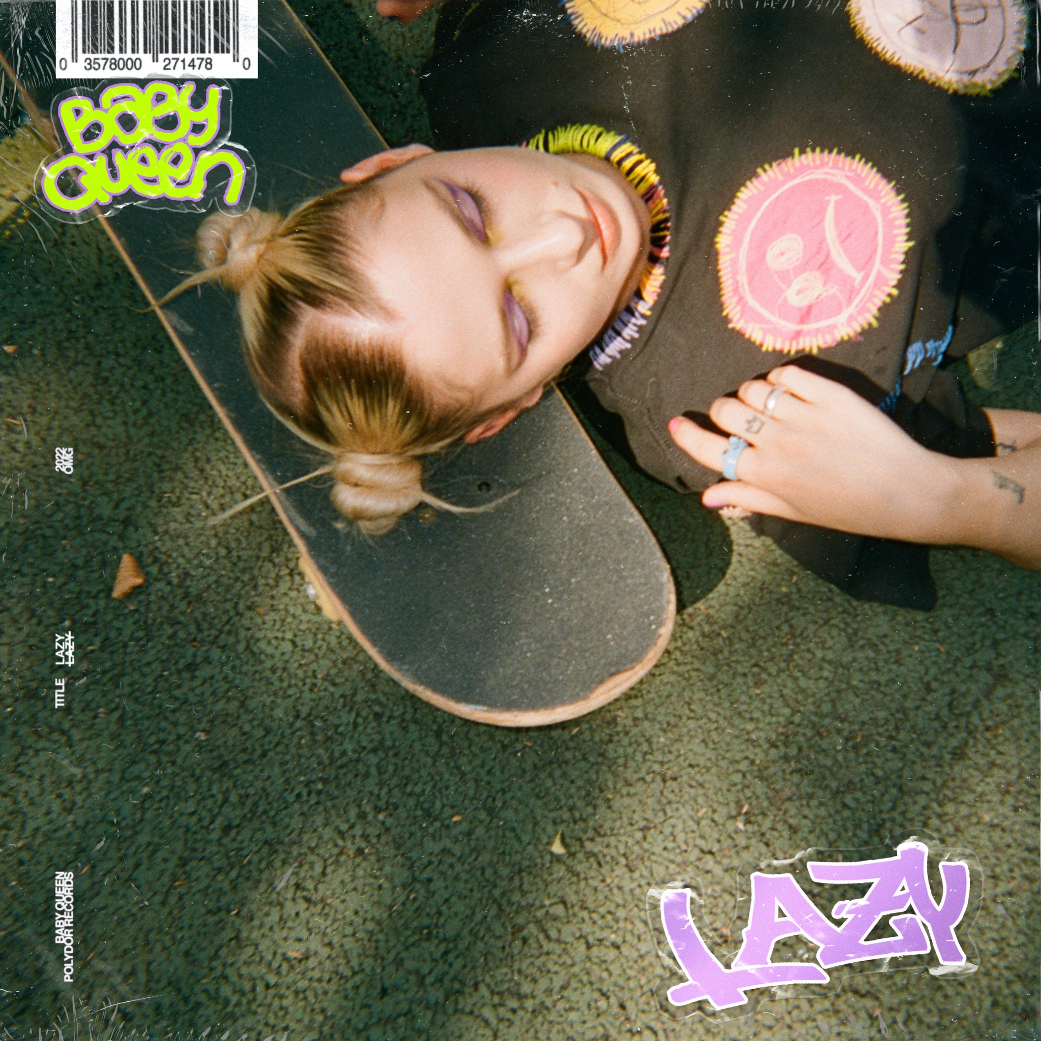

“Gen Z’s new musical muse” Evening Standard

Pop’s favourite anti-hero Baby Queen today (Sept 28th) shares her new single ‘Lazy’ via Polydor Records. Set to be the ultimate Gen-Z slacker anthem, ‘Lazy’ is the follow-up to the boisterous ‘Nobody Really Cares’, described by NME as Baby Queen’s “pop-punk ode to not giving a shit”. It tops off a busy few months for the 25-year-old rising anti-pop star, who supported Olivia Rodrigo on the European leg of her ‘SOUR’ world tour as well as clocking up a string of headline shows and festival performances while working on her debut album. Next week she heads to the US to support Conan Gray on tour throughout October before returning to play a one-off show at London’s iconic Heaven on November 1st(which sold out in a matter of hours).

Baby Queen – aka Bella Latham – was asked to elaborate on the track but, in line with the sentiment expressed, she’s too f*****g lazy.

‘Lazy’ follows the soaring success of ‘Colours Of You’, a track written specifically for Netflix’s smash hit LGBTQ+ drama ‘Heartstopper’, based on Alice Oseman’s young adults book series of the same title. Since launching, ‘Colours Of You’ has clocked up 15.7million streams and been embraced by the Heartstopper community globally. Baby Queen surprised fans at her triumphant headline show at London’s Electric Ballroom when she invited the Heartstopper cast to join her onstage to sing the final chorus of ‘Colours Of You’, much to the audience’s delight.

Baby Queen has been dubbed a voice for the underdog generation and one of the most exciting new artists to emerge in recent times. Known for her sharp lyrical narratives, her songs candidly document experiences and explore themes that resonate with her die-hard fanbase, The Baby Kingdom, which is seeing a huge surge in new members.

Since the release of her critically acclaimed 2021 mixtape, The Yearbook, Baby Queen’s star has continued to soar, receiving accolades and glowing reviews from key publications across the board including Clash, DORK, DIY, Hunger, Wonderland, Notion, The Evening Standard, GQ, BEAT, The Independent, i-D, Gay Times, Rolling Stone, The Sunday Times and NME who dubbed her “a future leader of pop”. Tipped as an artist to watch this year with her inclusion on the BBC Sounds of 2022 list, she is well on her way to fulfilling that expectation and more.

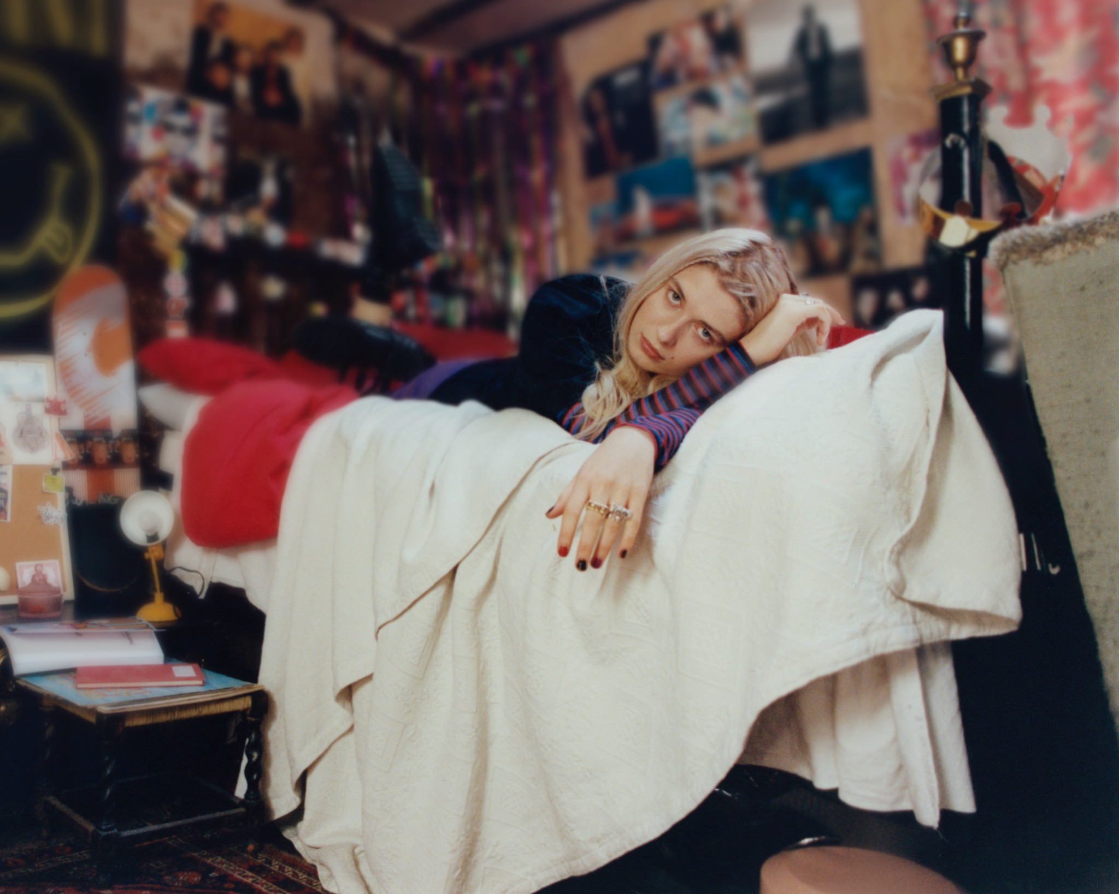
LEAD PRESS PHOTO (credit: Jono White)

FOLLOW BABY QUEEN:
INSTAGRAM // TIKTOK // FACEBOOK // TWITTER // YOUTUBE

For more info please contact Jenny@chuffmedia.com

