BECKY HILL RELEASES BRAND NEW SINGLE ‘LAST TIME’

AUTUMN/ WINTER 2020 UK HEADLINE TOUR RE-SCHEDULED TO AUTUMN 2021

“Becky’s catalogue of undeniable hits has cemented her reputation as one of Britain’s most influential artists in the world of Dance.” Sigala

“Becky is the voice of many so dance anthems that have been staples of my DJ sets over the years.” Joel Corry

​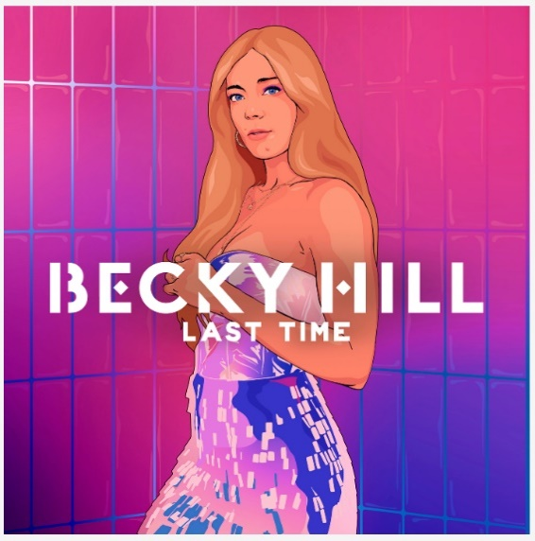

WATCH/SHARE THE MUSIC VIDEO FOR ‘LAST TIME’ HERE

26th March 2021: Today show-stopping vocalist, hitmaking songwriter and dance music trailblazer Becky Hill releases her brand new single ‘Last Time’.

‘Last Time’, which is written by Becky Hill and produced by Lostboy is the forthcoming single to be lifted from Becky’s upcoming debut studio album release out this Summer.

“I could talk the usual BS about how “excited” I am to be releasing this single, but as much as that’s true it’s more than excitement for me.” says Becky. “’Last Time’ marks the start of me seeing the fruits of years of hard graft. THIS is the year of my debut album release and I couldn’t think of a better song to be kicking off my album year with than ‘Last Time’. I worked on the song with Lostboy (‘Sunrise In The East’), Negin and Tom Mann and after talking through current life experiences we started working on something that I immediately fell in love with. By the time I laid the vocal down I think we all knew we had something special. This year I intend to take my career and my music to the next level, not only in the UK, but worldwide. I love what I do passionately, and I hope you love this single and the music I have coming over the summer as much as I do!”

Becky Hill’s ‘Last Time’ follows the release of ‘Better off Without You’ ft Shift K3Y, (which is Certified Platinum after accumulating over 600,000 sales) and ‘Heaven On My Mind’, (which saw Becky achieve her highest ever debut chart position, has accumulated over 55 millions stream and is now Certified Silver). The accompanying music video for ‘Last Time’ is directed by Jordan Rossi. Full of imitable energy and encompassing TikTok style choreography, it follows Becky on an epic night out clubbing with her mates as she tries to push thoughts of a flaky beau to the back of her mind.

Becky Hill’s debut studio album will follow Get To Know, the 2019 released 13 track collection of singles Becky either released herself or wrote and guest performed on. Get To Know is now certified Gold after being confirmed by Official Charts as one of 2020’s top 5 most streamed albums by a female artist in the UK and peaking at no.16 on the Billboard Dance/Electronic Albums Chart in the US.

Following ongoing restrictions Becky Hill’s Autumn/ Winter 2020 headline tour has been rescheduled to Autumn 2021. Original tickets will remain valid for the rescheduled shows. Kicking off at Engine Shed, Lincoln on Wednesday 29th September and wrapping up at Pavillons, Plymouth on Thursday 21st October June. Due to popular demand, (with the majority of dates sold out), Becky’s 17 date headline UK tour will now encompass three additional shows. See below for details of all shows, including the three new additions. Tickets for the tour are available to purchase here.

With an irrefutable aptitude for writing chart smashing pop songs, Becky Hill is one of Britain’s most in-demand musical exports of the moment. She has 180 songs registered with ASCAP - no mean feat considering only 17% of PRS for Music's registered songwriters are female - and an impressive string of hits to her name. Having written and performed on ten singles which charted in the top 40 of the UK Official Singles Chart, (including two top 10 singles, one number 1 and eight platinum records), Becky has now amassed over 1.75 billion streams on Spotify alone, and 900 million streams in the UK. She has over 14 million monthly listeners on Spotify after being crowned the 2nd most-streamed British Female Solo Artist on Spotify UK in both 2019 and 2020.

BECKY HILL – AUTUMN 2021 UK HEADLINE TOUR DATES

Wed 29 Sep - Engine Shed, Lincoln (additional date)
Fri 1 Oct - o2 Victoria Warehouse, Manchester ***sold out***
Sat 2 Oct - o2 Academy, Leeds ***sold out***
Sun 3 Oct - o2 Academy, Glasgow
Tue 5 Oct -o2 Academy, Newcastle ***sold out***
Wed 6 Oct - o2 Academy, Sheffield ***sold out***
Tue 7 Oct - Rock City, Nottingham ***sold out***
Sat 9 Oct - o2 Academy, Liverpool (additional date) ***sold out***
Mon 11 Oct - Dome, Brighton ***sold out***
Tue 12 Oct - o2 Academy, Oxford (additional date)
Wed 13 Oct - o2 Academy Brixton, London
Fri 15 Oct - UEA, Norwich ***sold out***
Sat 16 Oct - o2 Academy, Birmingham ***sold out***
Sun 17 Oct - Great Hall, Cardiff ***sold out***
Tue 19 Oct - o2 Academy, Bristol ***sold out***
Wed 20 Oct - o2 Academy, Bournemouth
Thu 21 Oct - Pavilions, Plymouth​

BECKY HILL’S ‘LAST TIME’, RELEASED VIA EKO RECORDS/ POLYDOR, IS AVAILABLE TO STREAM/DOWNLOAD NOW
https://BeckyHill.lnk.to/LastTimePR

WATCH/ SHARE THE VIDEO FOR BECKY HILL’S ‘LAST TIME’ HERE

DOWNLOAD ARTWORK, PRESS SHOT & VIDEO BTS HERE
ARTWORK

Follow Becky Hill here:
INSTAGRAM
TWITTER
FACEBOOK

For more info please contact Warren@chuffmedia.com on 07762 130510

