BRING ME THE HORIZON
Single - Kool-Aid - Out Today
LISTEN HERE
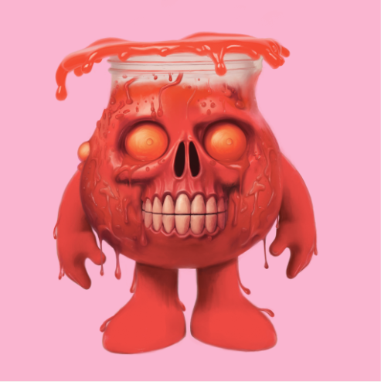

The mighty Bring Me The Horizon kick off 2024 with the release of a mammoth new single Kool-Aid, out today via RCA/Sony Music. The official video for Kool-Aid will follow the release.
The band had a monumental 2023 that comprised of a plethora of sold out shows (including their triumphant headline performance at Download), the Fall Out Boy stadium US tour and most recently a tour of Asia and headline slot at NEX_FEST Japan, which they also curated. They are set to smash more milestones this year with a sold out UK tour, that includes two nights at the 02 (selling over 110k tickets the first day they went on sale). Their highly anticipated new studio album, ‘POST HUMAN: NeX GEn’ will also be released this year.
‘Kool-Aid’ follows ‘DArkSide’, ‘LosT’, ‘AmEN!’, ‘DiE4u’ and ‘sTraNgeRs’, part of the globally acclaimed Post Human series, which has streamed over a massive 350M times before album release!

BRING ME THE HORIZON
UK TOUR DATES JANUARY 2024
9th – Cardiff, Motorpoint Arena
10th – Bournemouth, BIC
12th – Birmingham, Utilita Arena
13th – Manchester, AO Arena
14th – Glasgow, OVO Arena
16th – Newcastle, Utilita Arena
17th – Liverpool M&S Bank Arena
19th – Sheffield, FlyDSA Arena
20th – London, O2 Arena
21st – London, O2 Arena
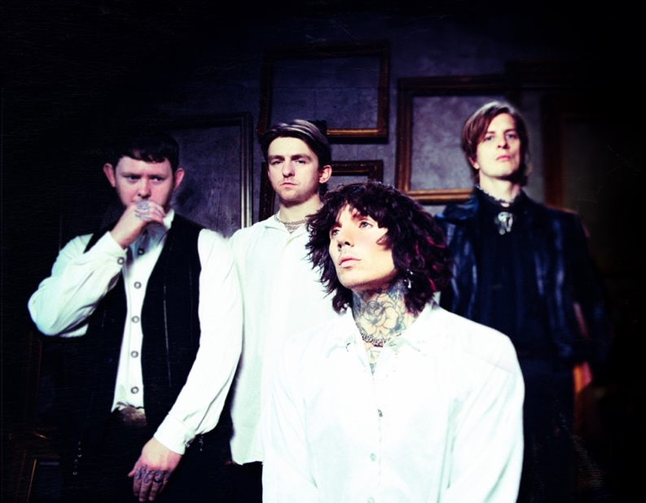
About Bring Me The Horizon
BRIT and Grammy-nominated, multi-platinum-selling group Bring Me The Horizon are fast becoming one of the most successful rock bands on the planet, selling over 5 million albums globally to date. They have toured the globe multiple times, playing sold-out shows in over 50 countries. They are revered festival headliners and their June 2023 Download main stage performance in front over 100k fans is their most recent triumph, along with headline slots at Reading & Leeds Festival in 2022 and wowing a traditionally non-rock crowd at Glastonbury Festival in 2016 & 2019. They kicked off their POST HUMAN era in 2020 with the release of the first of four EPs aptly titled ‘POST HUMAN: SURVIVAL HORROR’. The critically acclaimed release debuted at Number 1 on the UK Album chart. 2022 saw them appear at the BRIT Awards where they joined Grammy award winning singer-songwriter Ed Sheeran for an electrifying performance of ‘Bad Habits’. The group released their gold-certified sixth studio album, ‘amo’, in 2019, which debuted at Number 1 in 17 markets and was named “one of the most anticipated albums of 2019” by Billboard, it also garnered the band their second Grammy nomination for Best Rock Album, after the LP’s first single ‘MANTRA’ earned them a nod for Best Rock Song in 2018. The Sheffield group also received their first BRIT Award nomination for Best Group in 2021. They have now also amassed over 1 billion video views on YouTube and are in the top 500 most streamed artists globally on Spotify with over 1B streams alone last year across 3 songs. ‘Kool-Aid’, ‘DArkSide’, ‘LosT’, ‘AmEN!’, ‘DiE4u’ and ‘sTraNgeRs’ are part of the globally acclaimed Post Human series, which has been streamed over a massive 350M times to date. Bring Me The Horizon are vocalist Oli Sykes, guitarist Lee Malia, bassist Matt Kean and drummer Mat Nicholls.

INSTAGRAM |FACEBOOK | WEBSITE |YOUTUBE | SPOTIFY

For more information and press enquiries please contact

Jenny Entwistle
Jenny@chuffmedia.com

