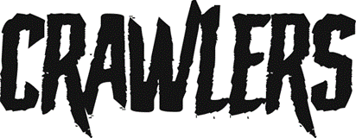

CRAWLERS SHARE NEW SINGLE
‘KILLS ME TO BE KIND’

TAKEN FROM EAGERLY AWAITED DEBUT ALBUM
‘THE MESS WE SEEM TO MAKE’
SET FOR RELEASE 16/02/2024

LISTEN HERE

Today (January 19th) CRAWLERS share their new single ‘Kills Me To Be Kind’ via Polydor Records. The single comes as the Liverpool alt-rock four-piece ready themselves for the release of their hotly anticipated debut album ‘The Mess We Seem To Make’ on February 16th.
‘Kills Me To Be Kind’ takes the band into a world of anthemic rock, worthy of stadium crowds and explosive chants, yet holds a sentiment close to the hearts of those in young diminishing relationships.
“Kills Me To Be Kind" is a song for all the people pleasers. The ones ready to settle in a relationship where they felt diminished of their true self and finally breaking out of that moment,” elaborates lead singer Holly Minto of the track.
It follows a string of electrifying releases from CRAWLERS including debut album cuts ‘Call It Love’ and ‘Would You Come To My Funeral’, which launched as a Radio 1 Hottest Record in the World’ in September, and cements their reputation as one of the most exhilarating bands to come out of Liverpool in recent years.
Speaking about ‘The Mess We Seem To Make’, singer Holly Minto says, “This album debut comes from us honing our craft, being vulnerable with each other, finding our sound and saying exactly what we wanted to. I think that's a lot of what the Crawlers sound is, being honest with each other about how to get the correct emotions out - trying, failing, and pushing each other to keep playing and writing to the limits.”
True to their word ‘The Mess You Seem To Make’ takes on a whole range of challenging topics; trauma, sexual politics, mental health, the general goings on in a young person’s life. Across the record, feelings of loneliness, insecurity and toxic forms of dependence are held up to the light and examined in close context.
It digs deeper into what fans already know and love about Crawlers’ eclectic alt-rock sound and builds on the relationship of trust they have with producer Pete Robertson and engineer Tom Roach at Liverpool’s Coastal Studios, crafting anthemic rock songs where each member's playing personality can truly thrive. Rather than forcing themselves in any one sonic direction, they maintained the free-wheeling spirit of 2022’s mixtape ‘Loud Without Noise’, producing a striking debut which cements their status as the UK’s next big crossover alternative act.
‘The Mess We Seem To Make’ features 12 tracks and will be available on various formats including Deluxe CD, white vinyl, blue splatter vinyl and silver glitter cassette.
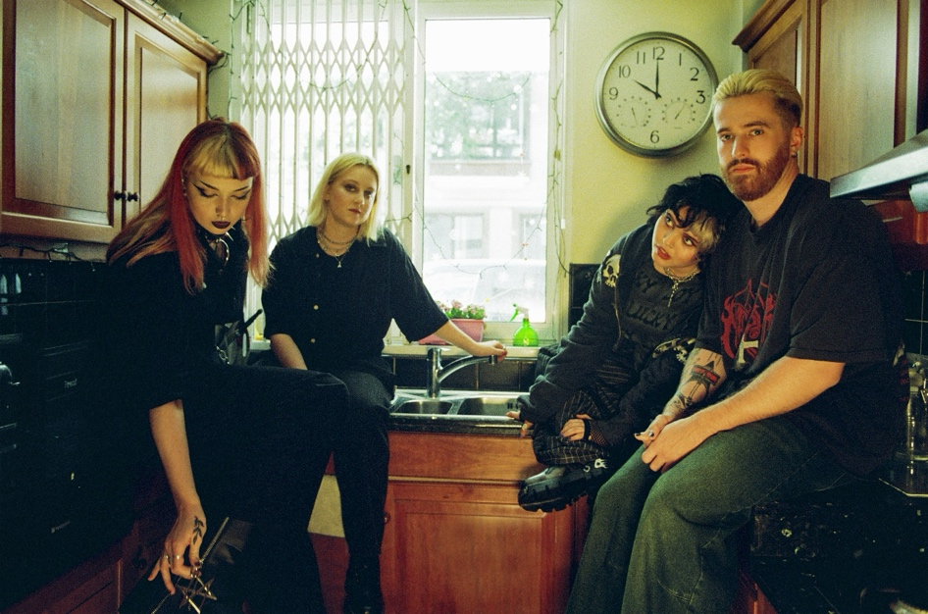
Photographer: Megan Doherty

Record Store Tour:
6th February Edinburgh – Assai
6th February Glasgow – Assai
7th February Leeds – Vinyl Whistle
8th February Manchester – HMV
10th February Bristol – Rough Trade
11th February Cardiff – HMV
12th February Nottingham – Rough Trade
14th February London – Rough Trade East
15th February Brighton – Resident Record Store

Tour Supporting Mother Mother:
17th February Sheffield – Network
18th February Manchester – O2 Victoria Warehouse
25th February Newcastle – O2 City Hall
28th February Leeds – O2 Academy
29th February London – Troxy
3rd March Nottingham – Rock City
4th March Cardiff – Great Hall
5th March Brighton – Dome
7th March Birmingham – O2 Institute

ABOUT CRAWLERS
To become a great rock band, you often need to begin with a certain alchemy. There needs to be talent, determination, a solid friendship which can withstand the rigours of creative difference or public critique. But you also need a sizable dose of ambition, the kind of unapologetic belief that your voice is one which needs to be heard. Such was already the case for Crawlers way back in 2018, where Amy Woodall, Liv May and Holly Minto were at uni together in Liverpool. Having formed in 2018, the band spent their first few formative years gigging around the Liverpool scene. Amy, Holly and Liv were already polishing their grunge-rock sound when they recruited drummer Harry Breen. Newly solidified as a four, their formidable live reputation has already encouraged the kind of organic fanbase that will help them become the UK’s next big crossover alternative act. Over the years, each new release has sealed CRAWLERS reputation as one of the UK’s most exciting young bands, with last years’ debut mixtape “Loud Without Noise” cementing their global status through helping them to achieve a huge 80+million streams to date.
CRAWLERS are Holly Minto (she/they), Amy Woodall (she/her), Liv May (she/they) and Harry Breen (he/him).
Connect with CRAWLERS
INSTAGRAM | TWITTER | FACEBOOK

For more information and press enquiries please contact

Jenny Entwistle
Jenny@chuffmedia.com

