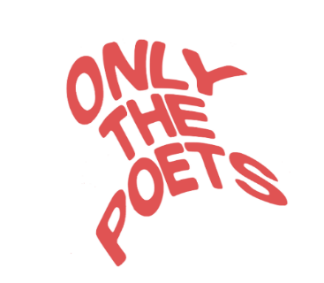
‘JUMP’
The new single out now
LISTEN/WATCH HERE
HEADLINE LONDON SHOW AT SHEPHERDS BUSH EMPIRE MAY 3RD
EUROPEAN TOUR DATES
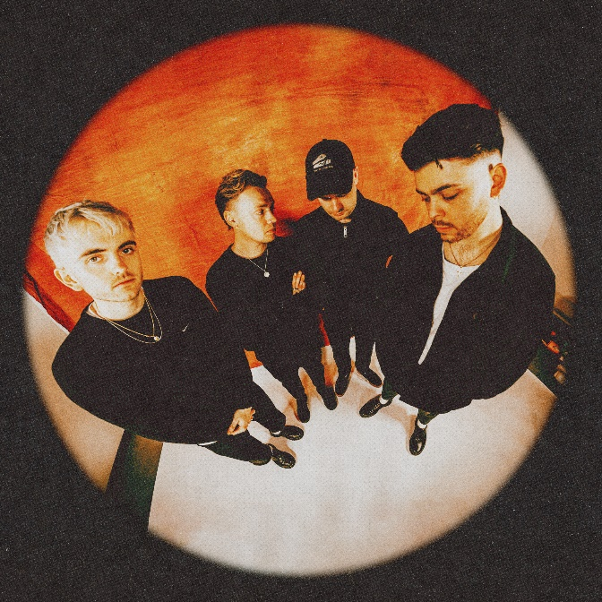
Only The Poets have shared their anthemic new single ‘JUMP’ via EMI Records. Produced by King Ed (Baby Queen, Dylan) and mixed by Dan Grech (Vaccines, Liam Gallagher) it’s an urgent, attention-grabbing next step from a band already inspiring fervent support from their fast-growing fanbase.

“So if you’re gonna run, I’ll run with you/ Falling off the edge of the deep blue/ My mother always warned me when I was young/ But if you’re gonna jump I’ll jump in too,” singer Tommy Longhurst promises. A rousing call to arms set to widescreen, galloping riffs, it bridges the gap between sparkling indie-pop and the everyman swagger of Bruce Springsteen and, more recently, Sam Fender. Longhurst says,

“JUMP! is about all the times when you need to follow your heart and not your head. Too often in life we don’t take the leap, always wondering about potential problems and over thinking. It’s a song all about being completely unapologetic about jumping into something new and exciting, whatever that might be.”
Comprised of Longhurst, bassist Andy “Roo” Burge, guitarist Clem Cherry and drummer Marcus Yates, the Reading four-piece have established themselves as one of the UK’s biggest emerging live acts in just a few short years. Unsigned until recently, the band’s DIY ethos saw them build things from the ground up, playing student house parties, pub circuits and small venues to selling out 1,600-capacity venues in the UK and across Europe.

“We did it the old school way,” Lockhurst says. “We all come from hard-working backgrounds, and we understand you have to put the work in. So building a fanbase through live shows just made sense. We’d drive up to Stockton-on-Tees and play in front of two people or get booked for tiny festivals, whenever we could play we would. Even though initially the rooms were small, for us to be playing music together was just an amazing feeling. And then when you start to see it building it all becomes a hundred times more intense.”

Growing up in Reading and nearby Banbury, the Reading Festival loomed over the band, dropping an annual hint (notably witnessing Arctic Monkeys’ first headline slot) that a “small town existence” wasn’t the only option thanks to music. They began creating their own songs, Longhurst’s autobiographical lyrical honesty and raw feelings combined with big horizon-filling melodies inspired by 90’s British indie instantly connected with audiences.

Following sold out tours across the UK and Europe last year – and a massive run on the continent in support of Lewis Capaldi earlier in 2023 – Only The Poets have announced a European tour for this spring, with reduced ticket prices for fans who financially struggle to attend. Due to overwhelming demand, additional dates have already been added in Prague and Warsaw. The tour culminates in London on 3rd May for their headline show at London’s Shepherds Bush Empire.

ONLY THE POETS LIVE DATES:
11TH APRIL – PALLADIUM WARSAW
12TH APRIL – PALLADIUM WARSAW
15TH APRIL – SIMMCITY VIENNA SOLD OUT
16TH APRIL – ROXY PRAGUE
17TH APRIL – ROXY PRAGUE
18TH APRIL – METROPOL BERLIN
20TH APRIL – EWORK COLOGNE UPGRADED
21ST APRIL – MELKWEG MAX AMSTERDAM SOLD OUT
23RD APRIL – TRIX ANTWERP
3RD MAY – SHEPHERDS BUSH EMPIRE LONDON
FOLLOW ONLY THE POETS: OTP // INSTA // TWITTER // FB

For more information and press enquiries please contact
Jenny Entwistle
Jenny@chuffmedia.com

