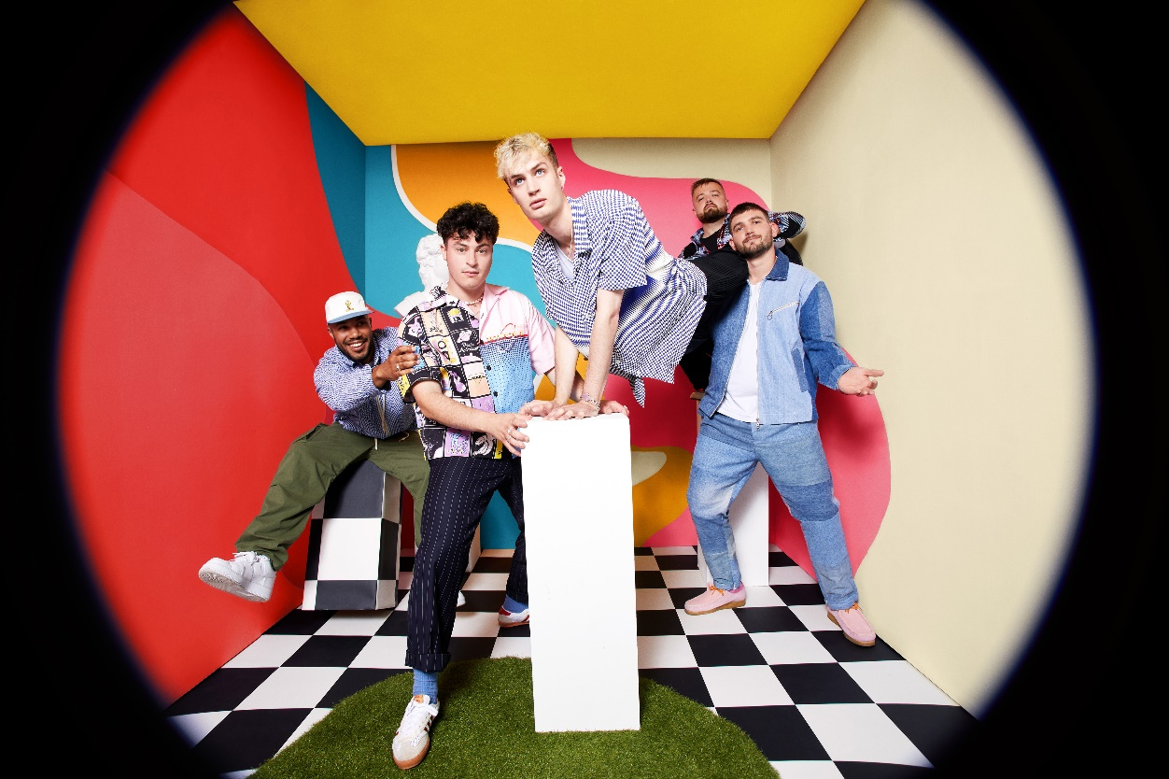
KAWALA KICK OFF 2022 WITH BRAND NEW SINGLE ‘JESSE C’MON’

DEBUT ALBUM ‘BETTER WITH YOU’ OUT MARCH 4^{TH,} 2022

LISTEN TO ‘JESSE C’MON’ HERE

“We’ve always been a little outsider-y. We don’t fit the pop narrative; we don’t quite fit the usual band narrative. We’re really happy to be taking up that space, but I think this is our flag in the sand moment. The album really says: This is us, here we are!” – Jim Higson, KAWALA

KAWALA are back and starting out 2022 with their exuberant new single ‘Jesse C’mon’, out now on EMI records.

A slice of vibrant, danceable pop, ‘Jesse C’mon’ sees the band layering their trademark harmonies and chiming guitars to create a sophisticated, yet instantly accessible song dealing with those people in the world who have a little issue with the truth.

“Jesse is a character we made up who represents and embodies all the people in the world who intentionally lie all the time” the band explains. “Everybody knows a Jesse.”

The surreal and vibrant video for ‘Jesse C’mon’ was created by Spanish video director NYSU (Bastille, New Order) alongside the band and takes the idea of a catchy tune to some strange places.

“When we first wrote the song, the thing that stood out about it was how it instinctively made you start bopping your head. And as we listened back to what we’d made, one of us would start bopping his head, and suddenly we were all doing it” the band explain. “We wanted to showcase how infectious this was through the main characters’ consistent head motion throughout the video. Through the ingenious vision of NYSU, we were able to balance this with the constantly evolving chaos all around him. we wanted to make it hard to keep your eyes off it!”

Containing a spectrum of thoughts, feelings and observations, the band’s debut album, ‘Better With You’, is driven by golden melodies, danceable afrobeat-inspired rhythms and immediate harmonies that create a truly encompassing atmosphere across its ten songs. The album follows a series of acclaimed EPs and live shows from the North London band over the last two years which has seen them establish a community focused fanbase across the country.

Fittingly, their debut album is a celebration of this communality, with a lyrical thread running through its songs charting the band’s growth as people and as artists. The record’s artwork helps reflect this, with the band having chosen to ask a number of individuals who have helped them along the way to paint or draw different panels that eventually formed the overall mosaic of the cover.

On the album itself tracks like previous single ‘Searching’ and the (cheekily named, non-cover) ‘Ticket To Ride’, along with new tracks ‘Marathon’ and ‘Echoes’ are filled with an intoxicating hopefulness that unfurls into bright, pop moments, sure to stir minds and bodies. While On the flip side of the coin, songs like ‘Hypnotized’, ‘Jesse C’Mon’ and ‘Good Like This’ provide a more immersive musical landscape that offers a contemplative, personal vibe.

Recorded over the last 12 months as restrictions tightened and eased, KAWALA – completed by guitarist Dan Lee, bass player Reeve Coulson and drummer Ben Batten – found themselves collaborating with an array of leading production talent on their new record after their initial plan of retreating to a residential studio was scuppered by the pandemic.

Athlete's Joel Pott (George Ezra, Shura, Tom Walker), Cam Blackwood (George Ezra, London Grammar), Joe Rubel (Maisie Peters, Ed Sheeran), Dan Bryer (Tom Grennan, Rag'N'Bone Man) and Mark Ralph (Years & Years, Georgia) are among those the group have drawn on to collaborate on production and songwriting, as they took advantage of the windows when recording sessions were possible. Confident in their own artistic instincts, KAWALA were happy to draw on these unique artistic perspectives as they formulated a debut that lives up to their own vision.

Ultimately, anyone who hears ‘Better with You will be immediately aware of the bigger spirit that drives everything this band does. KAWALA’s debut is an album that offers a strong, vivid connection as its irresistible rhythms ripple around a yearning, emotional core. This might be a record about life’s journeys, but it is also one full of songs that will illuminate the road ahead.

The album marks the culmination of years of work which has seen the band grow from humble begging’s to the world class act they are today. Along the way they have done everything from play socially distanced shows in UK parks (after the first easing of restrictions in 2020), appear on FIFA 2021, write and perform in their own YouTube sitcom (the mad-cap Paradise Heights) and become ambassadors for the Music Venue Trust. Each step on the journey has seen the band grow and expand on what KAWALA means to their community.

At the end of 2021 the band headed out on their biggest UK and Ireland tour to date which culminated in an emotional sold-out show at the O2 Kentish Town Forum, the venue at the heart of the London community where the band spent their formative years.

“We grew up just around the corner from such a prestigious venue” says the band. “It always felt like the pinnacle of success to us when we were younger and just starting out. We couldn’t explain in words how it felt to achieve this dream of ours, it meant so much to us and our amazing fans there felt that too. The things you wait the longest for are always over the fastest”

The band are going to be following up these shows with their 2022 headline tour which will see them taking in even bigger venues and finish at the legendary Shepherds Bush Empire. The boys will also be playing a number of instore shows at record stores around the country around the release of ‘Better With You’ in March.

2022 INSTORE ACOUSTIC TOUR
Thurs 3rd March – Rough Trade - Bristol (6pm)
Fri 4th March – HMV – Liverpool (12.30pm)
Fri 4th March – HMV – Manchester (5pm)
Sat 5th March – Crash Records – Leeds (1pm)
Sat 5th March – Beyond Vinyl – Newcastle (6pm)
Mon 7th March – HMV – Birmingham (12.30pm)
Mon 7th March – Rough Trade – Nottingham (6pm)
Tues 8th March – Rough Trade East – London (6pm)
Thurs 10th March – Banquet Records – Kingston (6pm)

2022 HEADLINE TOUR
Thurs 7 Apr – Stylus – Leeds
Fri 8 Apr – The Caves – Edinburgh
Sat 9 Apr – Saint Luke’s – Glasgow
Mon 11 Apr – O2 Institute – Birmingham
Tues 12 Apr – The Marble Factory – Bristol
Wed 13 Apr – O2 Ritz – Manchester
Fri 15 Apr – O2 Shepherds Bush – London
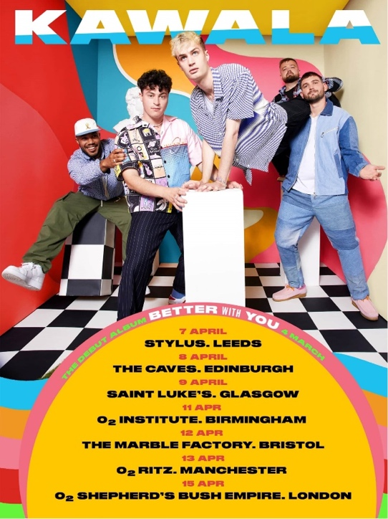

For more information please contact warren@chuffmedia.com

