

**OLIVIA DEAN UNVEILS ‘IT ISN’T PERFECT BUT IT MIGHT BE’**

**FOR THE NEW WORKING TITLE FILM**

***‘BRIDGET JONES: MAD ABOUT THE BOY’***

**FROM UNIVERSAL PICTURES, STUDIOCANAL AND MIRAMAX**

**THE SONG TO FEATURE AS LEAD TRACK AND END CREDITS**

[**LISTEN HERE**](https://oliviadean.lnk.to/IIPBIMBPR) **|** [**WATCH TRAILER HERE**](https://www.youtube.com/watch?v=AZr9lYz12jw)

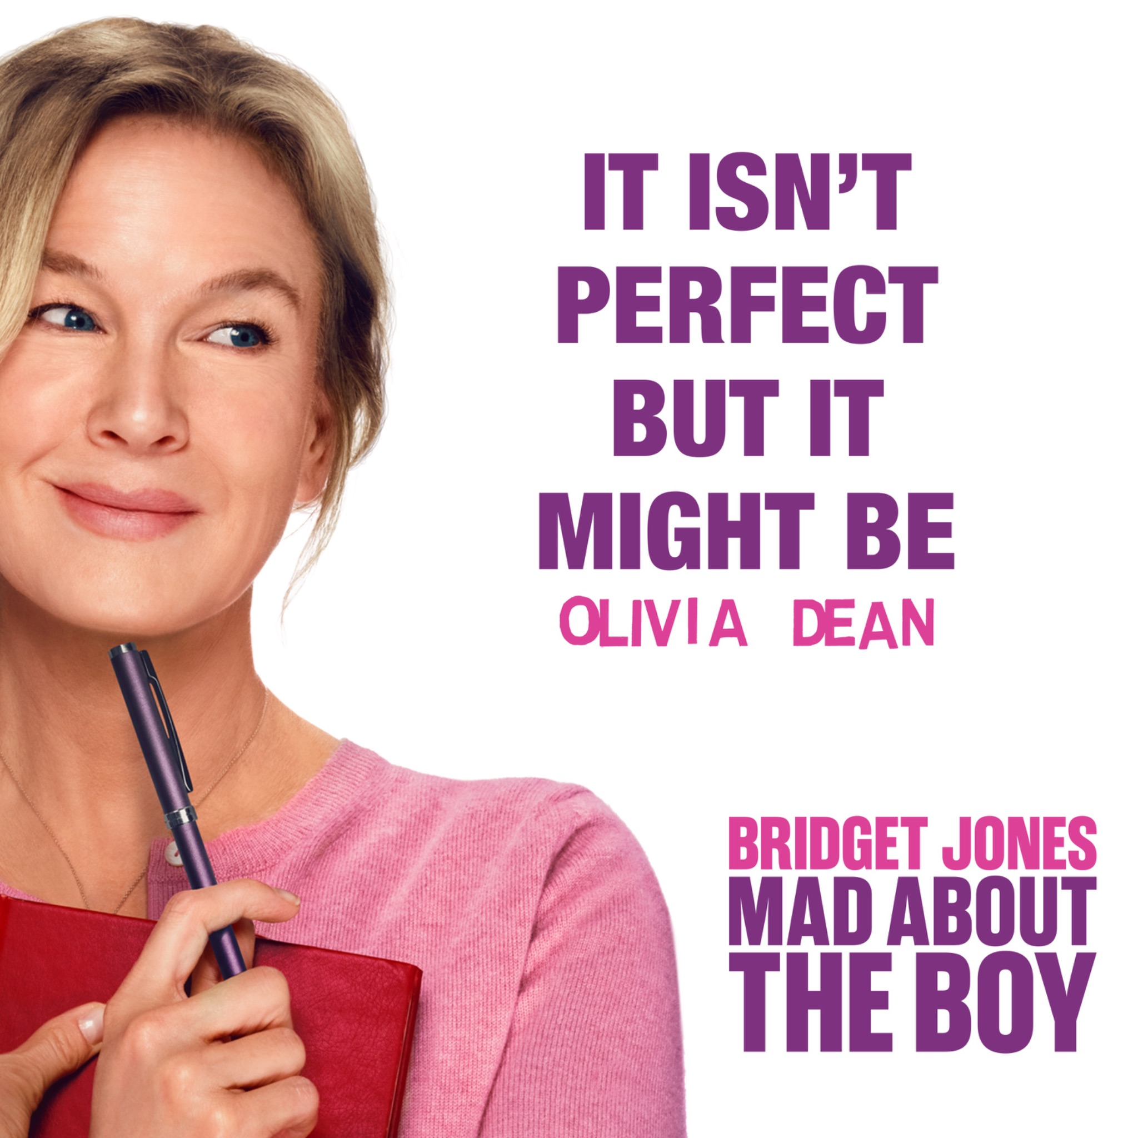

*BRIDGET JONES: MAD ABOUT THE BOY*

STREAMS EXCLUSIVELY ON PEACOCK IN THE U.S. FEBRUARY 13, 2025

AND ARRIVES IN THEATRES INTERNATIONALLY

BEGINNING FEBRUARY 12, 2025

[Today] Multi-BRIT and Mercury nominated singer songwriter **Olivia Dean** returns with the release of **‘It Isn’t Perfect But It Might Be’ (from *Bridget Jones: Mad About the Boy*)**, out via **Capitol Records**.

The song serves as the official lead track and end credits for the new chapter in the blockbuster romantic comedy franchise: ***Bridget Jones: Mad About the Boy***. Capturing the classic charm and wit synonymous with the franchise, the track will play over the end credits, earning its place as an unforgettable part of the Bridget Jones experience.

Working Title’s ***Bridget Jones: Mad About the Boy***, from Universal Pictures, StudioCanal and Miramax, streams exclusively on Peacock in the U.S. beginning February 13, 2025, and arrives in theatres internationally beginning February 12, 2025.

Written and recorded exclusively for the film, **‘It Isn’t Perfect But It Might Be’** is a romantic ballad that reflects Bridget’s whimsical, complex and emotional journey in the film. With **Dean**’s rich and soulful voice taking centre stage, the track effortlessly blends themes of passion, vulnerability and the nuances of modern romance - all while maintaining the playful, heartfelt tone fans of the series, and **Dean** herself, love. A perfect musical companion for Bridget’s new chapter on the big screen, the song will also feature in a nostalgic montage of the franchise’s most memorable moments, shown during the film’s closing scenes.

**Speaking on the song Olivia said:** *“I’ve always loved the Bridget Jones films, they’re timeless classics. After seeing* ***Mad About The Boy*** *I was so moved by the journey we’ve watched Bridget go on over the years. ‘It Isn’t Perfect But It Might Be’ is about giving yourself permission to love again after grief, and trusting that things might just work out after all, even if it’s not how you expected them to. This is the first time I’ve been a part of something like this and I can’t wait for it to come out!”*

Directed by Michael Morris (*To Leslie*, *Better Call Saul*) and starring two-time Oscar winner Renée Zellweger in her iconic role as Bridget Jones, the film, based on the best-selling book series by Helen Fielding, reunites its all-star cast, including Hugh Grant, Emma Thompson, and Colin Firth, alongside new characters played by Oscar nominee Chiwetel Ejiofor (*12 Years a Slave*, *Children of Men*) and Leo Woodall (*One Day*, *White Lotus*).

**‘It Isn’t Perfect But It Might Be’** brings back the relatably flawed, yet endearing Bridget that audiences have grown to love across three previous hit films. *Bridget Jones: Mad About the Boy* will also include **Dean’s** lauded 2023 single **‘Dive’**, taken from her critically acclaimed first studio album ‘***Messy’***, expressing the emotion and charm that have defined Bridget’s journey, while complementing the film’s nostalgic tone.

In the film, Bridget is facing a new chapter in her life, having been widowed four years earlier when the love of her life, Mark Darcy, was killed on a humanitarian mission in Sudan. She’s now juggling being a single mum, starting a new career and forging a new path toward life and love. The film reflects the realisation that life and love are never perfect—an idea beautifully captured in both the story and song. **Dean’s** undeniable talent have cemented her status as one of the UK’s standout artists and **‘It Isn’t Perfect But It Might Be’** further highlights her unmistakable artistry, offering fans a glimpse of more exciting releases still to come.

**About Olivia Dean  
Olivia Dean** is a multi-BRIT and Mercury Prize-nominated singer-songwriter who has quickly become one of the most exciting musical talents in the UK to date. Renowned for her distinctive fusion of neo-soul, R&B, and jazz, she has carved out a unique sound that blends timeless genres with a modern flair, earning her widespread acclaim from the industry and fans alike. With over **5.6M+** Spotify monthly listeners worldwide, she has earned a reputation for her soulful powerhouse vocals, emotive songwriting, and signature style. Dean’s music has captivated audiences globally, and her contribution to *Bridget Jones: Mad About the Boy* marks her first collaboration with the beloved film franchise.

**About *Bridget Jones: Mad About the Boy***

Two-time Academy Award® winner Renée Zellweger returns to the role that established a romantic-comedy heroine for the ages, as Bridget, now a widowed single mother, must juggle work, parenthood and romance. With the help of her loyal friends, Bridget navigates encounters with a younger man—and a series of awkward interactions with her son's science teacher—as she strives to forge a new path toward life and love.

**Stream ‘It Isn’t Perfect But It Might Be’**

(from ***Bridget Jones: Mad About the Boy*** Original Motion Picture Soundtrack):

[https://OliviaDean.lnk.to/IIPBIMBPR](https://oliviadean.lnk.to/IIPBIMBPR)



**Photo Credit**: PetrosStudio

**FOLLOW OLIVIA DEAN:**

[Instagram](https://www.instagram.com/oliviadeano/) | [Spotify](https://open.spotify.com/artist/00x1fYSGhdqScXBRpSj3DW?si=9buqD0cfQ5iGQNPN0jaUMA) | [TikTok](https://www.tiktok.com/@oliviadeano_?lang=en)

**Jenny Entwistle**[**jenny@chuffmedia.com**](mailto:jenny@chuffmedia.com)