

**AMAZON MUSIC KICKS OFF THE HOLIDAY SEASON WITH**

**TOM GRENNAN**

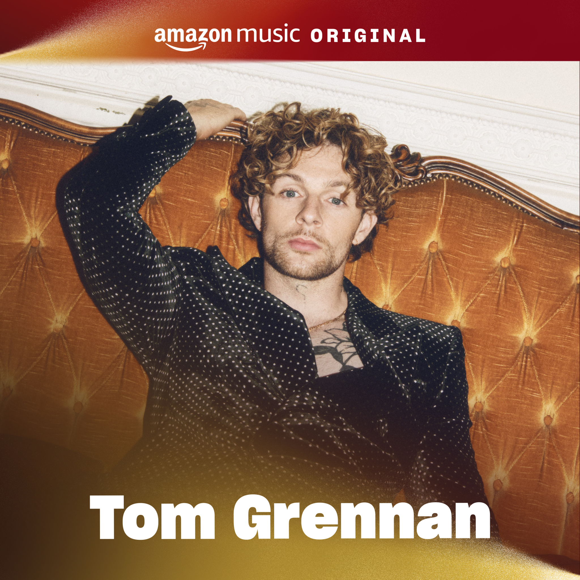

**BRAND NEW AMAZON MUSIC ORIGINAL TRACK “IT CAN’T BE CHRISTMAS (AMAZON MUSIC ORIGINAL)” RELEASED TODAY**

**TOM GRENNAN ANNOUNCED TO HOST FESTIVE AMAZON MUSIC CITY SESSION ON DECEMBER 5TH IN LONDON**

**FESTIVE MERCH COLLECTION WILL BE AVAILABLE EXCLUSIVELY ON** [**AMAZON.CO.UK**](https://amzn.to/TomGrennanOfficial)

**Monday 4th November:** Amazon Music today announce the exclusive release of *“It Can’t Be Christmas (Amazon Music Original)”*. The brand-new Christmas song by singer-songwriter Tom Grennan kickstarts the festive season, available only on Amazon Music [here](https://amzn.to/tomgrennan).

Tom said *“I love everything about Christmas, spending time with friends and family, eating great food, and listening to Christmas music. So it was a no brainer for me to team up with Amazon Music to create a festive song of my own. I hope you enjoying listening to “It Can’t Be Christmas (Amazon Music Original)” as much as I enjoyed making it.”*

“It Can’t Be Christmas (Amazon Music Original)” is is destined to become an instant Christmas classic. The new Amazon Music Original song is the latest release to join a growing list of holiday tunes released exclusively on Amazon Music, including previous tracks from global superstars like Taylor Swift's "Christmas Tree Farm," Katy Perry's platinum-certified "Cozy Little Christmas," John Legend's gold-certified "Happy Xmas (War Is Over)," and Sam Ryder’s “You’re Christmas to Me”, which hit #2 on the UK Official Singles Chart last year. With many more exclusive hits, Amazon Music is the ultimate destination for holiday music.

The new track follows the continued evolution of one of UK music’s most exciting talents, and the latest chapter in the story of a multi-platinum-selling artist who’s already picked up multiple BRIT and Ivor Novello nominations and an MTV Award for Best UK Act, along with countless airplay smashes and a rise to arena-selling, festival headliner status.

To celebrate the release of “It Can’t Be Christmas (Amazon Music Original)”, Tom will host a festive Amazon Music City Session in London, where he will be performing the song alongside other hits on December 5th. The unique performance will be streamed on the [Amazon Music UK channel on Twitch](https://eur02.safelinks.protection.outlook.com/?url=https%3A%2F%2Fwww.twitch.tv%2Famazonmusicuk&data=05%7C02%7CJanet.Choudhury%40umusic.com%7Cb332aa05cfb84acb9c2f08dcd9617f67%7Cbbcb6b2f8c7c4e2486e46c36fed00b78%7C1%7C0%7C638624260025443033%7CUnknown%7CTWFpbGZsb3d8eyJWIjoiMC4wLjAwMDAiLCJQIjoiV2luMzIiLCJBTiI6Ik1haWwiLCJXVCI6Mn0%3D%7C0%7C%7C%7C&sdata=O08VXZW1VJh4WCtSWMpJCykoZ7jVPqwWlktcsZjcRgQ%3D&reserved=0), allowing fans around the world to tune in to the celebrations live from London. More information on how to secure tickets to the performance will be available from 15th November.

Featuring some of the biggest names performing on intimate stages in unique venues, the City Sessions series spans musical genres offering fans a unique opportunity to tune in to a once-in-a-lifetime show from some of their favourite artists. Viewers around the world can tune in to the shows on the Amazon Music channels on Twitch. The highly successful intimate performance and livestream series has captivated audiences across the globe with previous performances including superstars Kings of Leon, Nelly Furtado, Bastille, Leigh-Anne and more.

Amazon Music has also teamed up with Tom to create limited-edition festive merchandise range and vinyl of his Amazon Music Original. The ­­limited-edition collection is available now and features three designs, in six colours, across t-shirts, tank tops and hoodies with prices starting from £22. The vinyl can be pre-ordered from 4th November, before its official release on 20th December. All items can be ordered [here](https://amzn.to/TomGrennanOfficial).

**About Tom Grennan**

Multi-platinum selling artist TOM GRENNAN is one of the UK’s biggest and most exciting talents. With two number one albums under his belt alongside multiple Brit and Ivor Novello nominations, countless airplay smashes and an MTV Award for Best UK Act, he has risen over the course of three albums to headlining festivals and selling out arena tours. Tom Grennan’s fourth album is shaping up to be a stunning addition to his already-impressive discography, which has seen him accumulate over 1.5 million album sales and 2.5 billion streams across his gold-selling debut Lighting Matches (2018), his first UK Number One album Evering Road (2021) and What Ifs & Maybes (2023), another Number One and Tom’s third gold-selling album in a row.

**About Amazon Music**

Amazon Music is an immersive audio entertainment service that connects fans, artists, and creators through music, podcasts, and culture. Amazon Music brings fans closer to what they love, with curated and personalised playlists, artist livestreams, artist merch, and Amazon Exclusive podcasts. Prime members get access to over 100 million songs in shuffle mode, All-Access playlists, plus the largest catalogue of top ad-free podcasts, included with their membership. Customers can upgrade to Amazon Music Unlimited for full, on-demand access to 100 million songs in HD and a growing catalogue of Ultra HD and Spatial audio. Anyone can listen to Amazon Music by downloading the Amazon Music app for free, or wherever they listen to music including Alexa-enabled devices. Learn more at <https://www.amazon.co.uk/music>

**For more information and press enquiries for TOM GRENNAN please contact**

**Jenny Entwistle**

[Jenny@chuffmedia.com](mailto:Jenny@chuffmedia.com)