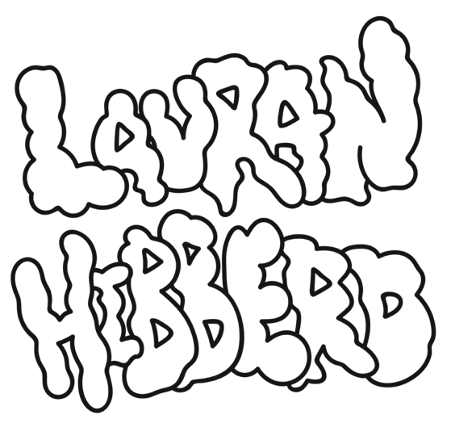
Lauran Hibberd shares effervescent second LP single ‘I’m Insecure’, out June 1st via Virgin Music

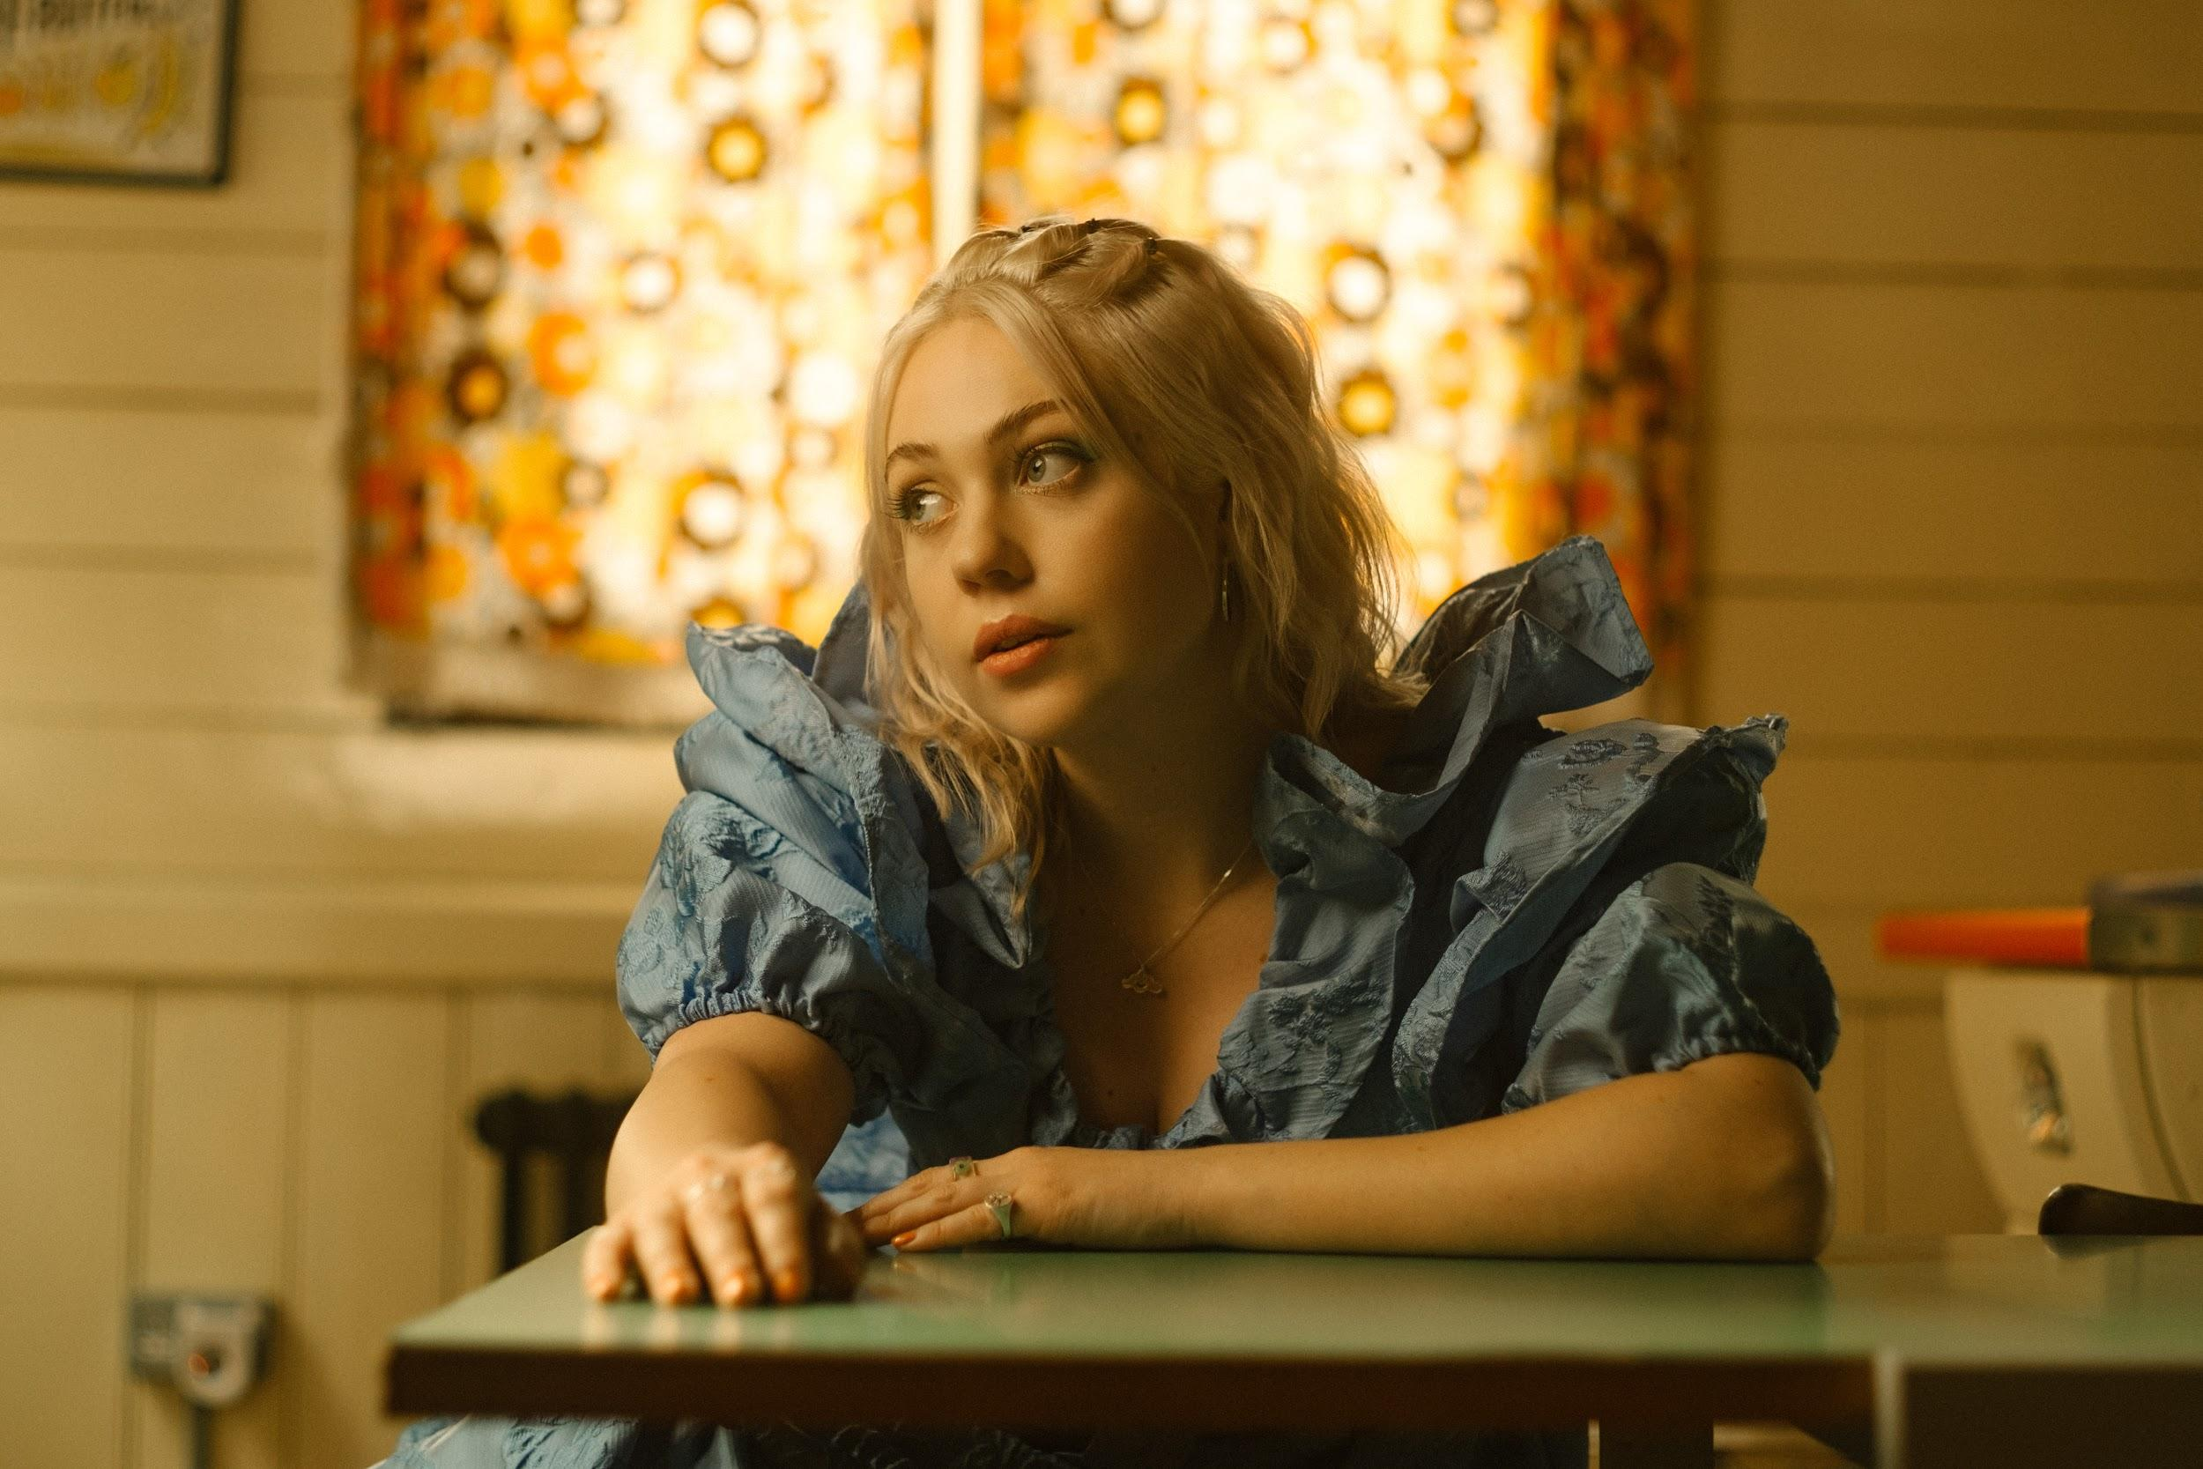
Photo Credit: Steve Glashier

“Such. Huge. Choruses…the next hottest thing” DIY

“A firecracker of a track” Billboard

“Tongue-in-cheek slacker-pop” NME

“Garage rock tunes...huge pop hooks” NYLON

“Grunge-inflected, punky bubblegum pop…she continues on her upward trajectory in explosively exciting fashion” The Line Of Best Fit

"Queen of slacker pop…if these bopping tunes are any indication, her next steps should be followed very closely" Dork

"Each song from the rising talent feels immaculately well packaged…cool-as-heck indie rock" Clash

"If you’re a fan of excellent indie then keep your eyes on Lauran Hibberd. We’re certain she won’t disappoint you" Gigwise

“Fizzy indie rock bangers” Music Week

“Slacker pop has a new frontrunner …every single one of Lauran Hibberd’s tracks is 10/10 great” Upset
“High-energy pop sensibilities and a tongue-in-cheek attitude” Rock Sound

Isle Of Wight power pop specialist Lauran Hibberd shares fizzing new cut ‘I’m Insecure’, the second official single from forthcoming debut LP ‘Garageband Superstar’, set for release August 19th via Virgin Music.

"You know when you are so insecure but also sure enough of yourself to attempt to rap - yeah, me neither”, Hibberd remarks. “This song was such a turning point for me writing wise, it solidified the album for me early on. It’s a track about being stuck in your own head, I’ve struggled a lot mentally being a very small pawn on the very big chess board that is the music industry and I think this is the most honest I’ve ever been about it in a track. Saying that, writing it has helped me jump right out of the fish bowl, now I feel more confident and am having more fun than ever."

Signalling the newest addition to her thrilling catalogue of adrenaline-fueled hits, ‘I’m Insecure’ follows previous album teaser ‘Step Mum’ earlier this month, alongside news of her debut album tour, and sees the indie sensation partner once again with revered producer Larry Hibbitt (Nothing but Thieves, Don Broco, Dinosaur Pile-Up, Sea Girls), as her spectacular ascent towards the upper echelons of the indie landscape gathers further pace.

Brimming with charisma and satire-fuelled anthems, the DIY Magazine Class of 2022 star’s remarkable potential is reinforced by the groundswell of support across the press landscape (The Guardian, The Times, NME, The Line Of Best Fit, Dork, DIY, Billboard, Consequence of Sound, NYLON, Clash, Gigwise, Kerrang, Rock Sound, Upset) over the last few years, as well as significant praise across the BBC Radio 1 (Clara Amfo, Jack Saunders, Gemma Bradley) and BBC 6 Music (Chris Hawkins) airwaves, as she tackles the next phase in her thrilling development.

Fresh from nationwide dates supporting chart-toppers The Snuts and Stand Atlantic, as well as a sold-out 2021 UK headline tour, the enigmatic musician’s raucous live show has already seen her earn impressive support tours with Hippo Campus and The Regrettes in recent times. Earmarked for several prominent slots throughout the summer festival season (sharing stages with the likes of Bombay Bicycle Club, Everything Everything and Sundara Karma), Hibberd will also be hitting the road this autumn to coincide with the release of her debut album.

Lauran Hibberd’s ‘I’m Insecure’ is out June 1st via Virgin Music and will be available on all digital platforms.

Live Dates

4th June - Live At Leeds
4th June - Sonic Wave, Birmingham
16th June - Rock For The People, Czech Republic
9th July - 2000 Trees, Cheltenham
22nd July - Truck Festival
29th July - Y Not Festival
30th July - Camp Bestival
31st July - Kendal Calling
5th August - Wide Skies & Butterflies Festival

17th Sept - Arts Club (Loft), Liverpool
18th Sept - Brudenell Social Club, Leeds
19th Sept - King Tut’s, Glasgow
21st Sept - Mama Roux’s, Birmingham
22nd Sept - Clwb lfor Bach, Cardiff
23rd Sept - The Garage, London
24th Sept - Wedgewood Rooms, Portsmouth
30th Sept - Strings Bar & Venue, Newport

Lauran Hibberd Online
Facebook / Twitter / Instagram / Website / Spotify / TikTok

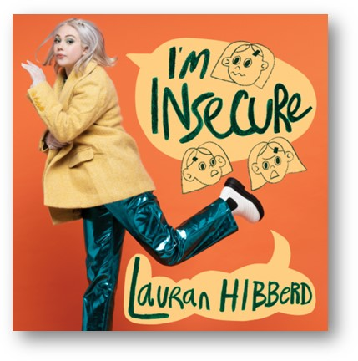

For more information and press enquiries please contact

Jenny Entwistle
Jenny@chuffmedia.com

Melanie Balbrick
assistant@chuffmedia.com

