STONE announce new EP Punkadonk 2
Out October 27th on Polydor Records

Share new single ‘If You Wanna’

UK tour with DMA’S this December
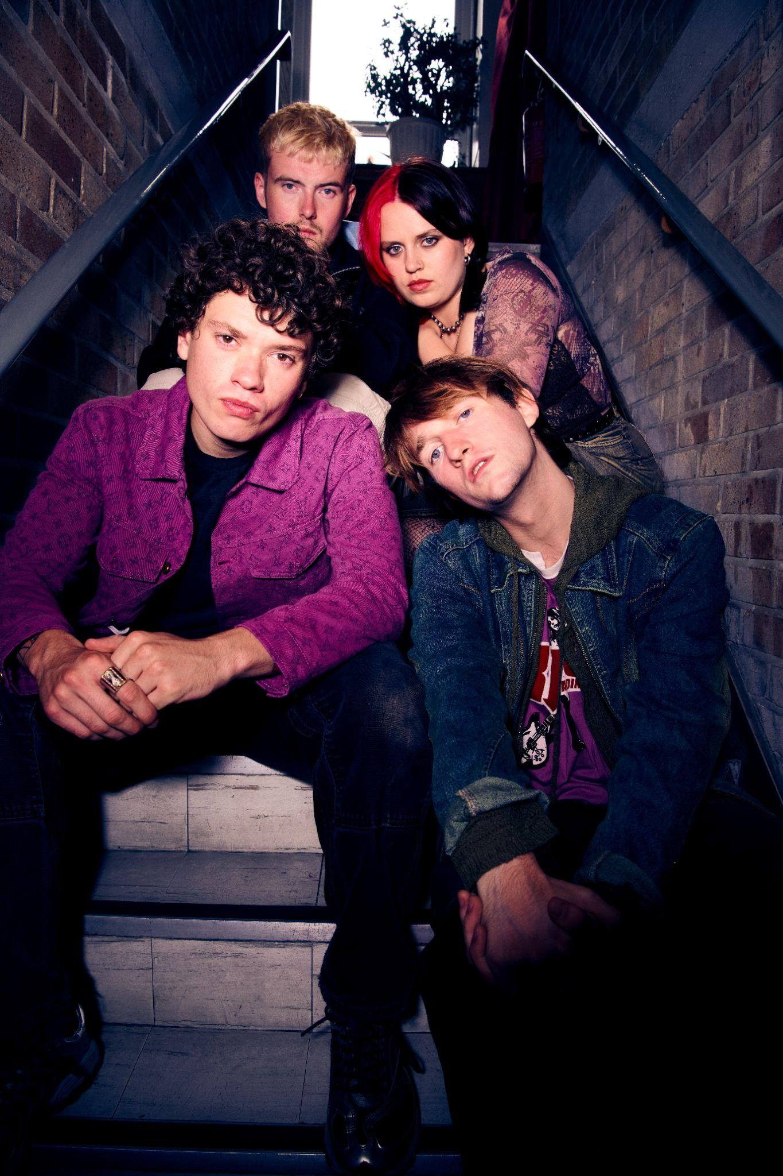
Download High Res

"Bruising post-punk full of Scouse spirit and soul"
NME

“STONE are the post-punks with a reputation for mosh-pit starting licks and the snarling delivery of frontman Fin Power”
Rolling Stone UK

“Full throttle and immediate but undeniably powerful – from a band that must be seen live to be truly believed. Expect venues around the country to be shaking in anticipation."
Dork

“A perfect post-pandemic band…raucous live shows and playfully rowdy indie bangers”
DIY

LISTEN HERE
PRE-ORDER PUNKADONK 2 HERE
Having spent the Summer sharing bills alongside international heavyweights, including Glastonbury Festival, Mad Cool, and BST in support of Bruce Springsteen, STONE are set to release their second EP Punkadonk 2 on October 27th via Polydor Records. The Liverpool four piece mark the news with fresh single ‘If You Wanna,’ which premiered as Clara Amfo’s ‘Hottest Record In The World’ on BBC Radio 1, landing today alongside a live session version, watch here. It follows support from the station for their euphoric pop rock jam ‘I Gotta Feeling,’ which was named Vick and Jordan’s ‘Tune of the Week.’ Having recently revealed the exciting news that they’ll be hitting the road with DMA’S through the UK this December, STONE’s own headline tour has been shifted into February, full dates below.

Slicing through the static, ‘If You Wanna’ is STONE’s call to cherish the things that bind and fuel us. Whether sung loud in the backseat with friends, or with perfect strangers in a festival mosh, it’s a salve tailor-made to be relished in company. The band reflect; “With 'If you Wanna,’ we wanted to write the type of song you would wanna sing along to with your friends. The song is about finding positivity in this colourful Gen Z experience.”

The release of their debut EP Punkadonk late last year capped off a breakout 12 months for STONE, showcasing the band’s knack for fusing thrilling, frenetic rock with more intimate explorations of the Gen-Z experience. Punkadonk 2 elevates the foundations of its predecessor to new heights, emphasising their command of light and shade with raw authenticity and fervent determination. EP opener ‘If You Wanna’ sets their intention, before moving into ‘Compulsive’ which unpacks the duality of feeling simultaneously distant yet grounded across its resounding hard rock chorus. This tension carries over onto 'Am I Even a Man,' where frontperson Fin Power candidly captures his tumultuous transition into adulthood, struggling to form his own identity whilst untangling deep-rooted notions of stoicism and masculinity. Euphoric pop-rock cut ‘I Gotta Feeling,’ lets the air back in - a wry takedown of ego and toxic bravado packed with biting one liners and inspired by a real night out. The EP unfolds into the carefree ‘Left Right Forward’ before closing with ‘I’m Still Waiting,’ a scathing commentary on the unrealistic expectations imposed on youth as they navigate the unique intensities of modernity.

Storming straight out of the new era Liverpool scene with a formidable live reputation preceding them, alongside Fin Power (vocals/guitar), STONE are completed by Elliot Gill (lead guitar) Sarah Surrage (bass), and Alex Smith (drums). It’s clear that the band are striking a chord beyond just the mosh pit and into the digital world by way of their flourishing online community, which has almost doubled in the last 6 months alone. Their burgeoning fanbase already includes some of music’s biggest names, which has led to handpicked support slots from the likes of YungBlud, Inhaler, Sam Fender, as well as blistering festival sets at Reading and Leeds and Louis Tomlinson’s ‘Away from Home’ line up in Malaga. The band have been tipped as ones to watch by the likes of NME, Dork, Rolling Stone UK, MTV and more, and championed across both BBC Radio1 and 6Music. As the band continue to stake their claim as one of the UK’s most exhilarating young acts, Punkadonk 2 is set to unfurl as the next poignant flagbearer of their identity, and a momentous stride forward for STONE’s personal growth and artistic maturity.

Listen to ‘If You Wanna’ on all platforms:
STONE.lnk.to/IfYouWanna

Pre-order Punkadonk 2:
STONE.lnk.to/PRESAVE_PUNKADONK2

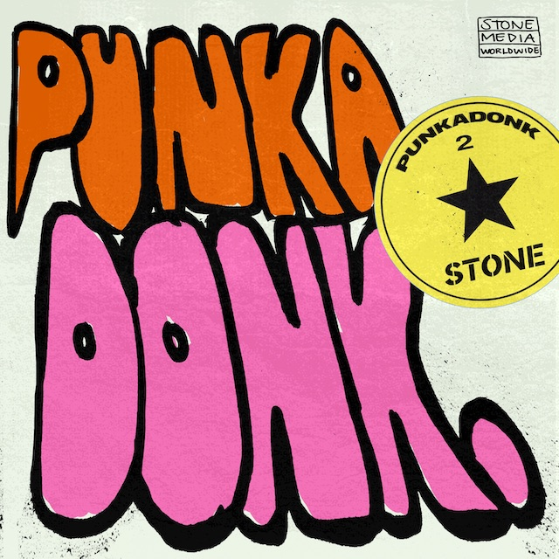
Punkadonk 2 artwork | Download Here

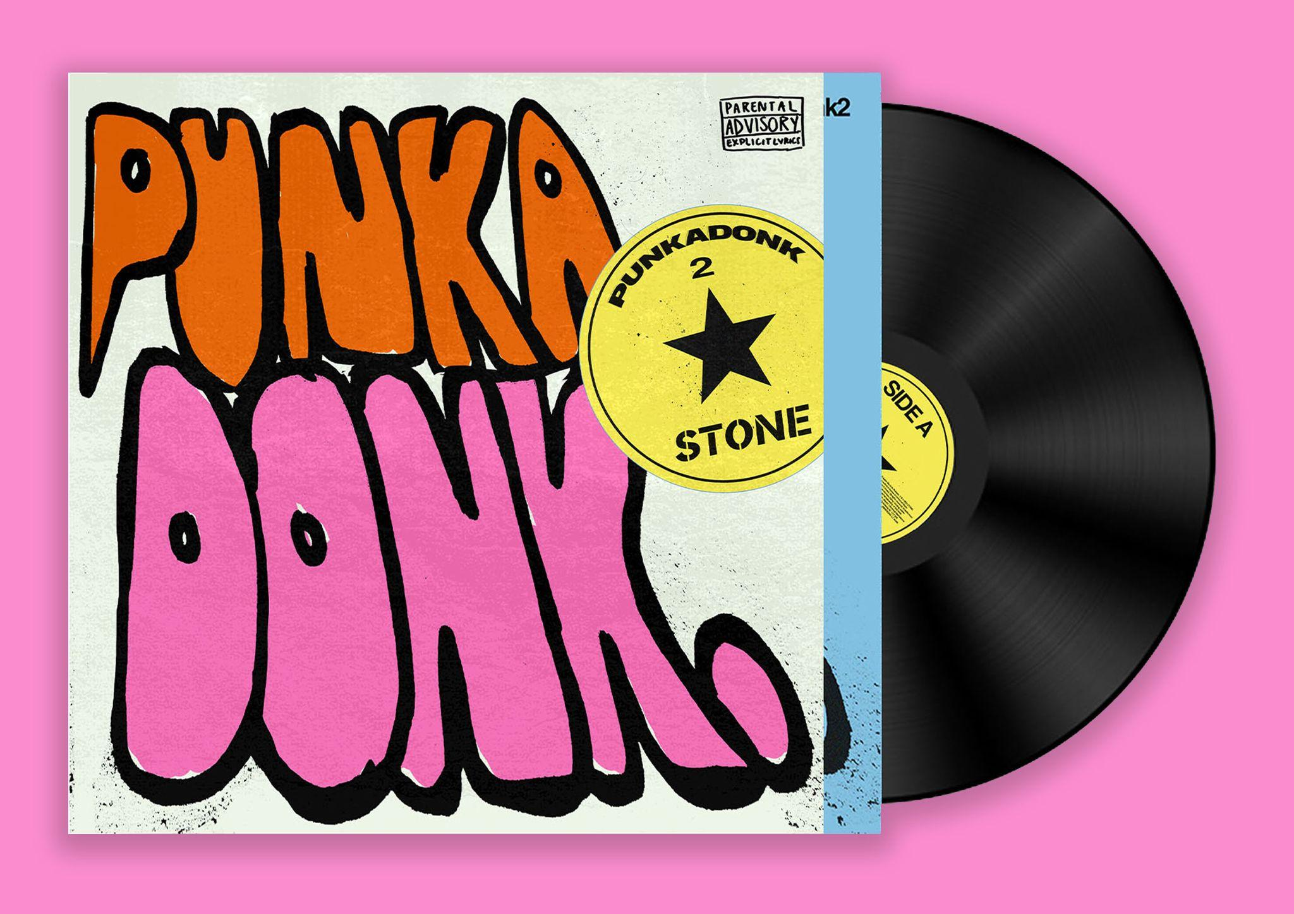
Punkadonk 2 Vinyl format

STONE - Punkadonk 2
Tracklist:
01. If You Wanna
02. Compulsive
03. Am I Even A Man
04. I’ve Gotta Feeling
05. Left Right Forward
06. I’m Still Waiting
STONE live dates:
Tickets here

28 Oct | Amsterdam, NL | London Calling @ Paradiso
29 Oct | Brussels, BEL | Botanique Rotonde
05 Dec | Norwich, UK | University of East Anglia*
06 Dec | Southampton, UK | O2 Guildhall*
07 Dec | Nottingham, UK | Rock City*
09 Dec | Liverpool, UK | University Mountford Hall*
10 Dec | Newcastle-Under-Lyme, UK | Keele University Student Union*
11 Dec | Bristol, UK | O2 Academy*
12 Dec | Cardiff, UK | Great Hall - Cardiff University*
14 Dec | Glasgow, UK | O2 Academy*
15 Dec | Manchester, UK | Warehouse Aviva Studios*
17 Dec | London, UK | HERE at Outernet*
18 Dec | London, UK | HERE at Outernet*
23 Feb | Leeds, UK | University Stylus - headline
24 Feb | Glasgow, UK | Garage - headline
29 Feb | London, UK | Garage - headline
01 Mar | Manchester, UK | Academy 2 - headline
02 Mar | Newcastle, UK | University - headline

* with DMA’S

Follow STONE:
Website | Instagram | Facebook | Youtube | TikTok | Spotify

For more information please contact
Warren Higgins
Warren@chuffmedia.com on 07762 130 510

