STONE release new single ‘I Gotta Feeling’
Announce UK headline tour for October
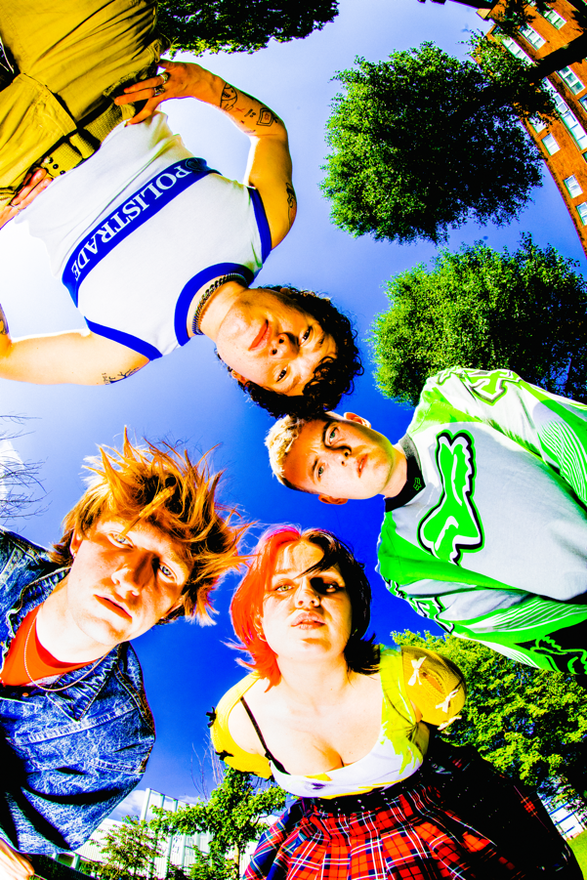
Playing Glastonbury Festival next week
Photo Credit: | Download High Res

"Bruising post-punk full of Scouse spirit and soul"
NME
“STONE are the post-punks with a reputation for mosh-pit starting licks and the snarling delivery of frontman Fin Power”
Rolling Stone UK
“Full throttle and immediate but undeniably powerful – from a band that must be seen live to be truly believed. Expect venues around the country to be shaking in anticipation."
Dork
“A perfect post-pandemic band…raucous live shows and playfully rowdy indie bangers”
DIY

Gearing up for their debut appearance at Glastonbury Festival next week, where they will take to the BBC Introducing stage on the Friday, Liverpool four-piece STONE share another euphoric, pop rock cut ‘I Gotta Feeling’ alongside a lyric video, watch here. The new track was premiered as Clara Amfo’s ‘Hottest Record In The World’ on BBC Radio 1 last night, and follows previous singles ‘Left Right Forward’ and ‘I Let Go’. Having recently showcased to a packed-out crowd at The Great Escape and sold-out a run of UK headline shows, ‘I Gotta Feeling’ continues STONE’s momentum - primed to be an instant fan favourite and live set staple for their coming Summer festival appearances and newly-announced October headline shows, full dates below. Later this week, the band will celebrate the new single with an event at their local karaoke bar in Liverpool, where they’ll bring fans along with them for a classic night out which is sure to include many enthusiastic renditions of STONE favourites.

‘I Gotta Feeling’ embodies everything that STONE does best - diffusing biting social commentary and lighthearted one liners into a thrilling, undeniably catchy rock cut which would feel as at home in a sweaty band room as it would on a heaving festival stage. Here, the instantly-discernable vocals of Fin Power are at their height - delivering the track’s message via his spoken word style and urgent choruses. A reflection on ego and toxic bravado, Fin explains; “‘I Gotta Feeling’ was written about when me and Alex went out on the night of the Grand National and how hostile the environment in the bars was - from people dressing like wannabee gangsters and also being upset they have lost money on the races. I walked around town with my notes app open and wrote lyrics whilst it was happening. The song also portrays how I used to relate to the ego these people have - but how liberating it is that I have escaped that toxic mentality. I feel like the song helps to show self-insight, and that lot of people will relate to it.”

Storming straight out of the new era Liverpool scene with a formidable live reputation preceding them, alongside Fin Power (vocals/guitar), STONE are completed by Elliot Gill (lead guitar) Sarah Surrage (bass), and Alex Smith (drums). It’s clear that the band are striking a chord beyond just the mosh pit and into the digital world by way of their flourishing online community, which has risen by over 40 percent in the past few months alone. A breakout 12 months was capped off by the release of debut EP offering Punkadonk in December last year, which fuses rousing, frenetic rock with a more intimate exploration of the Gen-Z experience. Their burgeoning fanbase already includes some of music’s biggest names, which has led to handpicked support slots from the likes of YungBlud, Inhaler, Sam Fender, as well as blistering festival sets at Reading and Leeds and Louis Tomlinson’s ‘Away from Home’ line up in Malaga. The band have been tipped as ones to watch by the likes of NME, Dork, Rolling Stone UK, MTV and more, and championed across BBC Radio1 and 6Music. The path is set for STONE to continue to forge ahead, staking their claim as one of the UK’s most exhilarating young acts.

Listen to ‘I Gotta Feeling’ on all platforms HERE
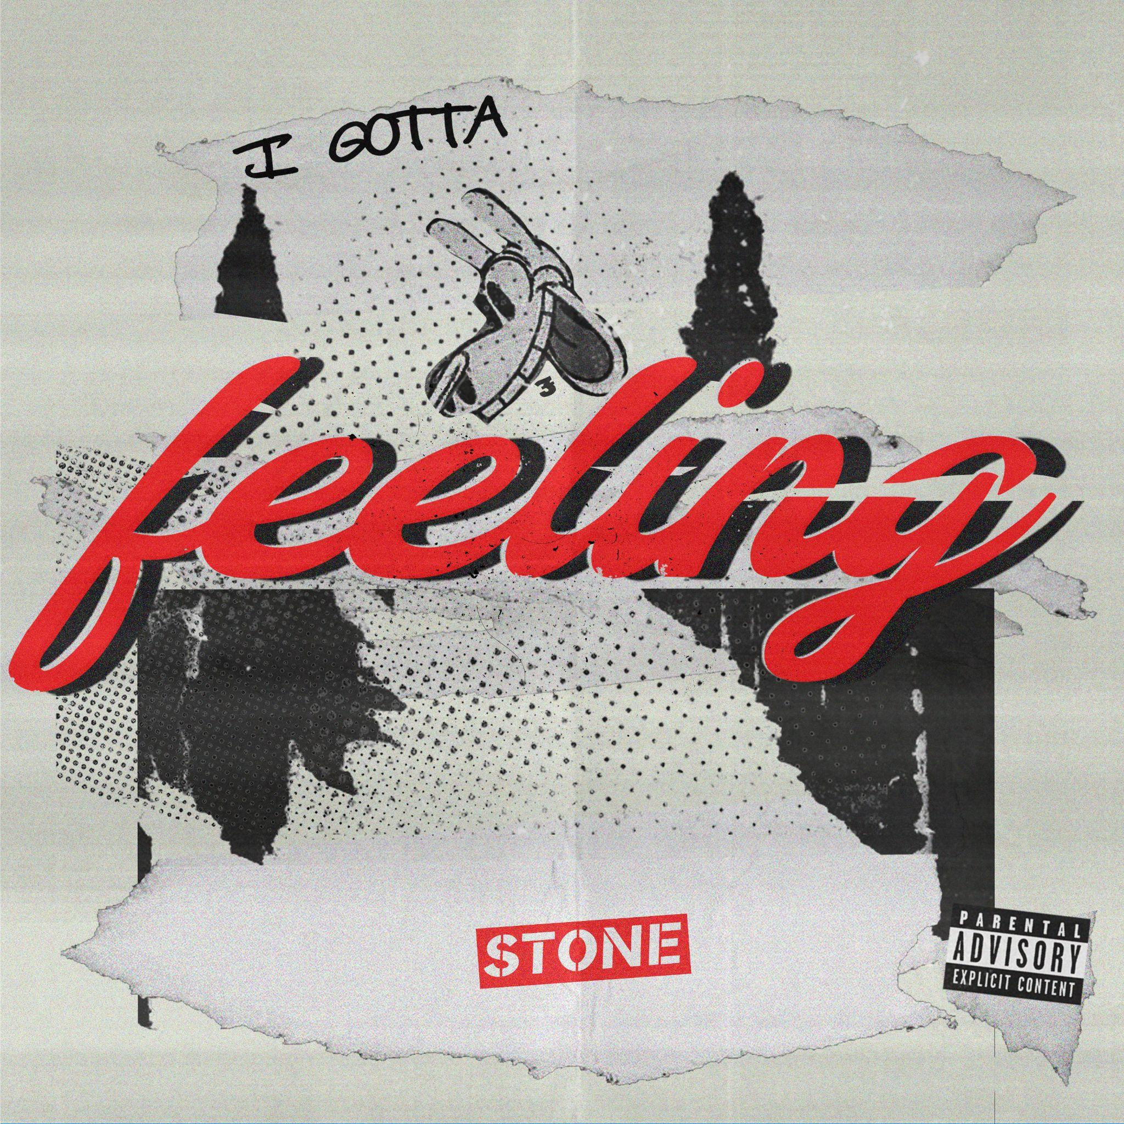

STONE 2023 live dates:
22 Jun | Cardiff, UK - headline
23 Jun | Glastonbury | Glastonbury Festival
01 Jul | Werchter, BE | Rock Werchter
02 Jul | Gloucester, UK | Barn On The Farm
07 Jul | Madrid, ES | Mad Cool Festival
08 July | Leeds, UK | Millennium Square supporting Blossoms.
21 Jul | Standon, UK | Standon Calling Festival
22 Jul | Sheffield, UK | Tramlines Festival
23 Jul | Oxfordshire, UK | Truck Festival
28 Jul | Cumbria, UK | Kendal Calling
26 Aug | Portsmouth, UK | Victorious Festival
1 Sept | Vlieland, NL | Into The Great Wide Open
02 Sept | Maastricht, NL | Bruis Festival
05 Oct | Newcastle, UK | Newcastle University - headline
06 Oct | Leeds, UK | Stylus - headline
07 Oct | Manchester, UK | Academy 2 - headline
08 October | Glasgow, UK | The Garage - headline
10 October | London, UK | The Garage - headline

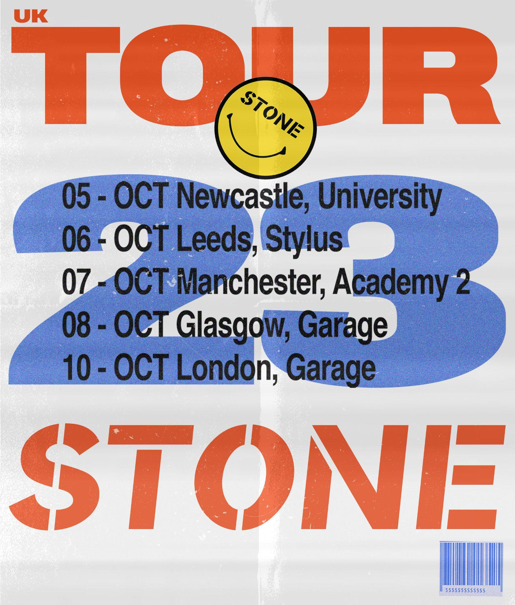
Follow STONE:
Instagram | Facebook | YouTube | TikTok | Spotify

For more information please contact
Warren@chuffmedia.com on 07762 130 510

