SELF ESTEEM
RETURNS WITH NEW SINGLE
‘I DO THIS ALL THE TIME’
ANNOUNCES NOVEMBER 2021 UK TOUR
Self Esteem today returns with her new single ‘I Do This All The Time’, premiered last night by Steve Lamacq on BBC Radio 6 Music. A part spoken-word ode to all the frustrations and societal norms that cloud expectations of ‘correct’ womanhood, the song’s lyricism comes as a tightly-held mantra for our comparison age: “don’t be intimidated by all the babies they have/don’t be embarrassed that all you’ve had is fun/prioritise pleasure.” The video for ‘I Do This All The Time’ is the first in a series of self-directed visuals shot at The Almeida Theatre with the help of Mr Mr Films.
Hi-res assets here // Photo credit: Olivia Richardson
“All my upcoming work is exploring how complicated it is to just be a human. I'm wonderful and i'm terrible. i hurt people and people hurt me. i feel everything and nothing. It's a shit laugh but then it can be quite jolly can't it. The video is the first chance to spot one of the many easter eggs for Self Esteem purists as well as the rather on the nose metaphor of me hugging myself - much like elton john in the movie rocket man does. enjoy!” says Self Esteem.
‘I Do This All The Time’ speaks to the impressive scale and ambition of Rebecca Lucy Taylor’s highly anticipated first new music since the release of her acclaimed 2019 debut album Compliments Please.
An umbrella for Taylor’s creative endeavours, Self Esteem has seen her undertake writing, painting, art-directing, and even organising the all-female Instagram festival ‘Pussy Pandemique’ to raise money for charity over lockdown.
Today Self Esteem also announces a 18 date UK headline tour, taking in shows across the country, including London’s Heaven and a hometown show at The Leadmill in Sheffield. A space for both catharsis and euphoric celebration, a Self Esteem live show is not to be missed. Tickets go on sale via https://www.selfesteem.love/.
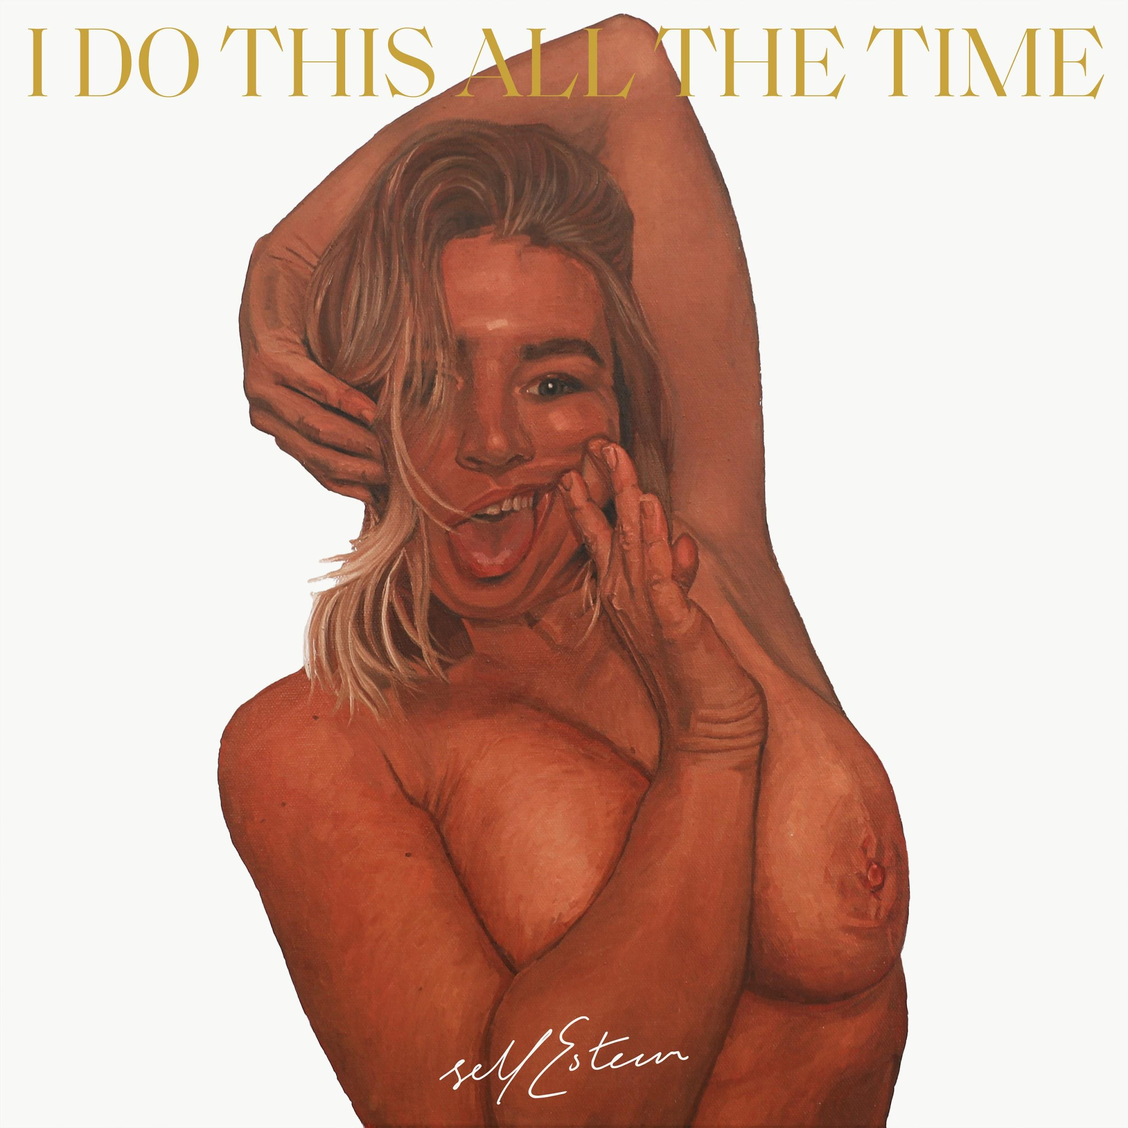

As Self Esteem, Rebecca Taylor has shaken off the shackles of her indie band past to become the unapologetic pop star she always wanted to be. With her statement debut Compliments Please she gave voice to the feelings of insecurity and misogyny-induced frustration that many of us face every day, emboldening a whole new audience with powerful, truth-telling lyricism that speaks to her love of rhythmic noughties pop and RnB. As Self Esteem, Taylor proves that we can all grow from what we go through, but that life is far too short not to embrace yourself in your most honest of forms – no apologies necessary.

UK 2021 TOUR DATES
30-Jul-21 Dorset Camp Bestival
8-Aug-21 Sheffield Get Together
1-Nov-21 Bristol Fleece
2-Nov-21 Newcastle Wylam Brewery
3-Nov-21 Cardiff Clwb Ifor Bach
4-Nov-21 Oxford O2 Academy
6-Nov-21 Edinburgh The Bongo Club
7-Nov-21 Glasgow Audio
9-Nov-21 Dublin The Workmans Club
10-Nov-21 Manchester Gorilla
11-Nov-21 Leeds Belgrave Music Hall
12-Nov-21 Sheffield The Leadmill
14-Nov-21 Norwich Arts Centre
15-Nov-21 Reading Sub 89
16-Nov-21 Southampton The Joiners
17-Nov-21 London Heaven
19-Nov-21 Margate Elsewhere
20-Nov-21 Brighton Patterns
23-Nov-21 Exeter Phoenix
24-Nov-21 Birmingham Hare & Hounds
25-Nov-21 Nottingham Metronome
Website / Instagram / Facebook / Twitter / TikTok

For all media enquiries please contact Warren@chuffmedia.com on 07762 130510

