**ONEREPUBLIC RELEASES NEW SINGLE “HURT WITH JELLY ROLL”**

**LISTEN**[**HERE**](https://onerepublic.lnk.to/Hurt-JR)

**WATCH**[**HERE**](https://onerepublic.lnk.to/HurtVideo)

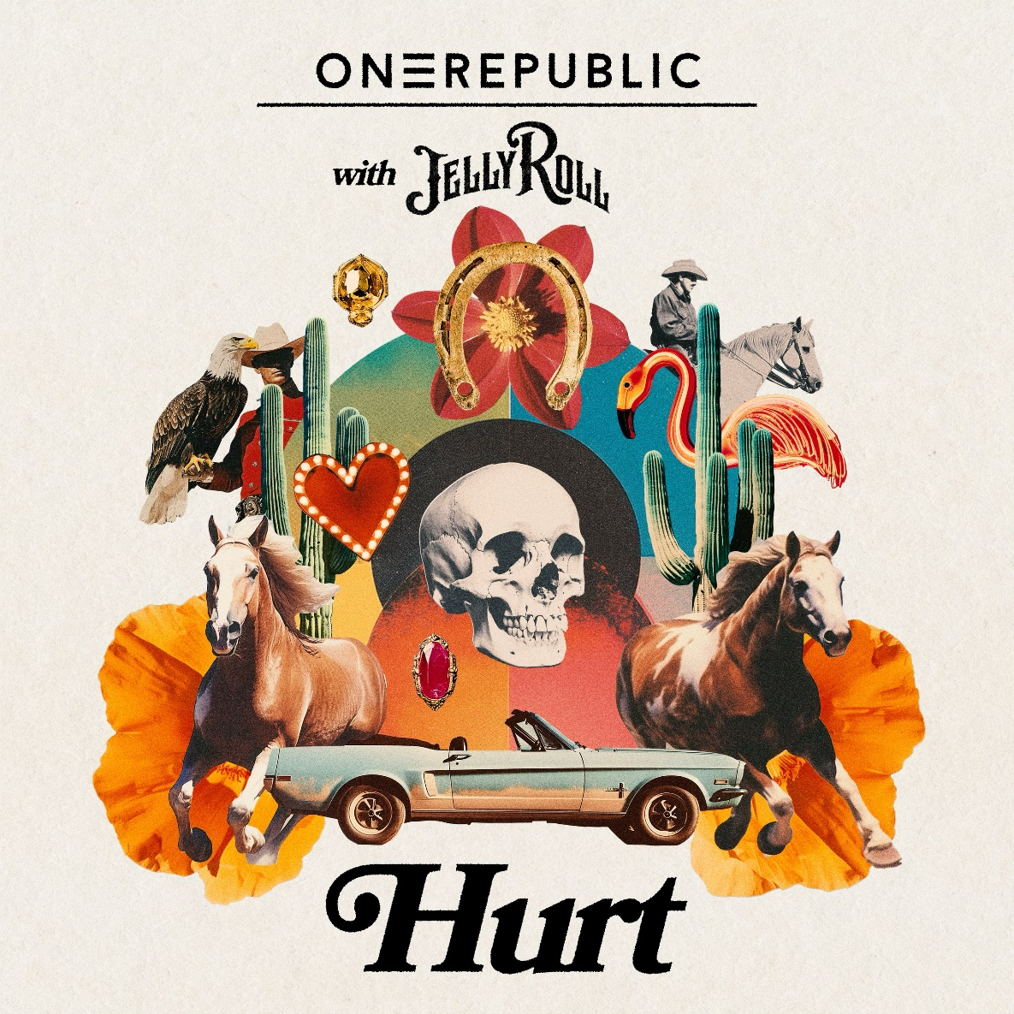

GRAMMY® nominated band, OneRepublic, have released their new single, “Hurt with Jelly Roll”. Listen [HERE](https://onerepublic.lnk.to/Hurt-JR). The original version of the song first appeared on OneRepublic’s latest album [*Artificial Paradise*](https://onerepublic.lnk.to/ArtificialParadise), released earlier this year.  
  
Alongside the track, the band also released their new music video for the song. Watch [HERE](https://onerepublic.lnk.to/HurtVideo). The video was directed by Isaac Rentz, who also directed the videos for “I Ain’t Worried” and “Sink or Swim”. “Hurt” made its broadcast premiere on MTV Live, MTVU, MTV Biggest Pop and on the Paramount Times Square billboards.”

The band most recently announced their ‘Escape to Europe’ 2025 Tour earlier this week. Kicking off at Dublin’s 3Arena on September 18, 2025, the band will perform at 27 arenas across major European cities including London, Paris and Berlin, concluding in Lisbon on November 16, 2025. The band will be joined by special guest Ella Henderson, whose UK number 1 debut single ‘Ghost’ was co-written by OneRepublic frontman Ryan Tedder. General tickets for the tour are on sale now. For full dates/more information please visit: [www.onerepublic.com/tour/](https://www.onerepublic.com/tour/)

***Escape To Europe* 2025 UK/EU Tour:**18-Sep Ireland, Dublin, 3Arena  
20-Sep UK, Birmingham, Utilita Arena  
21-Sep UK, Cardiff, Utilita Arena  
23-Sep UK, Glasgow, OVO Hydro  
24-Sep UK, Manchester, Co-op Live  
26-Sep UK, London, The O2  
28-Sep Netherlands, Amsterdam, Ziggo Dome  
29-Sep Germany, Hamburg, Barclays Arena  
1-Oct Germany, Cologne, Lanxess Arena  
2-Oct Germany, Berlin, Uber Arena  
4-Oct Poland, Lodz, Atlas Arena  
5-Oct Czech Rep, Prague, O2 Arena  
7-Oct France, Paris, Accor Arena  
8-Oct Belgium, Antwerp, Lotto Arena  
10-Oct Italy, Bologna, Unipol Arena  
11-Oct Italy, Milan, Unipol Forum  
30-Oct Denmark, Copenhagen, Royal Arena  
31-Oct Sweden, Stockholm, Avicii Arena  
1-Nov Norway, Oslo, Unity Arena  
4-Nov Latvia, Riga, Arena Riga  
5-Nov Lithuania, Kaunas, Zalgiris Arena  
7-Nov Germany, Frankfurt, Festhalle  
9-Nov Germany, Munich, Olympiahalle  
10-Nov Switzerland, Zurich, Hallenstadion  
11-Nov Austria, Vienna, Stadthalle  
14-Nov Spain, Madrid, Palacio Vistalegre  
16-Nov Portugal, Lisbon, MEO Arena

**ABOUT ONEREPUBLIC:**GRAMMY® nominated OneRepublic, is composed of singer/songwriter and lead vocalist Ryan Tedder, guitarists Zach Filkins and Drew Brown, keys player Brian Willett, bassist and cellist Brent Kutzle, and drummer Eddie Fisher. Since the group’s debut, OneRepublic has amassed over 5 billion streams on Spotify alone. The band released their debut album, *Dreaming Out Loud,* in 2007, including the 20 million selling hit single “Apologize,” which shattered digital sales and airplay records worldwide and earned them a GRAMMY® nomination. The group’s 2009 sophomore album, *Waking Up*, featured the smash singles “All the Right Moves,” “Secrets” and “Good Life.” Shortly after in 2013, the band released their certified-platinum album, *Native,*which included the No. 1 hit and 41 million selling single “Counting Stars.” OneRepublic released *Oh My My*, their fourth album in 2016 and their fifth album, *Human*, in 2021. In 2022, OneRepublic released their smash hit “I Ain’t Worried,” which was featured in the blockbuster hit, Top Gun: Maverick and boasts over 3 billion streams. In April of this year, the group released their smash hit single with David Guetta, "I Don't Wanna Wait,” which has amassed over 130 million streams globally since its release. They also shared "Nobody (from Kaiju No.8),” which serves as the end credit song for the hugely successful manga-turned-Anime series *Kaiju. No 8*. Additionally, the group collaborated with Italian Electronic group Meduza and German artist Leony for the release of "Fire,” the official song for the UEFA Euro 2024 tournament. Following the release of these singles, OneRepublic debuted their sixth album, *Artificial Paradise,*in July. It features all of the singles the group released earlier this year, as well as hits like “Hurt” and “Sink or Swim.”

**FOLLOW ONEREPUBLIC:**[YouTube](https://www.youtube.com/@OneRepublic) | [Instagram](https://www.instagram.com/onerepublic) | [Twitter](https://twitter.com/OneRepublic) | [Facebook](https://www.facebook.com/OneRepublic) | [Website](https://www.onerepublic.com/) | [Spotify](https://open.spotify.com/artist/5Pwc4xIPtQLFEnJriah9YJ) | [TikTok](https://www.tiktok.com/@onerepublic)

**For more information and press enquiries please contact**

**Jenny Entwistle**

[**Jenny@chuffmedia.com**](mailto:Jenny@chuffmedia.com)