BILLIE MARTEN
SHARES NEW SINGLE & VIDEO ‘HUMAN REPLACEMENT’ - ANNIE MAC’S HOTTEST RECORD IN THE WORLD ON BBC RADIO 1
NEW ALBUM FLORA FAUNA - OUT THIS FRIDAY ON FICTION RECORDS
2021 UK TOUR - INCLUDES LONDON’S EARTH 30 SEP
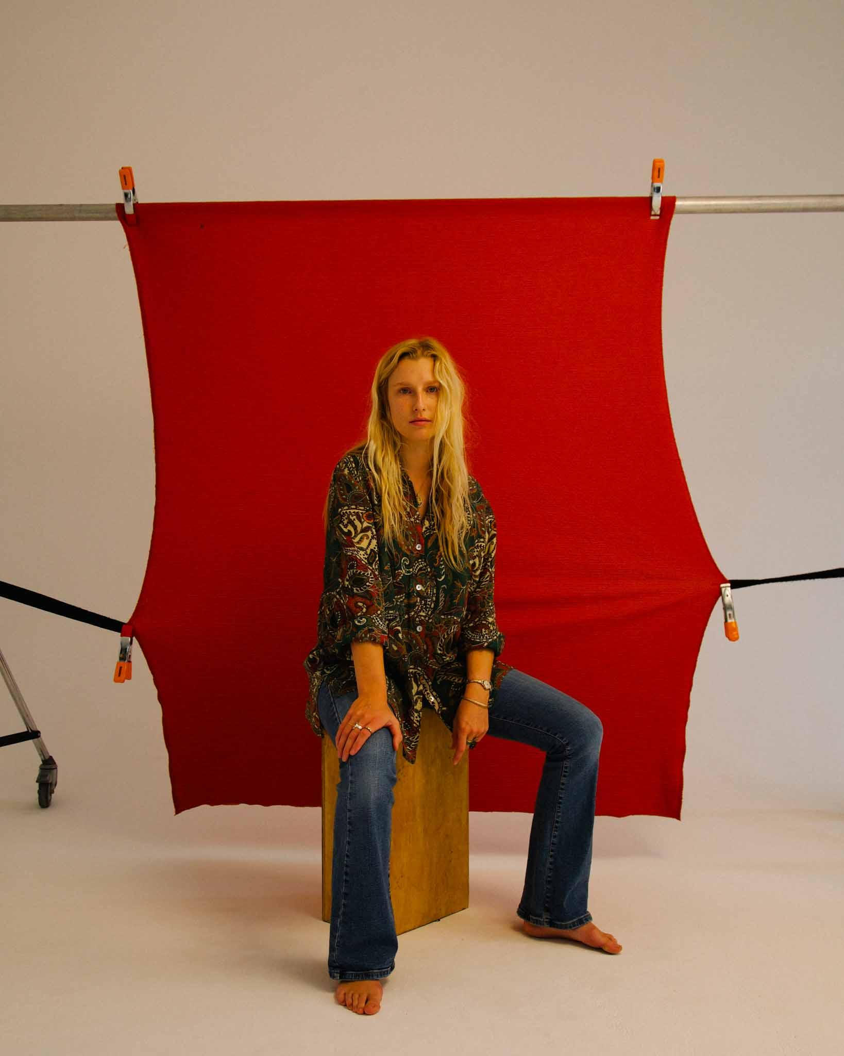
Photo credit: Katie Silvester
“Marten places herself in the company of Nick Drake, John Martyn, Kate Bush and Joni Mitchell - not just stylistically, but in terms of emotional pull she can apply with just a few piano chords and some half heard vocals” - Sunday Times Culture
“A gentle and reserved masterpiece” - The Line Of Best Fit
“A striking sensory experience. All signs point towards a colourful future” - DIY
“Marten fashions her own world of fragile darkness” - Evening Standard
“With a depth of feeling and conviction in her voice... Billie Marten is truly gifted” - GLAMOUR “...talent beyond measure and a wisdom well beyond her tender years” - Wonderland “Unbelievably beautiful” - Independent
“...spellbinding” - NYLON
“A sublime song” - Notion
“A breath of fresh air” - Yuck Magazine
Listen to ‘Human Replacement’ HERE
Watch the ‘Human Replacement’ music video HERE
Billie Marten has today shared her new single and video ‘Human Replacement’, the final taste of her third album Flora Fauna - out this Friday on Fiction Records.
The track premiered in Annie Mac’s much-coveted Hottest Record In The World slot on BBC Radio 1 last night and follows the sensational ‘Creature Of Mine’ in providing a window into the new record and Marten’s growth as an artist. ‘Creature Of Mine’ was also a Hottest Record and is currently playlisted at BBC R1, BBC Radio 6 Music, and Radio X. Billie Marten has announced a UK tour for later in the year, which includes a date at London’s EartH on 30 September. Pre-order Flora Fauna on all formats HERE.
Raised in the rolling hills of North Yorkshire on artists such as Nick Drake, Joni Mitchell, Joan Armatrading, and Kate Bush, Marten’s critically acclaimed debut album Writing of Blues and Yellows, was released in 2016 when she was still just 17, while its follow-up Feeding Seahorses By Hand was similarly lauded in 2019.Recorded with Rich Cooper in London, Marten’s new material blends those signature hushed, resonant vocals with a rapid pulse and rich instrumentation, her inspirations now stretching from krautrockers Can, to Broadcast, Arthur Russell, and Fiona Apple.
Speaking about the video for ‘Human Replacement’, which was directed by the award-winning creative Joe Wheatley, Marten explains: “This video is absolutely needed to match the message of the song, which was initially something I shied away from talking about. As creative discussions began between Joe Wheatley (Director) and I it became incredibly important to convey the absurdity of simply not being able to go out anywhere at night as a woman particularly, without that hideous stone-cold fear of what might happen to you. Hence every woman in the video needing the comfort and protection of full army gear to carry out the simplest of everyday tasks (like going for a run or walking home from work) and every man is without it. My trusty safety tank gets me to the shop for a pint of milk. It’s a deliberately absurd illustration of a disturbingly real problem that needed to be addressed.”
Alongside her nomination for the BBC Sound of 2016, support throughout Marten’s burgeoning career has rolled in from the likes of The Evening Standard, The Independent and The Sunday Times Culture. Flora Fauna’s lead single ‘Garden Of Eden’ - which was her first since 2019 - was met with rapturous praise in January 2021, drawing in national airplay from the likes of Annie Mac, Jack Saunders, Sian Eleri, Arielle Free and Gemma Bradley at BBC R1, Dermot O’Leary and Jo Whiley on BBC Radio 2, and landing playlist spots at 6 Music (where it eventually moved up to the A-List) and Radio X (C-List). The track was also lauded by Clash, DIY, Dork, NME, Notion, Stereogum, The Forty Five The Guardian, The Line Of Best Fit, and many more tastemakers.
Built on the minimalist acoustic folk foundations she made a name for herself with, Marten’s upcoming third album Flora Fauna is a more mature, embodied album fostered around a strong backbone of bass and rhythm. Shedding the timidity of previous work in favour of a more urgent sound, the songs mark a period of personal independence for Marten as she learned to nurture herself and break free from toxic relationships - and a big part of that was returning to nature. “I wasn’t really treating myself very well, it was a bit of a disruptive time. All these songs are about getting myself out of that hole - they’re quite strong affirmations. The name Flora Fauna is like a green bath for my eyes. If the album was a painting, it would look like flora and fauna - it encompasses every organism, every corner of Earth, and a feeling of total abundance.”
***
See Billie Marten live in 2021:
Jul 31 | Y Not Festival, Derbyshire
Aug 12 | The Joiners Arms, Southampton
Aug 13 | Boardmasters Festival, Newquay
Aug 29 | Victorious Festival, Portsmouth
Sep 12 | Lancaster Library, Lancaster
Sep 16 | Stereo, Glasgow
Sep 17 | O2 Academy, Leicester
Sep 18 | Jericho Tavern, Oxford
Sep 19 | Leadmill, Sheffield
Sep 21 | Castle & Falcon, Birmingham
Sep 24 | Brudenell Social Club, Leeds
Sep 28 | The Portland Arms, Cambridge
Sep 29 | Academy 3, Manchester
Sep 30 | EartH, London
Oct 2 | Ipswich Sound City, Ipswich
Oct 3 | The Boileroom, Guildford
Oct 8 | FOCUS Wales, Wrexham
Oct 9 | Are You Listening? Festival, Reading
Oct 10 | Tunbridge Wells Forum, Tunbridge Wells
Oct 16 | Wild Paths Festival, Norwich
Billie Marten - Flora Fauna - out 21/05/2021 on Fiction Records
1. Garden Of Eden
2. Creature Of Mine 3. Human Replacement 4. Liquid Love
5. Heaven
6. Ruin
7. Pigeon
8. Kill The Clown
9. Walnut
10. Aquarium

For more information and press enquiries please contact

Jenny Entwistle
Jenny@chuffmedia.com

