SELF ESTEEM

SHARES NEW SINGLE
‘HOW CAN I HELP YOU’
WITH SELF-DIRECTED VIDEO

TOURING THE UK IN NOVEMBER


Hi-res assets here

Self Esteem last night shared the video for her new single ‘How Can I Help You’ after its premiere on BBC Radio 6 Music, alongside an impressive live session for Steve Lamacq. The new release comes as a part of a stellar few days for Self Esteem after her triumphant set played to a packed out audience at Green Man Festival in Wales, performing the then-unreleased track to a rapturous audience.

‘How Can I Help You’ is a biting response to the misogynistic standards and objectification that women are subjected to, propelled by intense percussion and Rebecca Lucy Taylor’s sardonic lyricism: “How can I help you / Do what it is that you / Always hoped you could set out to prove? … Cos that’s what I’m put here to do / Isn’t it?”. The accompanying video for ‘How Can I Help You’ is the third and final video in a series of self-directed visuals shot at The Almeida Theatre and produced by Mr Mr Films.

Due for release on Friday 22nd October via Fiction Records, Self Esteem’s sophomore album Prioritise Pleasure features the acclaimed singles ‘Prioritise Pleasure’ and ‘I Do This All The Time,’ which made the Radio 1 and 6 Music playlists and was the subject of a much talked-about performance on Later... With Jools Holland.

Watch the video for ‘How Can I Help You’

"‘How Can I Help You’ is one of the first songs I wrote for the second album. After touring the first record and most weeks being told that I am underrated or intimidating I just felt very fed up. I guess I'll be eternally angry for the way as a woman unless you're sweet, nice, settled and quiet, you're considered 'different' and 'difficult'. I wanted to play the drums in the video to reclaim how often I used to feel self conscious playing them. The physical act of a woman playing a drum means your tits move - all I ever wanted to do was play but it always came with this fear of being looked at in that way. Now my tits move for me, my song, my video. I'm also aware it's probs a nice watch if you're that way inclined, but I'm afraid if you wanna watch it you have to hear what I've got to say. Click for the tits, stay for the feminism!" says Rebecca Taylor of the track and video.

She adds that her new album, Prioritise Pleasure, is “13 songs of cleansing myself of the guilt and fear of being a woman who is ‘too much’ and replacing that very notion with a celebration of myself, of you, of being a human and the way that isn’t always easy or perfect, and that’s ok. Sorry to my parents for the lyric ‘shave my pussy, that’s just for me’ but i think it’s maybe my finest hour!”

Listen to ‘How Can I Help You’

Pre-order Prioritise Pleasure

The follow up to Self Esteem’s acclaimed 2019 debut album Compliments Please, Prioritise Pleasure is a record that reminds us all of the importance of being our unapologetic selves, putting your insecurities out there in the hope that it can be the first step towards healing them. Honest disclosure has always been Self Esteem’s forte, and so each track on Prioritise Pleasure handles difficult themes with nuanced perspective, comforted and counter-balanced with an array of rhythmic flourishes that speak to the eclecticism of her experience and influence.

The funk-pop shimmy of ‘Moody’ is anthemic in its analysis of self-sabotaging habits, while opener ‘I’m Fine’ builds a stomp-and-clap wall of solidarity, staking out defiant new ground. Making use of Taylor’s penchant for voice notes, the song’s striking outro draws on snippets of conversation taken from work she did in 2019 with The National Youth Theatre, devising a short play with a group of young female-identifying creatives on the topic of consent.

“It turned into the most amazing month, sitting in a circle and having all these teenage chats,” Taylor says. “But every now and again, there would be some particular insight that would just put goosebumps all over my body.” One such moment was a story shared by a woman in her early twenties, whose fear of walking at night can be heard on the track. “It sounds so stupid, but me and my friends…if we are approached by a group of men, we will bark like dogs…there is nothing that terrifies a man more than a woman who appears completely deranged.”

“It sets the precedent for the whole record; like really, is that what we have to do to feel safe?” says Taylor. “I am so angry that I can't go on holiday alone. I'm so angry I can't walk home without someone freaking me out, or worse. And the idea that the only defence we have is to be terrifying is so wrong, but it’s as normalised in society as the idea of feeling heartbroken by a guy that doesn't text you back enough.”

Breaking a personal cycle of trauma-suppression, Taylor says, starts with laying out these instances of her personal experience – self-doubt, heartbreak, sexual assault, the urge to compare – and realising that one stands out as something that truly can’t be justified as part and parcel of life.

“What's the one thing that none of us deserve to have happened to us, but almost all women have had? But in order to fucking live and survive and not spend every day wanting to slay every man I see in the street, I've had to normalise it.” She pauses, finding a moment of clarity. “I guess this album, the reason it's so full of love for myself, is that I’m finally seeing that none of those things are my fault.”

Having allowed itself grace, Prioritise Pleasure is also a record of great joy. Working again with trusted producer Johan Karlberg [of afro-fusion trio The Very Best], it was stitched together throughout the pandemic in chunked sessions, the time between each batch encouraging Taylor to fully flesh out her ideas. With Prioritise Pleasure, Self Esteem comes one step closer to reminding listeners – and herself – that true success begins and ends with self-acceptance, telling your story in the way that only you can.

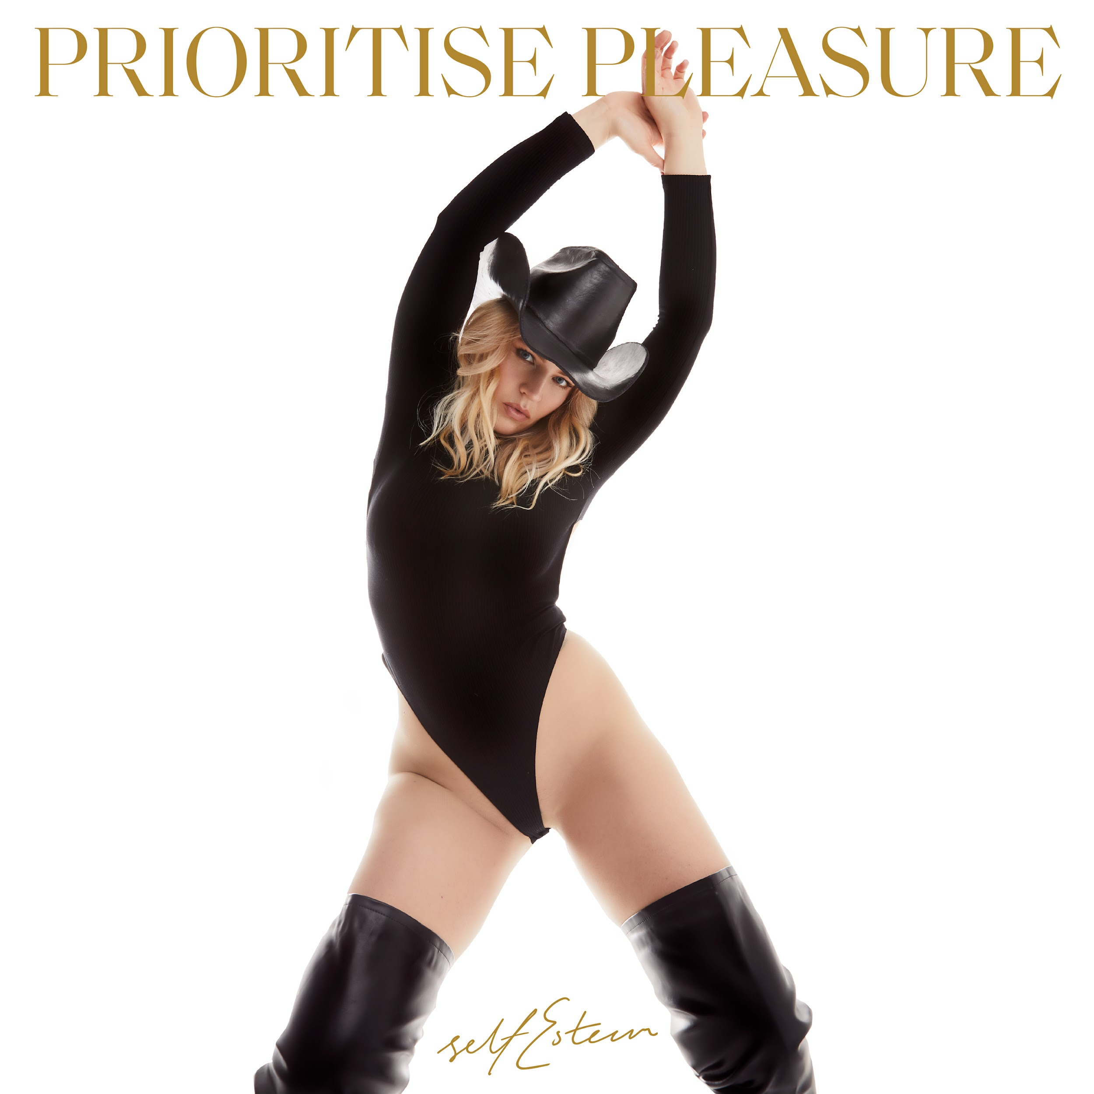
Prioritise Pleasure tracklisting

I’m Fine
Fucking Wizardry
Hobbies 2
Prioritise Pleasure
I Do This All The Time
Moody
Still Reigning
How Can I Help You
It’s Been A While
The 345
John Elton
You Forever
Just Kids

Self Esteem will also be embarking on an 18 date UK headline tour later this year, taking in shows across the country including London’s Heaven and a hometown show at The Leadmill in Sheffield. A space for both catharsis and euphoric celebration, a Self Esteem live show is not to be missed. Tickets are on sale now via https://www.selfesteem.love/.

UK 2021 TOUR DATES

3rd September - Wide Awake Festival, London
4th September - Neighbourhood Weekender, Warrington
1st November - Fleece, Bristol (SOLD OUT)
2nd November - Wylam Brewery, Newcastle
3rd November - Clwb Ifor Bach, Cardiff
4th November - O2 Academy, Oxford
6th November - The Bongo Club, Edinburgh
7th November - Audio, Glasgow (SOLD OUT)
9th November - The Workmans Club, Dublin
10th November - Gorilla, Manchester (SOLD OUT)
11th November - Belgrave Music Hall, Leeds (SOLD OUT)
12th November - The Leadmill, Sheffield (SOLD OUT)
14th November - Norwich Arts Centre, Norwich (SOLD OUT)
15th November - Sub 89, Reading
16th November - The Joiners, Southampton
17th November - Heaven, London (SOLD OUT)
19th November - Elsewhere, Margate (SOLD OUT)
20th November - Patterns, Brighton (SOLD OUT)
23rd November - Phoenix, Exeter
24th November - Hare & Hounds, Birmingham
25th November - Metronome, Nottingham

Website / Instagram / Facebook / Twitter / TikTok

For more information please contact warren@chuffmedia.com on 07762 130510

