BREAKOUT STAR MIMI WEBB RELEASES NEW SINGLE & MUSIC VIDEO “HOUSE ON FIRE”
ON TOUR ACROSS UK & NORTH AMERICA
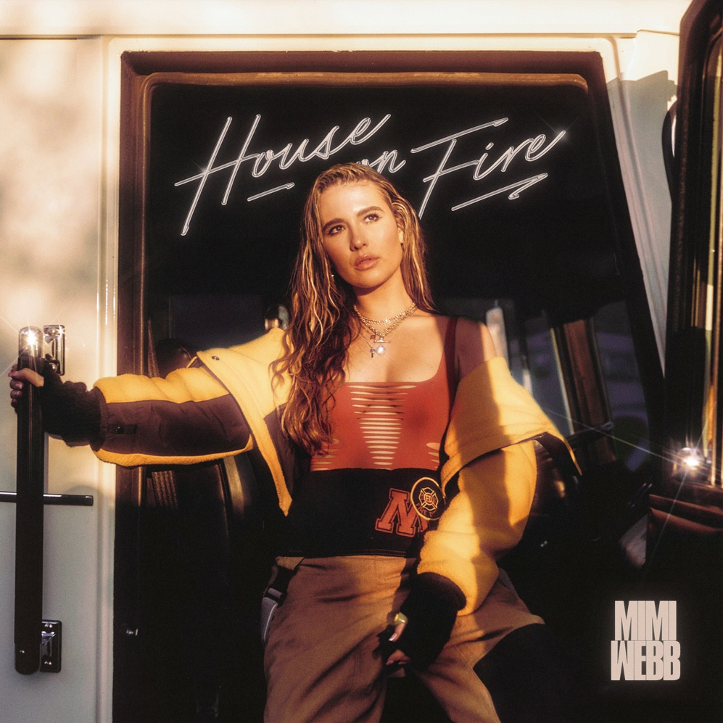

LISTEN/EMBED: HOUSE ON FIRE

Ready to heat up 2022, UK pop singer and songwriter Mimi Webb has unveiled a new single and music video “House On Fire” today via Epic Records/RCA.

On the track, the upbeat production illuminates another side of the fast-rising songstress. Her dynamic vocals lean into sassy verses before the hook assures, “I know you’re not at home, you liar, I’m gonna set your house on fire.” In the accompanying cinematic visual directed by KLVDR, Mimi exacts revenge upon a cheater as she reprograms him at “Seven Shades Hospital”. The clip climaxes with a show-stopping dance routine, which she impressively leads in a firefighter’s uniform! Her star power practically pops off the screen.
Right now, Mimi is enchanting audiences on a sold-out UK tour. Next up, she will support Tate McRae on her 2022 North American tour. It promises to be an unforgettable run for Mimi Webb and the fans who will witness her inaugural U.S. and Canada tour. Tickets are on sale HERE. Check out the full itinerary below.
Beyond posting up half-a-billion streams, she continues to garner unanimous critical applause. Vogue christened her one of “The 22 Musicians Set To Rule 2022,” and BBC named her among the “Sound of 2022.” Mimi Webb is undoubtedly on fire now.
TOUR DATES
FEBRUARY
2/18 TOUR DATE @ O2 Academy 2 (Liverpool, UK)
2/20 TOUR DATE @ Academy 2 (Manchester, UK)
2/21 TOUR DATE @ Academy (Dublin, Ireland)
2/23 TOUR DATE @ St Luke’s (Glasgow, UK)
2/24 TOUR DATE @ Uni (Newcastle, UK)
2/26 TOUR DATE @ O2 Academy 2 (Birmingham, UK)
2/27 TOUR DATE @ Trinity (Bristol, UK)
2/28 TOUR DATE @ O2 Shepherd’s Bush Empire (London, UK)
MARCH
3/08 TOUR DATE @ Vogue Theatre (Vancouver, BC)
3/10 TOUR DATE @ Showbox Market (Seattle, WA)
3/11 TOUR DATE @ Wonder Ballroom (Portland, OR)
3/13 TOUR DATE @ The FIllmore (San Francisco, CA)
3/14 TOUR DATE @ The Fonda Theatre (Los Angeles, CA)
3/15 TOUR DATE @ The Fonda Theatre (Los Angeles, CA)
3/17 TOUR DATE @ The Observatory OC (Santa Ana, CA)
3/18 TOUR DATE @ Crescent Ballroom (Phoenix, AZ)
3/21 TOUR DATE @ Scoot Inn (Austin, TX)
3/22 TOUR DATE @ House Of Blues - Houston (Houston, TX)
3/23 TOUR DATE @ The Hifi Dallas (Dallas, TX)
3/25 TOUR DATE @ Terminal West (Atlanta, GA)
3/27 TOUR DATE @ 9:30 PM Club (Washington DC)
3/28 TOUR DATE @ Theatre Of Living Arts (Philadelphia, PA)
3/30 TOUR DATE @ Irving Plaza (New York, NY)
3/31 TOUR DATE @ Irving Plaza (New York, NY)
APRIL
4/1 TOUR DATE @ Royale (Boston, MA)
4/3 TOUR DATE @ Virgin Mobile Corona Theatre (Montreal, QC)
4/4 TOUR DATE @ Danforth Music Hall (Toronto, ON)
4/5 TOUR DATE @ Saint Andrews Hall (Detroit, MI)
4/7 TOUR DATE @ The Basement East (Nashville, TN)
4/8 TOUR DATE @ The Basement East (Nashville, TN)
4/9 TOUR DATE @ House Of Blues Chicago (Chicago, IL)
4/11 TOUR DATE @ First Avenue (Minneapolis, MN)
4/14 TOUR DATE @ Gothic Theatre (Englewood, CO)
4/16 TOUR DATE @ THe Complex - Grand Room (Salt Lake City, UT)
ABOUT MIMI WEBB:
Mimi Webb projects a voice as magnetic, massive, and magical as her personality. As “the girl next door” with a hell of a vocal range, she’s quick to laugh, will let you know precisely what’s on her mind, and isn’t afraid to be heard. Originally hailing from the UK town of Canterbury, the pop singer and songwriter turns up the volume on every emotion with skyscraping runs and open-heart honesty.
Inspired by the likes of Amy Winehouse, Emelie Sandé, and Sam Smith, she started writing songs of her own at 13-years-old in diaries before eventually learning guitar. Around the same time, she enrolled in The BRIT School—known for alumni such as Adele, Amy Winehouse, Jessie J, and more. Three years later, she left home, moved in with a host family, and attended the prestigious BIMM [British Institute of Modern Music]. In 2019, she uploaded a handful of early compositions and collaborations online, landed management, and inked a deal with Epic Records. Mimi Webb’s impromptu acapella videos exploded with over 20 million views on TikTok, paving the way for a string of original fan favorites such as “Before I Go,” “I’ll Break My Heart Again,” and “Reasons,” and “Good Without.” Amassing close to half a billion streams, she made waves with international hits “Good Without” and “Dumb Love.” The singles concurrently captured places in the Top 15 on the UK Singles Chart, which cemented Mimi as “the first UK female artist, since Dua Lipa in 2017, to land two singles in the UK Top 15 before the release of her debut album.”
Music Week also recently announced Mimi Webb as the newest addition to their BBC Radio 1’s Brit List. The prestigious offering comes after selling out her first upcoming sold-out February UK tour including a sold out Shepherd’s Bush show. In addition to receiving widespread acclaim from Wonderland, teenVOGUE, Refinery 29, Euphoria, CLASH, FLAUNT, and Consequence of Sound, to name a few. With a voice just loud enough to give you goosebumps, Mimi Webb shines on her debut Seven Shades of Heartbreak EP and more to come.
For more information and press enquiries please contact

Jenny Entwistle
Jenny@chuffmedia.com

