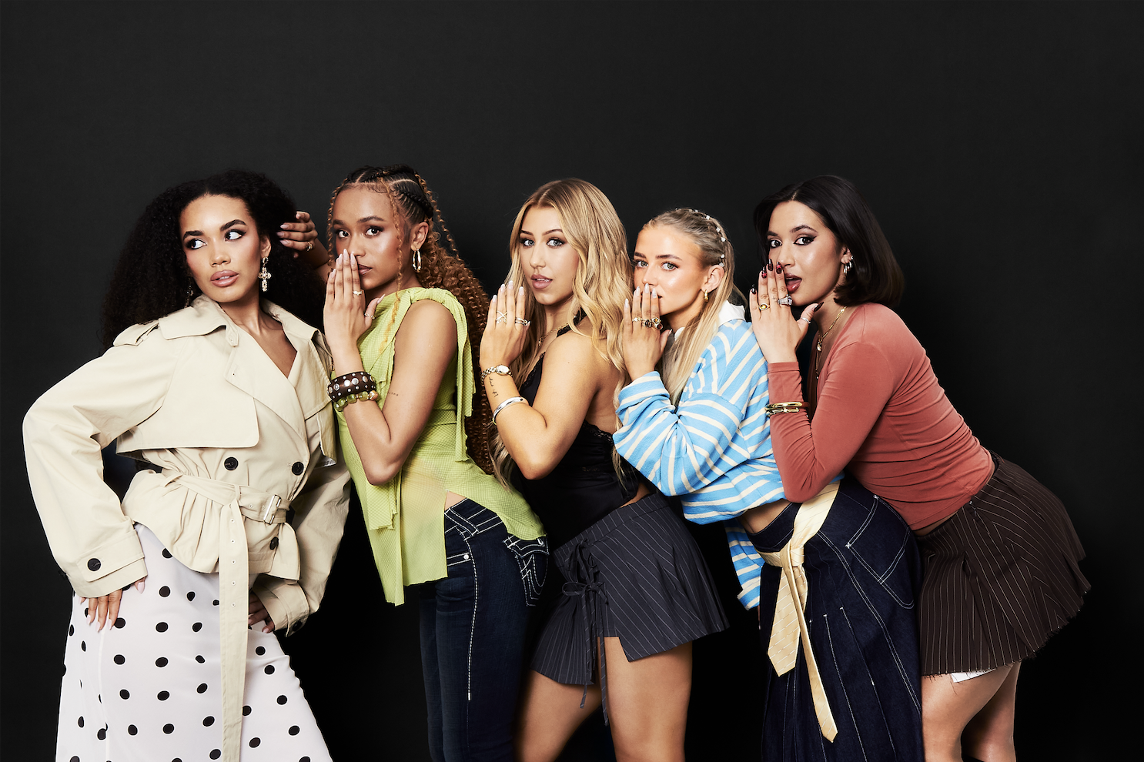
L-R: Summer, Shali, Emmy, Zoe, Reanna
XO premiere new single & video, ‘Hotline’
Debut mini-album - Need To Know - announced for October 16th release
UK headline tour also confirmed
“Pop girlies, assemble” - Sunday Times Style
“A titanic debut…breaking through pop boundaries, XO are doing it their way”
- CLASH
“Modern girl group sounds mixed with classic pop sensibilities, and the overarching feeling they’re capable of great things” - Rolling Stone UK
“Messy but charming: a tribute to keeping a ride-or-die circle that makes you want to be part of the gang” - The Fader
“An attitude-heavy update of Girl Power…a promising start” - The Guardian

Stream ‘Hotline’: https://xo.lnk.to/hotline
Watch the ‘Hotline’ video: XO.lnk.to/hotline/youtube
Pre-save Need To Know: XO.lnk.to/needtoknow
Stream Fashionably Late: XO.lnk.to/fashionablylate
XO are back today with a brand new single and video, ‘Hotline’, which is available now via Polydor Label Group. The One to Watch UK girlband have also announced details of their debut mini-album, Need To Know, which will see a release on October 16th; shortly before the group’s UK headline tour, which includes a London show at O2 Academy Islington this November.

Kicking off their new era in style, ‘Hotline’ imagines an advice centre for getting over an ex the XO way: think ludicrously catchy melodies, heavy, Timbaland-style beats, and the band’s quintessentially British humour (“all our operators are busy being iconic!”). ‘Hotline’ dials into the themes of friendship and sisterhood that became central to XO as they burst onto the scene last year, whilst also entering a whole new level of creativity, confidence - and in its eye-catching video, choreo - that already feels distinctively their own.
XO are fearless-five piece Emmy, Reanna, Shali, Summer and Zoe. Hailing everywhere from Essex to Liverpool and Hong Kong, the band draw on their individual strengths as much as the values, and vocals, that have quickly made them inseparable. In sound and spirit they evoke that classic lineage of UK groups, but with a contemporary and cutting-edge twist: think the unstoppable energy of Spice Girls as raised on the next gen pop-girls (Tate McRae), plus that new wave of global girlbands like Katseye. Yet XO are after something more imperfect and unapologetic in their firebrand of Pop - a thoroughly Gen Z vision of Girl Power.

Whether showing life behind-the-curtain on social media or gigging up and down the country in the back of a bus, XO are a girlband developing in front of your eyes and taking fans with them on every step of the journey. It’s a spirit that was summoned in XO’s debut EP, Fashionably Late, released late last year. Channelling the chaotic arc of a night out, the EP featured acclaimed first single ‘Lovesick’, Charli xcx co-write ‘Real Friends’, and early fan-favourite ‘Ponytail’ as XO brought their chaotic energy out into the world. The band landed early support across the likes of Radio 1 and BBC Introducing, made their TV debut and sold out their first UK tour with barely a single release to their name.

‘Hotline’ calls to action another major milestone for XO, namely this autumn’s mini-album Need To Know. A clear statement of the girls, their personalities and their edge, the project was loosely inspired by the advice columns Zoe spotted outlining “20 Things You Need to Know In Your Twenties. We thought - what if they were songs?” Louder, bolder and undeniably themselves, the results feel, as with the best pop bands, like a gang you just want to be a part of (and where those who need to know, will).

Carving out their own space in the UK and beyond, in 2026 XO marks the spot.


‘Hotline’ single artwork

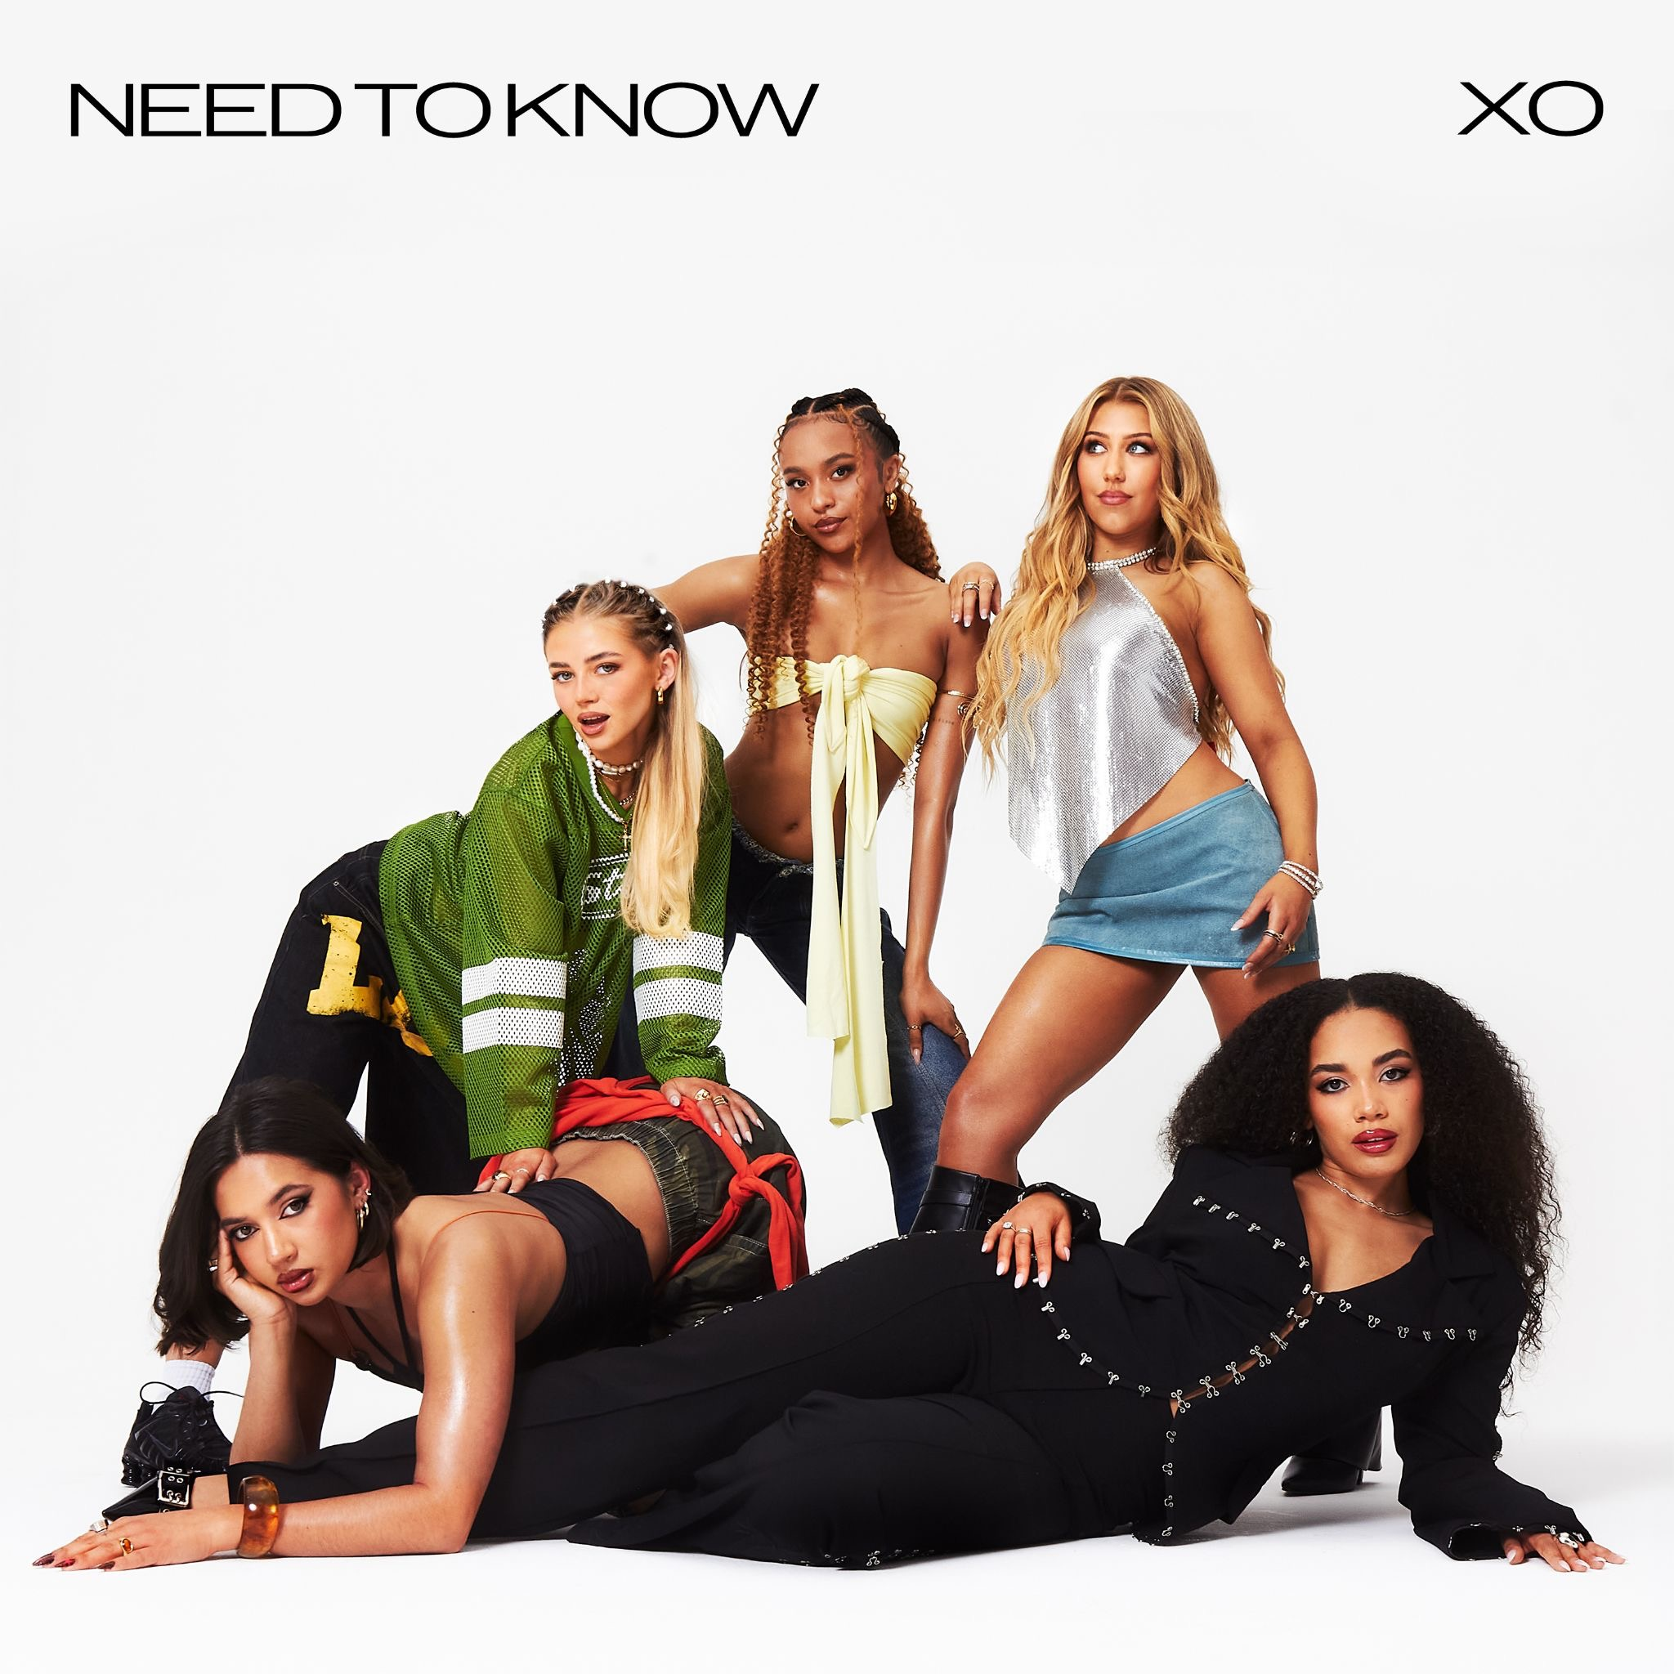
‘Need To Know’ artwork

24.06.26 || Isle of Wight Festival || Isle of Wight
01.11.26 || O2 Institute 2 || Birmingham
02.11.26 || The Fleece || Bristol
03.11.26 || O2 Academy Islington || London
04.11.26 || Academy 3 || Manchester
06.11.26 || King Tuts || Glasgow

FOLLOW XO!
Instagram || Tiktok || Official Site || Youtube

For more on info contact warren@chuffmedia.com

