
RETURNS WITH NEW SINGLE ‘HIGHER’
LISTEN

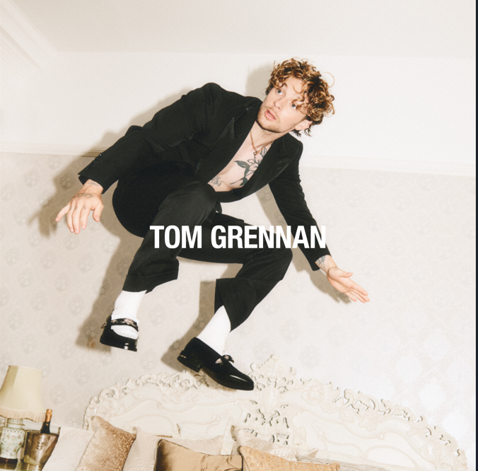
DOWNLOAD HIGHER ARTWORK
Fresh from headlining his biggest show to date, TOM GRENNAN today (20th September) announces his return with the release of new single ‘Higher’. A blast of uplifting, state-of-the-art pop, ‘Higher’ offers a thrilling first taste of the evolution of one of UK’s most exciting talents at his creative and confident best. “A lot of people don’t know what’s about to hit them,” he says, teasing what fans can expect of this new chapter.

With two number one albums under his belt alongside multiple Brit and Ivor Novello nominations, countless airplay smashes, sold-out arena tours and an MTV Award for Best UK Act, TOM GRENNAN is already one of the country’s biggest artists but with his upcoming new album he’s readying to take things to a whole new level. Working for the first time with songwriter and producer Justin Tranter (Britney Spears, Linkin Park, Dua Lipa. Fall Out Boy) Tom found himself a collaborator who understood exactly what he wanted to say and what he wanted to sound like: George Michael, Prince, Freddie Mercury. “So much of the new music is uplifting — it makes you dance, makes you sing — but for me there’s also the excitement of it being a sound I've never explored,” Tom says.

Recorded at London’s legendary Rak Studios, the song started with a piano riff. “The weird thing about me is that I make music in the studio but most of my good ideas come to me when I'm not actually in the studio,” he says. “On the day we wrote Higher I’d left the room but I just couldn’t get that riff out of my head. It turned into a melody, which turned into a phrase… I ran back into the studio, with the piano riff still playing, threw my hands up and sang: ‘It's taking me higher.’ Everyone in the room just went: ‘Boom. That’s it.’

Tom Grennan’s fourth album is shaping up to be a stunning addition to his already-impressive discography, which has seen him accumulate over 1.5 million album sales and 2.5 billion streams across his gold-selling debut Lighting Matches (2018), his first UK Number One album Evering Road (2021) and What Ifs & Maybes (2023), another Number One and Tom’s third gold-selling album in a row. That third album was also, he says, an early hint of what was to come. “It was the first time I thought: ‘I don't want to just be a singer-songwriter’,” he remembers. “It established the foundation for where I am with this album.”

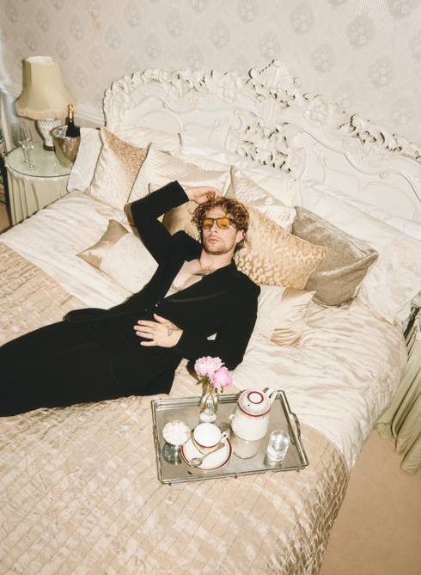

Download press photo here (credit: Ed Cooke)

Connect with TOM GRENNAN

INSTAGRAM
TIK TOK
YOUTUBE
FACEBOOK
X

For more information and press enquiries for TOM GRENNAN please contact

Jenny Entwistle
Jenny@chuffmedia.com

