BEARTOOTH DROP NEW SONG “HELL OF IT”

NEW ALBUM BELOW ARRIVES JUNE 25 VIA RED BULL RECORDS

STREAM / DOWNLOAD: https://ffm.to/hellofit
PRE-ORDER ALBUM: https://ffm.to/below

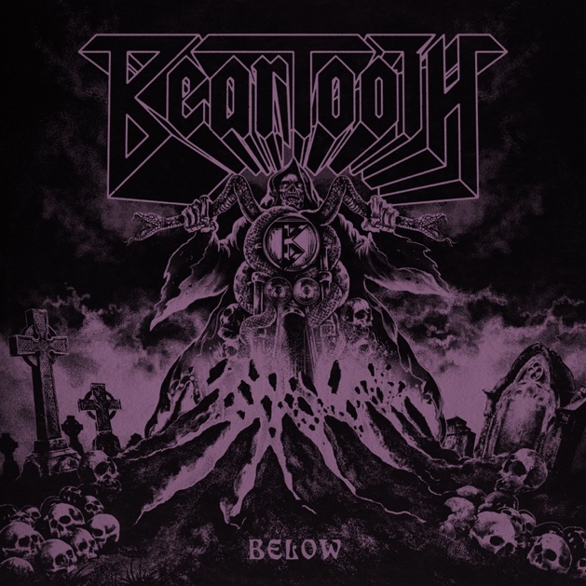
Friday, April 23, 2021 – Gold-selling, Columbus, Ohio-based rock band Beartooth have just dropped the new song "Hell Of It." Listen here.
The track crackles with a kinetic, punk rock energy from start to finish, and it never scrimps on the memorable, melodic choruses the band has become known for.
The track appears on Beartooth's upcoming fourth studio album, Below, out June 25 via Red Bull Records. Below is available for pre-order here.
"'Hell Of It' is one of my favorites on the album," says singer Caleb Shomo. "It's meant to try and melt as much face as possible. This song was really important for discovering the guitar tone for the album and the use of pedals to expand on parts. The breakdown in this might be my favorite of all."
Beartooth thrilled their legion of faithful fans last month with a blistering one-two punch! First, they surprise-dropped "Devastation." The band quickly followed with the video for "The Past Is Dead." The clip finds the band in performance mode, which is its most natural state. The members are surrounded by a stunning display of pyrotechnics and an otherworldly demon named "Barry," who has been dubbed the official mascot for the album cycle and can be spotted in the album cover art pictured above.
Critical accolades swiftly followed the "Devastation" drop, with Knotfest dubbing the material "next level heavy," while Rock Sound summed things up, saying, "Bludgeoning riffs, an earworm of a chorus and one of the hardest mosh calls you will hear all year, it's quite something." Meanwhile, "The Past Is Dead" was dubbed "anthemic" by Revolver, as Loudwire highlighted the band's dynamic nature and how the song's "energy remains high." Kerrang! proclaimed it "a swaggering pop-metal nugget."
Beartooth harness the sacred and profane, purging inner darkness with a dizzying light. The fearlessly determined and boundlessly creative Midwest powerhouse perfects a sound sought by a generation of bands. Their marriage of colossally catchy choruses and post-hardcore, soaked in sweaty metal, is without rival. Its effect is evident by their religiously dedicated global audience; tours with Slipknot, Bring Me The Horizon, Architects, and A Day To Remember; and a RIAA-certified plaque for their hit single "In Between."
Their latest release Below is a pure distillation of rage — weaponizing its deceptively radio-ready bombast to deliver stone cold truth missives, each packed like a bomb with noisy rock chaos.
Below also revels in the darker underbelly of traditional metal, soaked in stoner rock tones and doomy dirge. Beartooth offer no cure. The recovery comes in the process; the journey is the destination. As long as the dueling dichotomy of anguish and cathartic creative expression remain bound together, Beartooth will be here to oversee the show.
BELOW TRACK LISTING:
- Below
- Devastation
- The Past Is Dead
- Fed Up
- Dominate
- No Return
- Phantom Pain
- Skin
- Hell Of It
- I Won’t Give It Up
- The Answer
- The Last Riff
BEARTOOTH ARE:
Caleb Shomo — Vocals
Zach Huston — Guitars
Will Deely — Guitars
Oshie Bichar — Bass
Connor Denis — Drums

###

Follow Beartooth
Facebook | Twitter | Instagram | Website | Spotify | YouTube

For more information and press enquiries please contact

Jenny Entwistle
Jenny@chuffmedia.com

