

RETURN WITH NEW SINGLE ‘HAIRCUT’
FEATURING VICKY MCCLURE
LISTEN / WATCH

AND ANNOUNCE NEW ALBUM
‘IS THIS HOW HAPPINESS FEELS?’
EIGHTH STUDIO ALBUM SET FOR RELEASE APRIL 24th 2026
ON DISTILLER RECORDS

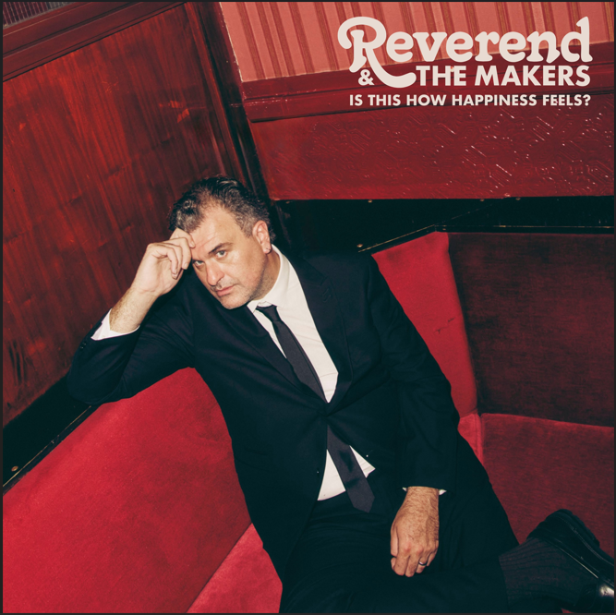
DOWNLOAD ALBUM ARTWORK

CELEBRATE 20th ANNIVERSARY WITH BIGGEST EVER HEADLINE SHOW
AT ROCK N ROLL CIRCUS AUG 30th

PRE-ORDER ‘IS THIS HOW HAPPINESS FEELS?’ HERE

Reverend & The Makers have today announced details of their new album ‘Is This How Happiness Feels?’ and released new single ‘Haircut’, a gleaming summertime banger which features actress Vicky McClure (Line of Duty/This Is England) on vocals.

The band’s eighth studio album ‘Is This How Happiness Feels?’ is set for release on April 24th 2026 through Distiller Records. It features 13 tracks and was produced by Danny Lafrombé and Jon McClure. It is the follow up to Reverend & The Makers Top 10 album ‘Heatwave In The Cold North’ and its announcement comes as the band ready themselves for their biggest headline show to date at Rock N Roll Circus on August 30th. The Sheffield five-piece’s eagerly awaited new album is their most musically accomplished yet, merging vintage, sparkling, life-affirming soul with contemporary lyrical storytelling. “This album has been a labour of love owing to personal reasons but has emerged as a joyous triumph,” says frontman Jon McClure. “It’s easily the best thing we’ve ever done and will surprise a few people too.”

Jon McClure admits he has been trying to persuade pal Vicky McClure to become a rockstar since seeing her onstage at Day Fever, which the pair co-created with filmmaker Jonny Owen. “Haircut was just about the catchiest thing I’ve ever written since me and my pal Danny did it to be honest. It’s a solid gold banger from day 1,” Jon says. “Having a British icon and mate like Vicky McClure is just a dream combo. Buzzing to share it with the world.”

Vicky McClure says, “My love for music has always been known, with Our Dementia Choir & Day Fever but this was totally unexpected! I love the song, Jon & Rev, always up for trying something new.”

With its Motown groove and Stax-style horns, ‘Haircut’ is Reverend & The Makers in full glorious swagger, the song’s Northern soul shuffle the perfect backing for a back-and-forth duet between Jon McClure and Vicky McClure. It's the most jubilant and irresistibly infectious anthem you’ll hear this summer.

‘Haircut’ is Reverend & The Makers’ first new music this year following their Christmas single ‘Late Night Phone Call’ which was released in support of Samaritans. Both songs feature on ‘Is This How Happiness Feels?’, which will be available on Cassette, Vinyl, CD and digital pressing.

Reverend & The Makers’ seventh studio album, 'Heatwave In The Cold North,' hit No. 6 on the Official Charts in 2023. This marked their first Top 10 album since their 2007 debut, 'The State of Things,' which reached No. 5, and delivered their biggest single in over a decade. With a remarkable unbroken streak of seven Top 20 albums to their name, the band is showing no signs of stopping their remarkable ascent in the year they celebrate their 20th anniversary as a band.

Reverend & The Makers are: Jon McClure (lead singer), Ed Cosens (guitar), Laura McClure (keys/vocals), Antonia Pooles (bass), Ryan Jenkinson (drums)

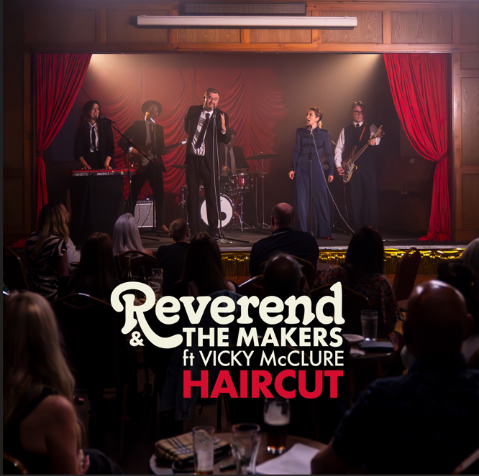
SINGLE ARTWORK


DOWNLOAD PRESS PHOTO

Connect with Reverend & The Makers

website | tiktok | facebook | X | instagram | youtube | threads

For more on info contact warren@chuffmedia.com

