PALACE
RETURN WITH NEW SINGLE ‘GRAVITY’
ANNOUNCE LARGEST UK & EUROPEAN TOURS TO DATE
PLAY O2 ACADEMY BRIXTON FEBRUARY 11TH

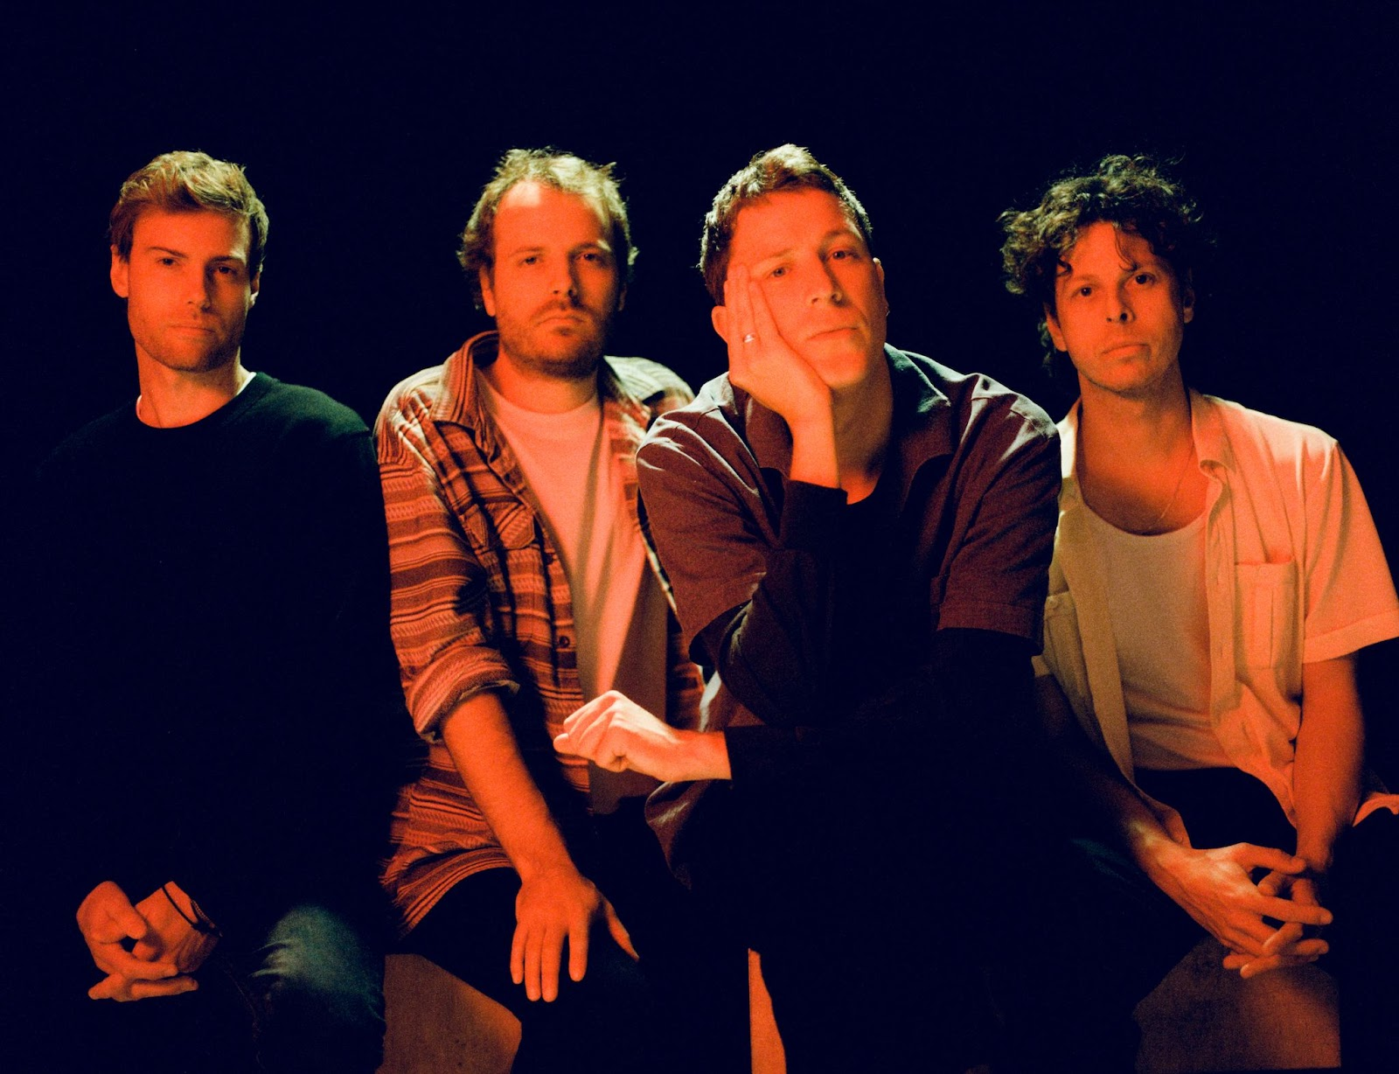
Credit: Daniel Harris

London-based Palace return today with the first taste of their third album and the announcement of their biggest UK and European tours to date. New single ‘Gravity’ is a woozy, swirling reflection on existentialism that spirals into a soaring breakdown that’s sure to be a crowd favourite by the time the band hit the road next February.

WATCH THE OFFICIAL VIDEO FOR ‘GRAVITY’ HERE

“Gravity is about the perspective-shifting realisation of our own insignificance- that we are all just atoms of air and water in an infinite universe.” says frontman Leo Wyndham; “It’s these sobering night-time thoughts that can keep us awake in a state of paranoia, doubting our own purpose and place.”

2019’s sophomore album ‘Life After’ is a stunning record with a clear message; hope. Its eleven tracks, that include the heart-wrenching ‘Heaven Up There’, are full of the melodic warmth and rich textures that have come to define Palace’s sound. It is an album in equal parts about loss as well as a manual to moving on, stronger than before.

Having built a dedicated live following through mesmerising shows at some of the country’s finest venues, Palace played some of the world’s biggest festivals in 2019 including main stage slots at Mad Cool, Latitude and Glastonbury’s Park Stage before an autumn tour culminating at their biggest show ever at a sold-out Camden Roundhouse. The band kicked off 2020 by selling out their debut USA tour ahead of returning to the studio to start work on their third album. With a host of new 2022 UK & European dates now confirmed, Palace are set to continue their enviable trajectory upwards through the best venues the world over. See below for the full list of new tour dates.

Leo Wyndham, Matt Hodges and Rupert Turner released their acclaimed debut EP ‘Lost In The Night’ in 2014, followed by the ‘Chase The Light’ EP the following year, their debut album ‘So Long Forever’ in 2016 and sophomore album ‘Life After’ in 2019.

LISTEN TO ‘LIFE AFTER’ HERE

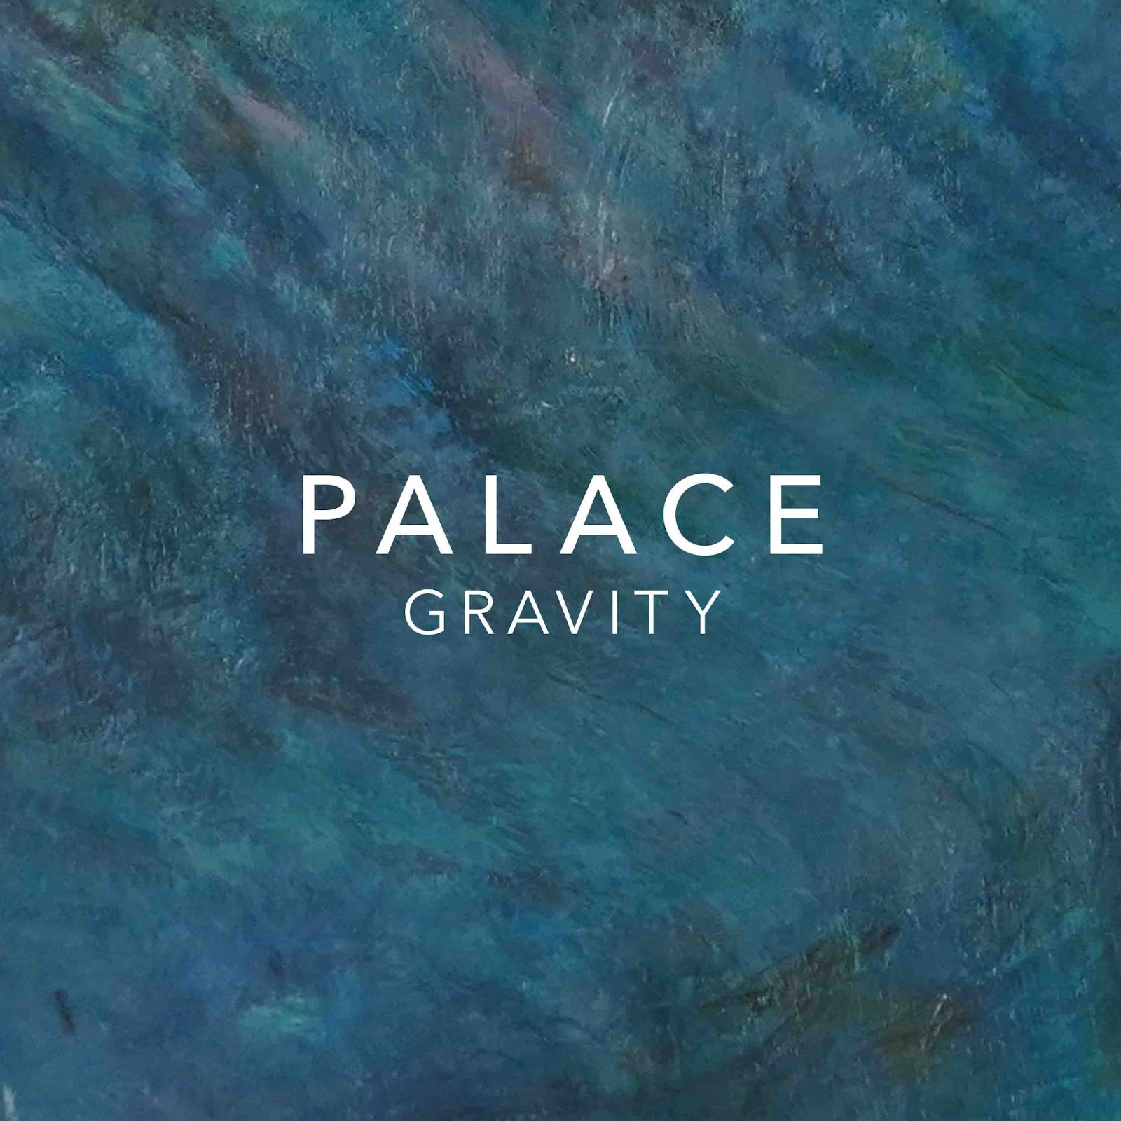

UK & IRELAND TOUR 2022
February 3rd, Glasgow, SWG3
February 4th, Manchester, O2 Ritz
February 5th, Bristol, O2 Academy
February 6th, Leeds, University Stylus
February 8th, Dublin, Vicar St
February 10th, Nottingham, Rock City
February 11th, London, O2 Academy Brixton

EU TOUR 2022
February 17th, France, Paris, La Maroquinerie
February 18th, Belgium, Ghent, Vooruit Balzaal
February 19th, Germany, Cologne, Luxor
February 20th, Switzerland, Zurich, Mascotte
February 22nd, Italy, Milan, Magnolia
February 24th, Austria, Vienna, Arena
February 25th, Germany, Munich, Strom
February 26th, Czech Republic, Prague, Café V Lese
February 27th, Hungary, Budapest, Durer Kert
March 1st, Poland, Warsaw, Hydrozagadka
March 2nd, Germany, Berlin, Heimathafen
March 4th, Denmark, Copenhagen, VEGA small hall
March 5th, Germany, Hamburg, Mojo
March 6th, Netherlands, Amsterdam, Paradiso

Instagram | Facebook | Twitter | Website

For all media enquiries contact warren@chuffmedia.com on 07762 130510

