Mabel, Jax Jones & Galantis drop brand new single, ‘Good Luck’
Available now on Polydor Records
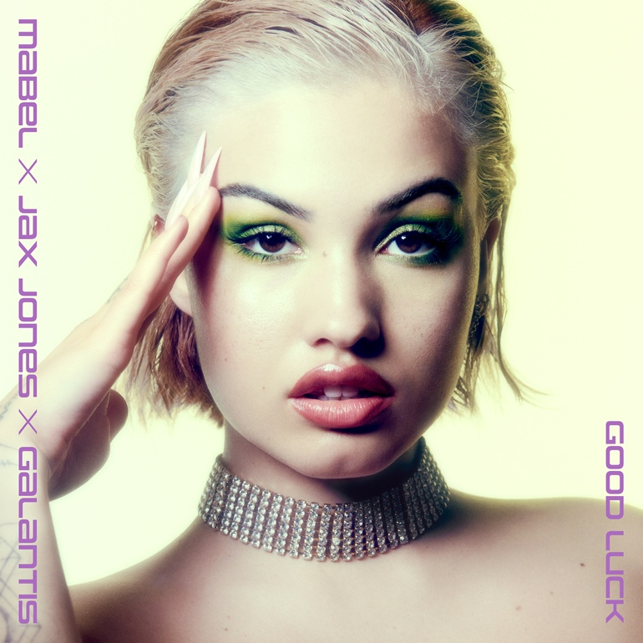
Praise for ‘Let Them Know’
“One of the biggest, ballsiest, pop songs of the year” NME
"Pushes Mabel further into the pantheon of star status, all while retaining the relatable charm that brought her success in the first place" Clash
“Sassy, savvy pop perfection” Sunday Times
“An icon” Wonderland
‘Good Luck’ is the brilliant new single from Mabel, Jax Jones & Galantis and available now on Polydor Records.
Euphoric, hedonistic and anthemic, ‘Good Luck’ distils influences of house, heartbreak, and female solidarity into attitude-heavy pop – the kind that has seen Mabel, on her own clear terms, blossom into the homegrown superstar you see today. ‘Good Luck’, says Mabel, “is the empowering song you need when getting ready to go out: when you’re feeling low about someone, and your friends will take you out to get that person off your mind.” Recalling the defiant roots of inescapable hit ‘Don’t Call Me Up’, the theme is brought to dynamic life in the ‘Good Luck’ video; which further explores the visual universe of first single ‘Let Them Know’, in which the club is no mere physical state but also a fearless new state of mind...
To understand the strength behind ‘Good Luck’ is to also know the emotional journey Mabel has been on these last few years. A candid, positive and important voice in contemporary pop, the Brit Award winner’s new music emerged not just in the wake of a startling few years in the public eye, but through the life-changing lens of the pandemic. Right at the beginning of lockdown, Mabel and her dogs moved back in with her parents, she threw herself into dance classes, and channelled everything she missed (close friends, the big night out, young love, feeling unafraid) into this brand new musical chapter. Inspiration on tracks like ‘Good Luck’ ran deeper for Mabel than the imagined dancefloor: she avidly watched and re-watched ‘Paris Is Burning’, ‘Pose’ and ‘Drag Race' between writing songs, reflecting on how dance music became a generational hub for expression, liberation and inclusion. As she continued work on the project in the UK, US and between various lockdowns, Mabel made a joyous return to the live circuit with scene-stealing appearances at the likes of Reading & Leeds and Mighty Hoopla. It was also a chance for Mabel to tease what she had been working on, dropping new single ‘Let Them Know’ – an unapologetic anthem about dressing up (with nowhere to go), and projecting confidence for anyone who’s ever felt like they don’t deserve to be in the room.
Having just landed a staggering eleventh top 20 smash with ‘I Wish’ (a collaboration with Joel Corry), Mabel has now surpassed 4.5 billion streams and 2.5 million adjusted album sales for debut album ‘High Expectations’ (the biggest selling debut by a British woman in 2019). The Mabel of 2022 is a young woman living in full and self-actualised power, and on ‘Good Luck’, she’s made yet another classic banger to empower anyone else who needs to feel that, too.
ABOUT GALANTIS: Setting a new standard for songwriting in dance music, Galantis is a collaborative project led by Christian Karlsson. The story of Galantis started back in 2009. Working as Bloodshy, Karlsson’s songwriting collaborations have included Madonna, Kylie Minogue, Katy Perry and Britney Spears (whose “Toxic” earned a GRAMMY for “Best Dance Recording”). This collaborative nature led to the birth of the Galantis project which had its live debut at 2014’s Coachella Valley Music and Arts Festival and has continued on years later as one of dance music's most dynamic and in-demand live performers. Galantis has received over 4.5 billion cumulative worldwide streams, over 1 billion video views to date, reached number 1 on Billboard Dance album charts and earned GRAMMY nominations across their three albums to date. Having collaborated with the likes of Little Mix and David Guetta on ‘Heartbreak Anthem’ – which spent 12 weeks in the UK Top 10 – Galantis most recently collaborated with Years & Years on Olly Alexander’s latest hit, ‘Sweet Talker’.
ABOUT JAX JONES: Jax Jones is a multi-platinum selling artist with over 32 million single sales and 6.7 billion streams. Jax has become a mainstay in modern British music and continues to create genre defying music for both the charts and specialist dance scene, working and collaborating with artists including Demi Lovato, Ed Sheeran, Bebe Rexha, Diana Ross, Joel Corry, Mark Ronson, Years and Years, Martin Solveig, RAYE and Stefflon Don. His last album ‘Snacks’ was the best-selling dance album of 2019 and his record label WUGD, in partnership with Polydor Records, continues to release and support music from developing acts. Jax Jones and Mabel last collaborated on the hit single ‘Ring Ring’, which has since been certified gold and charted at number 12 in the UK.

For more information and press enquiries please contact
Jenny Entwistle
Jenny@chuffmedia.com

