NATHAN CONNOLLY
NEW SINGLE ‘FIRES’ FEATURING SIMON NEIL, RELEASED 17TH MARCH
'The Strange Order Of Things' Debut Solo Album Released On April 21st

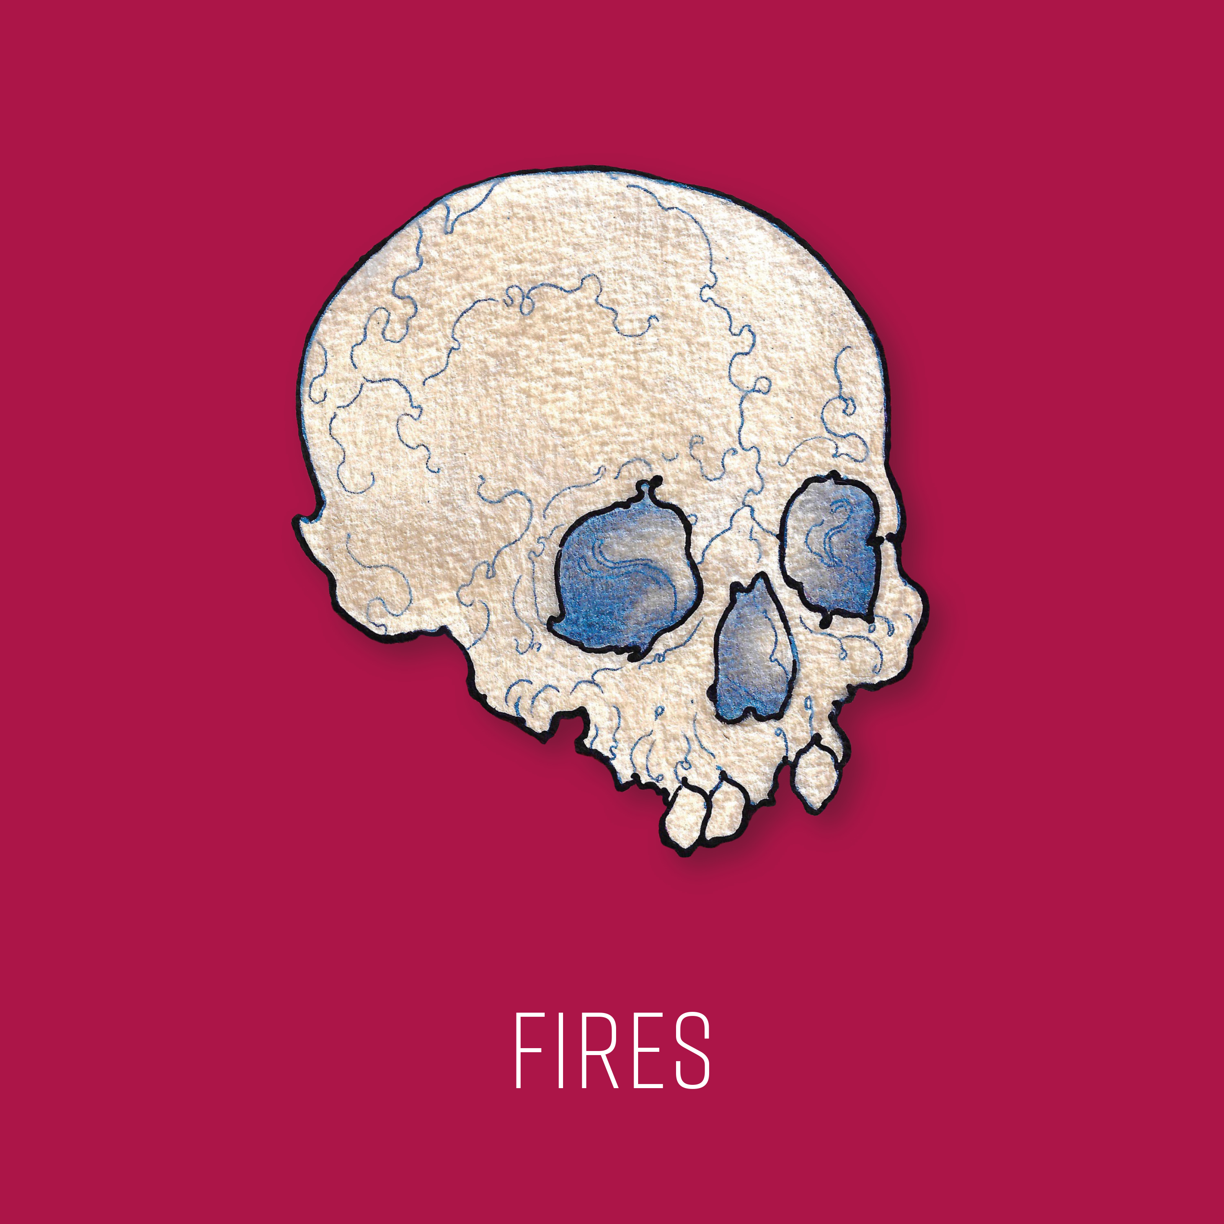

Nathan Connolly has been the guitarist with acclaimed Northern Irish rock band Snow Patrol since 2002. Since then, they have gone on to sell 17 million albums, achieve five UK platinum albums, an Ivor Novello award and Grammy and Mercury Music Prize nominations. In 2013, Connolly founded Little Matador, releasing their self-titled album the following year. Connolly began working on a solo album with producer Rocky O'Reilly in Belfast in 2017.

Lead single 'Fires' is a co-write with Simon Neil of Biffy Clyro, who also features on the track. It is set for release on March 17th.

"I have known Simon since back in my early days with Snow Patrol. The first show I remember playing together was a Zane Lowe MTV Gonzo show in Glasgow in 2003. Over the years we occasionally mentioned doing something together at some point. Finally, the opportunity came in the form of Fires. He is extraordinary and came at the song from somewhere I don’t think I would or could have," says Connolly.

Little Matador bandmate Dave Magee also co-wrote the track, with what Connolly describes as "an effortless gift for the riff".

Nathan Connolly's album, 'The Strange Order of Things' will be released on April 21st, with pre-order available now.

For all media enquiries please contact Warren@chuffmedia.com on 07762 130510

