Fletchr Fletchr Share Latest Single ‘Feel The Same’

LISTEN

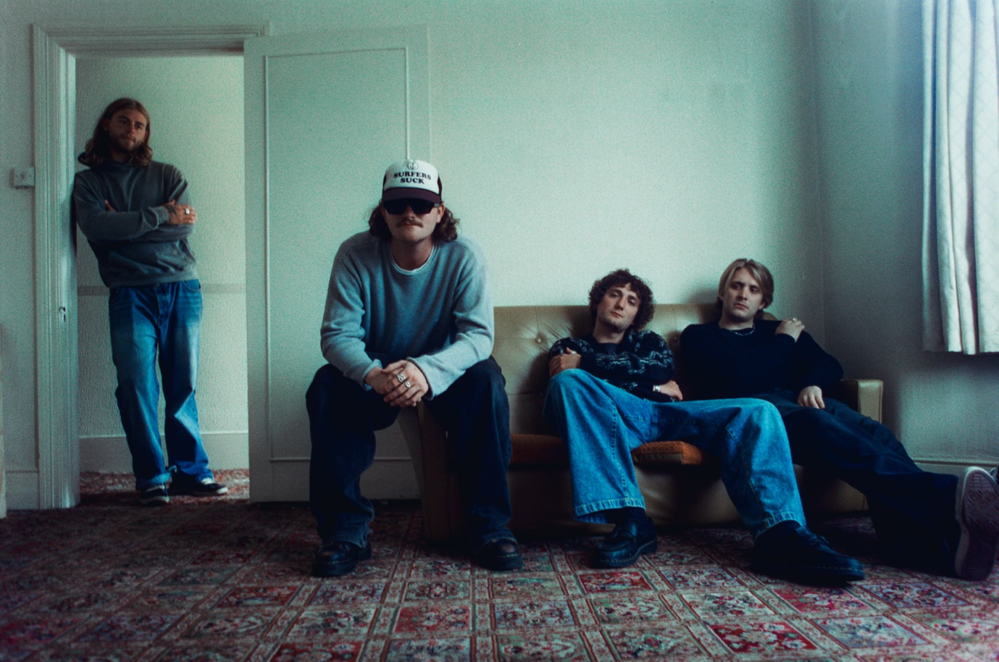
Credit: Charlie Harris

Fletchr Fletchr are pleased to share their new single, ‘Feel The Same’. Listen HERE.

Feel The Same is this exciting new British band’s klaxon call to chatting through your problems. It’s the realisation that no matter what our back stories, we’re all finding our way through assorted life experiences, that often elicit similar feelings of despair, and whilst worrying over similar anxieties. A problem shared needn’t be such a problem at all. It ultimately speaks to the importance of talking, and listening to, each other.

Vocalist Rohan Fletcher explains: “We wrote ‘Feel The Same’ as a way of getting a lot off our chests.
“In the room while writing, there was a realisation that we had been bottling things up and forgetting to talk to each other. To open up and write down exactly how we were feeling was liberating. The song is about what we learnt in that room, we all had a lot of the same stuff going on.”

‘Feel The Same’ is the second track to be taken from Fletchr Fletchr’s forthcoming EP We All Feel The Same, due for release in late November.

Having sold out a trio of last-minute Camden pub shows in recent weeks, the track follows their recent debut single, the ferocious ‘Jet Black’, and the announcement of the band’s first UK/EU headline tour.

The band will also celebrate their latest release tomorrow at an already sold-out show at The Blue Basement in Soho.

The four-piece were formed by three schoolfriends (vocalist/guitarist Rohan Fletcher, lead guitarist (and Jet Black’s producer) Adam Sanders, and drummer Oli Williams who Fletcher and Sanders nabbed from another school band). The trio all chose to study at the same university where they plotted the plight of their new band together. Bassist George Green arrived when Fletchr Fletchr were already almost fully formed, ushered on stage for a show merely days after joining.

Naming your band after the vocalist follows a curious lineage (Van Halen, Florence & The Machine, Mumford & Sons, Ben Folds Five to name but a few), yet the actual reasoning is somewhat sweeter. Firstly, it’s in tribute to Rohan’s father, who passed away as the band’s biggest fan and source of encouragement. And secondly, when Adam moved into Rohan’s family home, working at their pub alongside Rohan, it was commented by friends that the pair had become almost inseparable, with Adam welcomed as a genuine part of the family Fletchr – and thus Fletchr Fletchr were born.

The very adult but relatable emotions of anxiety, love, and grief are already at the heart of what the band are writing their nascent songs about, and are quickly finding a kinship with their young fanbase by tapping into those themes. None of it goes hidden, instead rocketed out verbatim in these dizzying guitar songs.

Fletchr Fletchr’s first headline tour kicks off at Green Door Store in Brighton on 11th November, stretching to 26th November at Downstairs at The Dome in London’s Tufnell Park. Full dates are listed below.

Remaining tickets can be found via the band’s website (www.fletchrfletchr.com).

Fletchr Fletchr Live:

6th October – Tenement Trail Festival, Glasgow
31st October – London Calling, Amsterdam
11th November – Green Door Store, Brighton
14th November – Academy 2, Dublin
15th November – Live at Leeds in the City
17th November – Cabaret Voltaire, Edinburgh
18th November – The Deaf Institute The Lodge, Manchester
20th November – O2 Institute 3, Birmingham
21st November – Dead Famous, Newquay
24th November – Louisiana, Bristol
26th November – Downstairs at The Dome. London

Fletchr Fletchr are:

Rohan Fletcher - Guitars / vocals
Adam Sanders – Guitars
George Green - Bass
Oli Williams - Drums
For more information, please contact jenny@chuffmedia.com

