BEARTOOTH SHARE NEW SONG “FED UP”

NEW ALBUM BELOW ARRIVES JUNE 25 VIA RED BULL RECORDS

HEADLINE UK/EUR TOUR KICKS OFF FEBRUARY 4th, 2022

STREAM / DOWNLOAD: https://ffm.to/beartooth_fedup
PRE-ORDER ALBUM: https://ffm.to/below

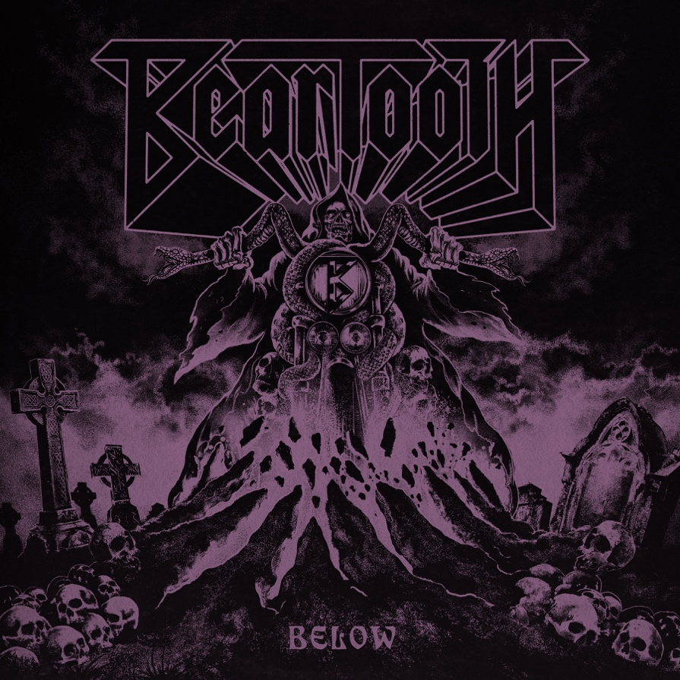
Friday, May 21, 2021 – Gold-selling, Columbus, Ohio-based rock band Beartooth have just shared the fast 'n' furious new song "Fed Up" from their fourth studio album, Below, which arrives on June 25 via Red Bull Records. Below is available for pre-order here.
Listen to "Fed Up," which roars out of the gates and never lifts its foot off the gas for even a nanosecond, here.
"'Fed Up' was written mid lockdown," says Shomo. "I really couldn't think of what to write about, so I just started thinking, 'What am I fed up with in life at the moment?' and wrote it down. The vibe of this song is garage rock with muddy, blown-out tones. We mixed that with the more pop styling on the vocals, and it made for a really special track."
The band will also return to the road this summer on a headline tour. The Below Tour kicks off on August 14 in Las Vegas and winds through the country before wrapping in Grand Rapids, Michigan on September 25. All confirmed dates are below, including several festivals at which the band will appear. Get tickets here or here. In other Beartooth tour news, the band was just announced to appear at Louder Than Life.
Beartooth thrilled their legion of faithful fans in late March with a blistering one-two punch! First, they surprise-dropped "Devastation." The band quickly followed with the video for "The Past Is Dead." The clip finds the band in performance mode, which is its most natural state. The members are surrounded by a stunning display of pyrotechnics and an otherworldly demon named "Barry," who has been dubbed the official mascot for the album cycle and can be spotted in the album cover art pictured above. The band also recently shared their latest single, the hyperkinetic new track "Hell Of It."
BEARTOOTH ON TOUR
W/ MOTIONLESS IN WHITE & STRAY FROM THE PATH

February 2022
4th Vienna, AT - Gasometer
6th Zurich, CH - Volkhaus
8th Munich, DE - Zenith
9th Stuttgart, DE - Porsche Arena
11th Hamburg, DE - Sporthalle Hamburg
12th Cologne, DE - Palladium
14th Tilburg, NL - 013
15th Brussells, BE - Ancienne Belguique
18th Birmingham, UK - O2 Academy
19th Manchester, UK - O2 Victoria Warehouse
20th London, UK - O2 Academy Brixton
22nd Paris, FR - Le Cabaret Sauvage
23rd Frankfurt, DE - Jahrhunderthalle
25th Berlin, DE - Columbiahalle
26th Leipzig, DE - Hause Auensee

Tickets are available from www.beartoothtickets.com / www.beartoothvip.com

BELOW TRACK LISTING:
“Below”
“Devastation”
“The Past Is Dead”
“Fed Up”
“Dominate”
“No Return”
“Phantom Pain”
“Skin”
“Hell Of It”
“I Won’t Give It Up”
“The Answer”
“The Last Riff”

BEARTOOTH ARE:
Caleb Shomo — Vocals
Zach Huston — Guitars
Will Deely — Guitars
Oshie Bichar — Bass
Connor Denis — Drums

Follow Beartooth
Facebook | Twitter | Instagram | Website | Spotify | YouTube

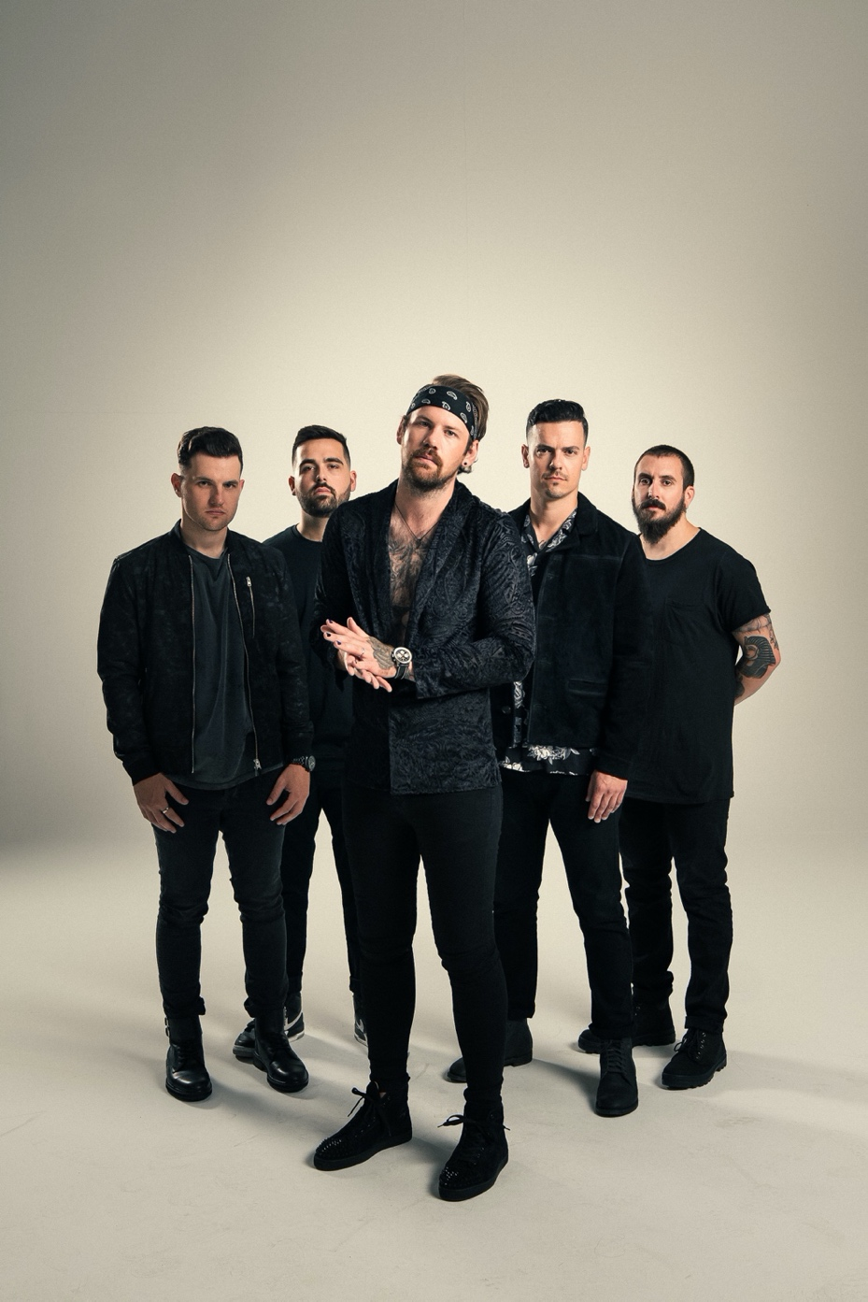

For more information and press enquiries please contact

Jenny Entwistle
Jenny@chuffmedia.com

