BRADLEY SIMPSON
TEAMS UP WITH NIEVE ELLA
FOR A NEW VERSION OF ‘FAVOURITE BAND’
LISTEN HERE / WATCH THE VIDEO HERE

ORIGINAL FEATURES ON HIS TOP 10 DEBUT ALBUM ‘THE PANIC YEARS’

THE PAIR REUNITE NEXT MONTH DURING BRADLEY’S UK HEADLINE TOUR

PRAISE FOR ‘THE PANIC YEARS’:

“Full of intelligent songwriting, a psychedelic edge and Americana influence.” – Wonderland

“A debut solo collection that sparkles with fizzy brilliance.” - Dork

“Lush, soaring vocals, and effortlessly cool alt-rock instrumentals.” – 1883

“A psychedelic rock feel, which perfectly caters to his rich, seasoned vocal tone.” – Euphoria

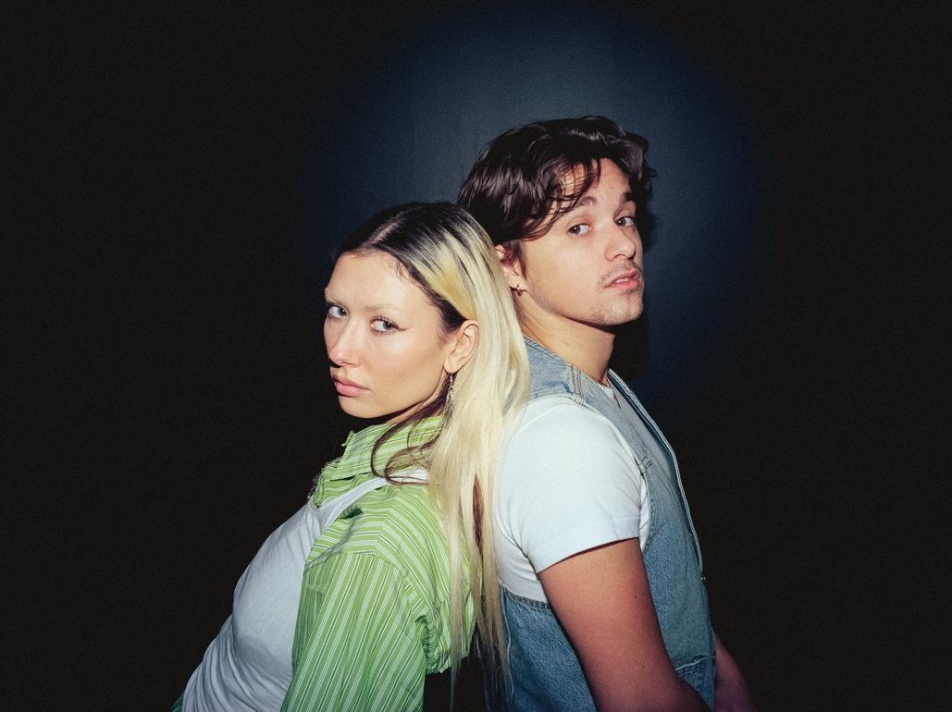

After securing a #7 chart position for his acclaimed debut solo album ‘The Panic Years’, Bradley Simpson now teams up with hotly-tipped artist Nieve Ella on a new version of one of its highlights, ‘Favourite Band’.

‘Favourite Band’ is a fictional tale of lovelorn vengeance with an unexpected twist. Bradley bites back at a break-up by vowing to make a hit so unavoidable that her new boyfriend becomes obsessed with it. Leaning into classic singer-songwriter territory with an alt-pop edge, the song now takes on a fresh perspective with Nieve Ella’s feature. Her new verse provides a female counterpoint to Bradley’s words, as if both partners in the fictional split are musicians with something to prove. The pair will be reunited next month as Nieve Ella has also been confirmed as support for Bradley’s headline UK tour next month.

Bradley says, “I’ve been a fan of Nieve’s for a long time, she actually popped up on my TikTok years ago and it’s been amazing to see her journey as an artist these past few years. She’s got a fantastic voice and is a great writer and we’ve written together a few times over the past few years so it was a really organic process getting ‘Favourite Band’ together. She’s a very talented artist and I’m looking forward to hopefully playing the song live together.”

Nieve adds, “Having a feature on one of Brad's songs, it's such an honour! I think his album is such a great representation of how good a writer he is, so getting the chance to be a part of one of the tracks is really exciting for me!”

The songs from ‘The Panic Years’ take on a new edge in the live environment, as proven by Bradley’s recent Amazon Music CURVED performance of ‘Favourite Band’. His shows have constantly sold-out, including London residencies at The Village Underground and The 100 Club through to international dates across Europe and North America.

Limited tickets for his UK and Ireland headline tour next month are available HERE. Nieve Ella will be special guest at all shows except for Dublin, which features Amy Michelle. Bradley will then tour Australia with stops in Melbourne, Brisbane and Sydney.

MAY
7th - Dublin, The Academy
10th - Newcastle, University
11th - Glasgow, SWG3 Galvanizers (LOW TICKETS)
13th - Sheffield, Leadmill (LOW TICKETS)
14th - Leeds, Beckett Student Union
16th - Manchester, O2 Ritz (LOW TICKETS)
17th - Birmingham, O2 Institute (SOLD OUT)
19th - Cardiff, Tramshed
20th - Bristol, SWX
22nd - Southampton, Engine Rooms
23rd - London, O2 Forum Kentish Town

About Nieve Ella
Hailed by Rolling Stone as “a defining voice of Gen Z” and tipped for stardom by NME, Nieve Ella crafts songs of revealing self-awareness which mix ‘90s indie grit with a refined pop edge. Her growing catalogue, including her recent EP ‘Watch It Ache and Bleed’, has been boosted with extensive Radio 1 support, while her arena-filling potential has been highlighted with tours as guest to Girl In Red, Dylan and Inhaler. She is now preparing for a big summer with sets at the Reading, Leeds, Neighbourhood Weekender and TRNSMT festivals.

Follow Bradley Simpson:
Spotify | Apple Music | TikTok | Instagram

For more information, please contact
Jenny Entwistle
jenny@chuffmedia.com

