Ignite Next Chapter with New Single “Eyes Closed”
LISTEN HERE

Band Also Premieres Enigmatic Music Video
Watch HERE

More Music Coming Soon

DOWNLOAD ARTWORK HERE

Launching yet another creative era, Imagine Dragons have returned TODAY with a brand-new genre-smashing single entitled “Eyes Closed” (KIDinaKORNER/Interscope) and accompanying music video.
Listen to “Eyes Closed” HERE.
Watch the enigmatic music video for “Eyes Closed” HERE.
This future-facing anthem co-mingles elements of alternative, rap, electronic, and rock. Industrial production bumps beneath deftly rhymed verses laced with swaggering attitude. Against a backdrop of gritty hip-hop beat-craft spiked with jarring synths and string swells, frontman Dan Reynolds charges forward with unapologetic and uncompromising cadences that culminates with a confident proclamation, “I could do this with my eyes closed.”
About the song, Imagine Dragons frontman Dan Reynolds commented, “After taking some time off the road and spending time catching up with family and loved ones, I finally have felt the desire to go back to the sonic places that originally brought me the most joy, but with a new outlook and mentality. The world looks much different after being a band for more than a decade. But some things will always remain the same. It’s finding that right balance of nostalgia and freshness that brings me the most joy in the studio. We had a lot of fun making this one and hope you enjoy it too.”
The last new music we heard from Imagine Dragons was “Children of the Sky (a Starfield song)” inspired by the blockbuster Sci-Fi role-playing game, Starfield™. In other big news, the band once again vaulted into the stratosphere with another major milestone. Their hit single “Bad Liar” just crossed 1 billion Spotify streams, enshrining Imagine Dragons as “the first group to score 10 songs in excess of 1b streams on Spotify.”
It’s just the beginning though. Stay tuned for the impending premiere of a stunning cinematic music video to accompany the track with more music coming soon from the band on the horizon.
Get ready for more from Imagine Dragons in 2024!
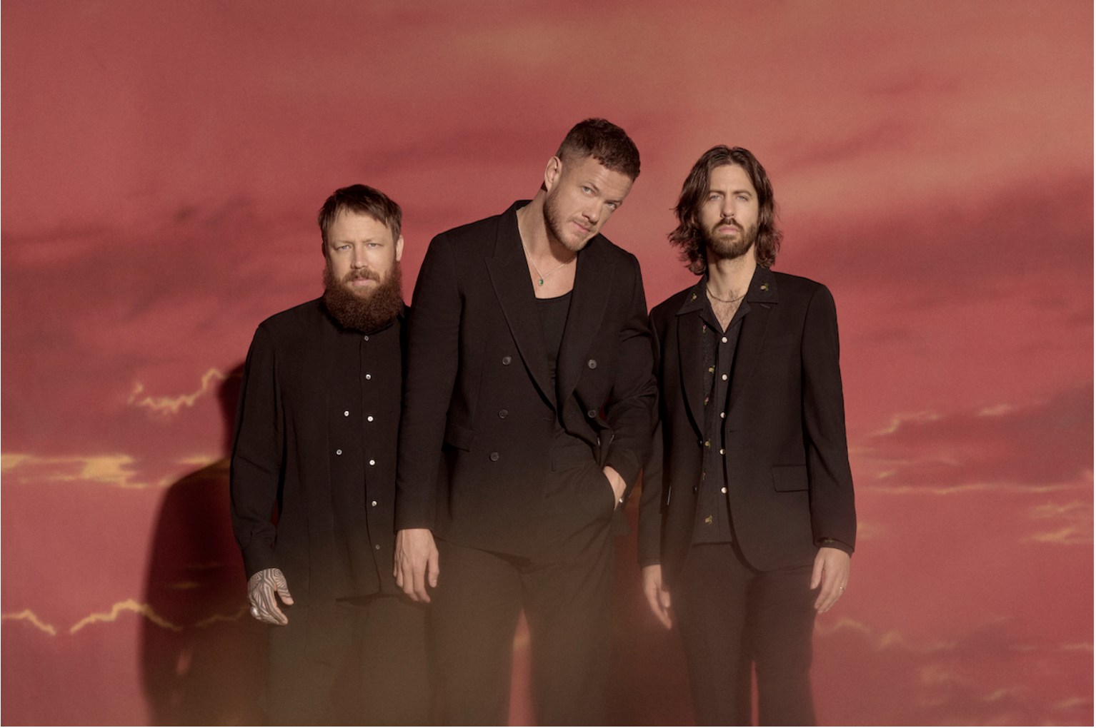
Photo Credit: Eric Ray Davidson

ABOUT IMAGINE DRAGONS:
Imagine Dragons continue to redefine rock in the 21st century. Filling stadiums, crafting cloud-rattling anthems, and breaking records at every turn, diamond-certified GRAMMY® Award-winning Las Vegas quartet Imagine Dragons occupy rarified air as one of the biggest rock bands in the world. Tallying cumulative sales of 74 million album equivalents, 65 million digital songs, and over 160 billion streams, they stand out as “the only band in history to earn four RIAA Diamond singles,” namely “Radioactive” (16x-platinum), “Believer” (13x-platinum), “Thunder” (12x-platinum) and “Demons” (11x-platinum). Since emerging in 2009, they’ve scored five consecutive Top 10 debuts on the Billboard Top 200 with Night Visions [2012] (7x-platinum) (KIDinaKORNER/Interscope), Smoke+Mirrors [2015] (platinum) (KIDinaKORNER/Interscope), Evolve [2017] (triple-platinum) (KIDinaKORNER/Interscope), Origins [2018] (platinum)(KIDinaKORNER/Interscope), and Mercury – Act 1 [2021]( KIDinaKORNER/Interscope). With the release of Mercury – Act 2 (KIDinaKORNER/Interscope) in 2022, they completed their first double-album opus produced by the legendary Rick Rubin. The hit single “Bones,” featured on Mercury Act 2, went to number one at Alternative Radio and remains in the Global Top 50 on Spotify. The band’s hit collaboration with East Atlanta-based rapper J.I.D, “Enemy,” has racked up billions of global streams and landed at #6 on the IFPI Global Singles Chart for 2022. Dominating radio, they remain one of only four bands to ever achieve consecutive Top 5 singles at Alternative radio, and the only band to repeat this feat. Most recently, Imagine Dragons made history on Spotify, as “Bad Liar” became their 10th song to surpass 1 billion streams. The band now holds the crown for the group with most billion-plus streamed songs, becoming the first in the platform’s history to have ten songs reach this milestone. Meanwhile, Imagine Dragons’ music videos for hits “Thunder” and “Believer” have garnered an astounding 2 billion YouTube views, while videos for “Radioactive” and “Demons” have surpassed over 1 billion views. They’ve collaborated with everyone from Kendrick Lamar, Lil Wayne, and Wiz Khalifa to Avicii and film composer Hans Zimmer. Giving back, they’ve raised millions for various causes, including their pediatric cancer charity the Tyler Robinson Foundation, and frontman Dan Reynolds' LOVELOUD Foundation and festival in support of LGBTQ+ youth. In 2022, Ukrainian president Volodymyr Zelensky named them ambassadors for UNITED 24, which benefits humanitarian aid in Ukraine. Imagine Dragons earned an impressive four nominations for the 2022 American Music Awards including “Favorite Pop Duo or Group,” “Favorite Rock Artist,” “Favorite Rock Album” and “Favorite Rock Song.” The band was also nominated for “Group of 2022” for the 2022 People’s Choice Awards. Most recently, they received an MTV VMA nomination for “Video For Good” for their acclaimed “Crushed” music video.
# # #

For more information and press enquiries please contact

Jenny Entwistle
Jenny@chuffmedia.com

