*“Thoughtful & poetic”* - **Americana UK**

"Channelling Dylan at his most poetic, metaphoric and meditative" - **Folk Radio UK**

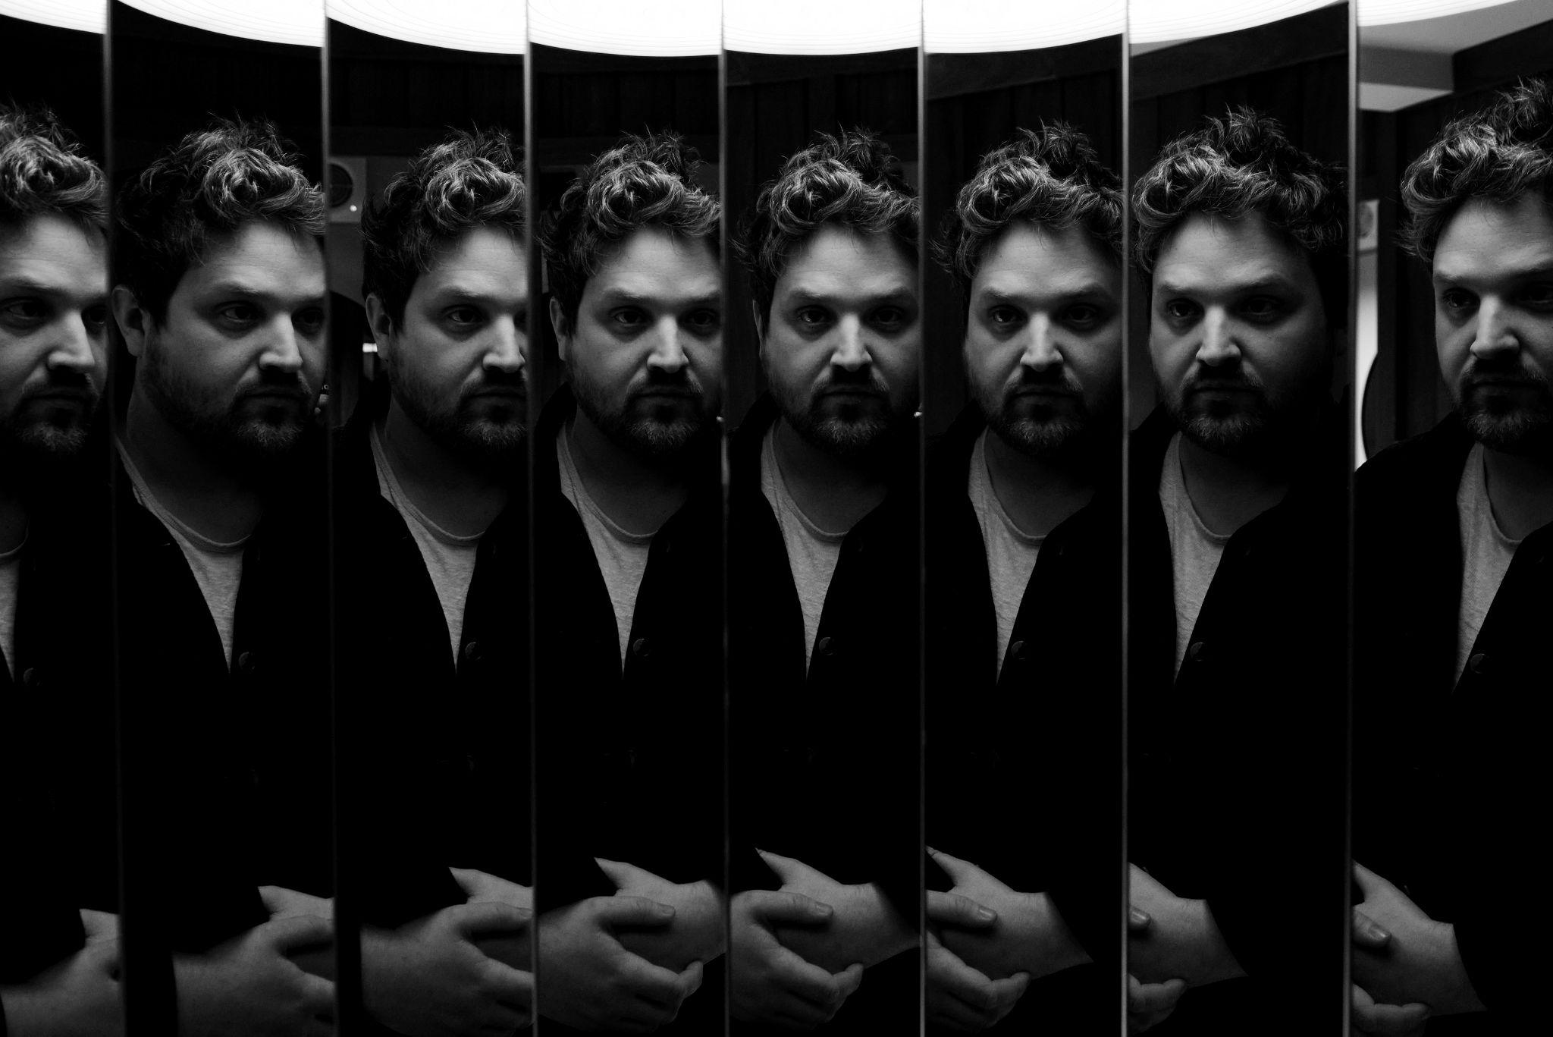

**PHOTO CREDIT: Rob Baker Ashton**

**WILL VARLEY RELEASES NEW SINGLE ‘EVERYTHING HAS A HEARTBEAT’ FEATURING ELENI DRAKE**

**STREAM:** [**https://folketown.lnk.to/WillVarleyEHAH**](https://folketown.lnk.to/WillVarleyEHAH)

**GIG TICKETS & MAILING LIST SIGN UP:** [**https://willvarley.com/**](https://willvarley.com/)

Off the back of three sold out shows in the Autumn and a string of support slots opening for The Libertines, English singer-songwriter Will Varley announces the first single ‘Everything Has A Heartbeat’, from his forthcoming 7th album, released on his new label MNRK Music Group, home to the likes of The Lumineers, Mt. Joy, Gregory Alan Isakov. with the single featuring British-Greek dream-folk artist & label mate, Eleni Drake.

“*‘Everything Has A Heartbeat’ was the first song I started working on for the album a couple of years ago. The lockdowns were lifting, I had no record label, two kids under four and no real idea of what to do next. But I felt like I was at the beginning of some kind of adventure and I had this great sense of freedom to try something new. It’s a song about letting go of darkness. Acknowledging the past, but also finding your way through it, and realising that everything is connected in the end. I’m a big fan of Eleni Drake’s music. Her vocals on this track were the very last thing we added to the album and it’s an honour having her on board.*”

‘Everything Has A Heartbeat’ coincides with the announcement of Will’s UK headline tour in the Spring of next year, joined by his formidable new backing band 'The Southern Rust', Varley will be showcasing material from the upcoming album as well as playing plenty of old tunes to boot.

*"The crowds we’ve had these last few months absolutely blew us away and as soon as we finished in Berlin I was desperate to do it all again.”* enthuses WIll*, “I've been working away in the studio for almost a year now, but there's nothing like playing live. It's been a while since I did a proper UK tour like this. I'll be playing at some of the best independent music venues in the world and I can't wait."*

**UPCOMING SHOWS:**  
25 MAR SHEFFIELD THE LEADMILL  
26 MAR EDINBURGH THE VOODOO ROOMS  
27 MAR GLASGOW DRYGATE  
28 MAR NEWCASTLE THE CLUNY  
29 MAR LIVERPOOL ARTS CLUB  
30 MAR NOTTINGHAM RESCUE ROOMS  
01 APR CAMBRIDGE THE JUNCTION  
02 APR BRISTOL THEKLA  
03 APR FALMOUTH THE CORNISH BANK  
04 APR SOUTHAMPTON THE JOINERS  
05 APR BRIGHTON PATTERNS  
06 APR MARGATE WHERE ELSE?

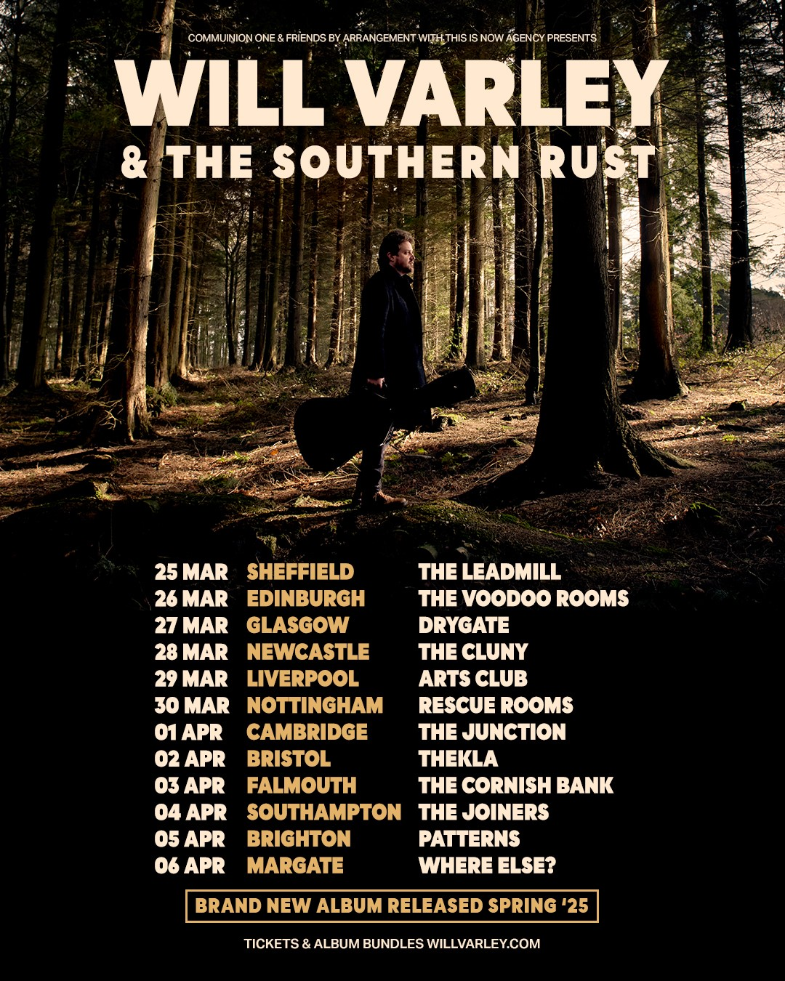

**For more information & media enquiries, please contact:**

**Warren Higgins**

[**warren@chuffmedia.com**](mailto:warren@chuffmedia.com)