
Release fan favourite single ‘Emotionally Hungover” out now
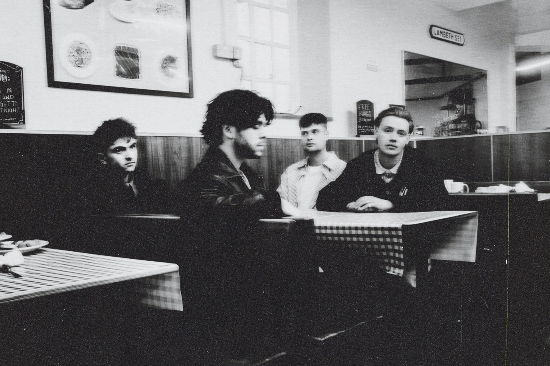
Listen HERE /Watch HERE

Fresh off the back of their biggest track to date, "You Hate That I’m In Love", Only The Poets return with another bold, emotionally raw alt-pop gem out now. Already a standout moment on their recent sold-out European tour, the single has become a fan favourite that’s been lighting up live sets with its gut-punch lyrics and unforgettable hook.

"Emotionally Hungover" is a bold continuation of the band’s sonically elevated new chapter. Co-written by frontman Tommy Longhurst with alt-pop powerhouses Matt Rad and Janeva, and produced by DanDlion, alongside the band’s very own Marcus Yates and Clem Cherry, it’s a track that perfectly blends lyrical vulnerability with arena-sized ambition.

The release follows a monumental 2025 for the band so far, with over 20,000 tickets sold across their European tour, alongside dates in the US with sold-out debut shows in New York, Los Angeles, and Boston.

The Reading four-piece, comprising of Tommy Longhurst, bassist Andy “Roo” Burge, guitarist Clem Cherry and drummer Marcus Yates, have established themselves in just a few short years as one of the UK’s biggest emerging live acts. The band’s DIY ethos saw them build things from the ground up, playing student house parties, pub circuits and small venues to selling out 1600 capacity venues in the UK and Europe: Longhurst’s autobiographical lyrical honesty and raw feelings touching on issues such as mental health, grief, heartbreak and loss instantly connecting with audiences. They’re a band that are rapidly becoming the voice of a generation who aren’t afraid to feel.

DON’T MISS A THING:
OTP // INSTA // TWITTER // FB

For more information and press enquiries please contact
Jenny Entwistle
Jenny@chuffmedia.com

