THE ITCH

SHARE NEW SINGLE
‘DRUGDEALER’

DEBUT ALBUM IT’S THE HOPE THAT KILLS YOU ARRIVES 10TH APRIL VIA FICTION RECORDS / I OH YOU

UK/EU HEADLINE TOUR MAY 2026

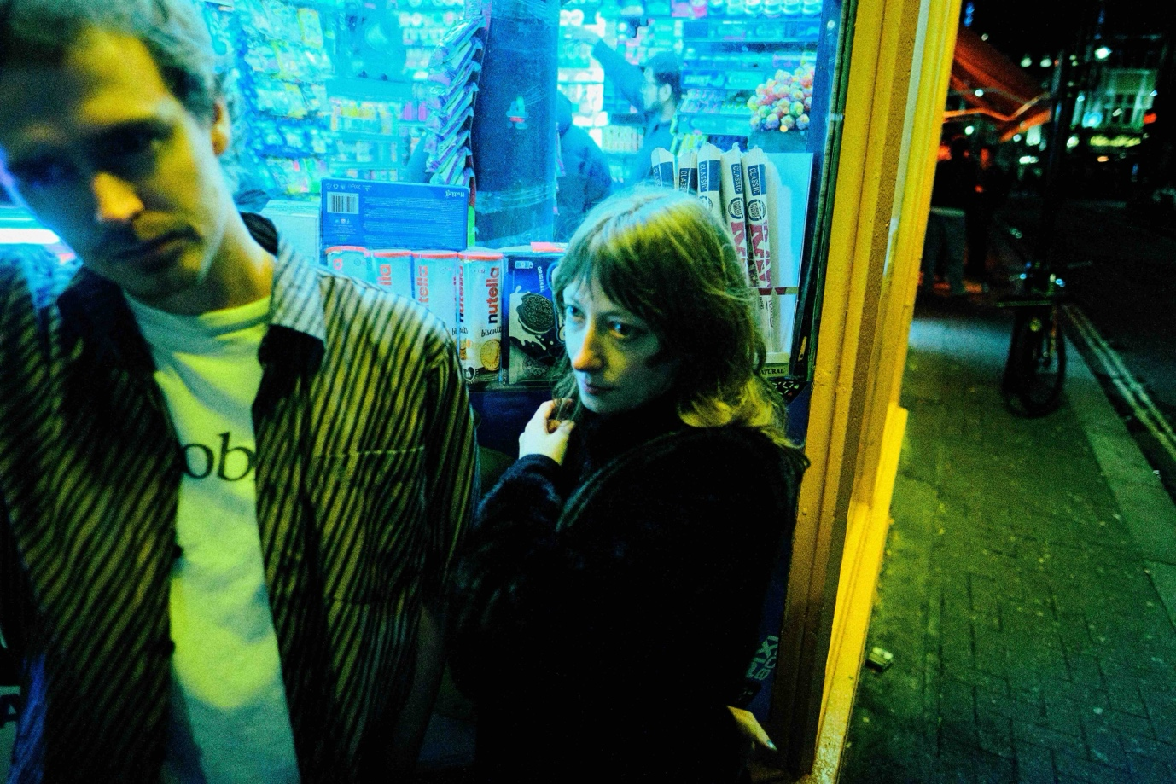
credit: The Itch [hi-res here]

The Itch share their new single ‘Drugdealer’: our fourth taster of debut album It’s The Hope That Kills You [released 10th April via Fiction/I OH YOU].

Co-produced with James Greenwood (Ghost Culture), ‘Drugdealer’ showcases a different side to the group, offering a more tender side from an act known for their club-adjacent blend of electronica and indie rock.

Tyrie describes ‘Drugdealer’ as their ‘first traditional love song’, albeit with a subliminal lyrical twist characteristic of many of the duo’s material. Set against shimmering synths textures and cinematic strings inspired by Ultravox’s Vienna and Suicide’s Dream Baby Dream, the song captures the tender and unsettling tension between caring for somebody and sustaining an illusion to maintain their happiness. ‘Tell me what you want to hear and I will say the rest,’ Tyrie sings in the first verse. ‘Send me to the corner shop for booze and cigarettes.’

Talking about the process behind writing the song, Tyrie says ‘I was listening to a lot of Elton John and Bernie Taupin songs at the time of writing and really wanted to write a song that dealt with metaphor like Rocket Man or Goodbye Yellow Brick Road – the idea of a love
song from the perspective of a drug dealer hit me when I was buying a pack of cigarettes for a friend at Wide Awake festival. ’

The accompanying music video was created by Tyrie using a mixture of camcorder footage and still photographs from tours and clubnights curated by the duo.

Watch ‘Drugdealer’ Video Here

Over the course of a debut album which finds harmony in juxtaposition, Simon & Georgia pool a hundred different touchstones to create something entirely singular. It’s The Hope That Kills You is crisp yet dishevelled. Introspective yet exuberant. And delivered with candid conviction while wry sarcasm consistently looms moments away.

Remixes for each of ITHTKY’s singles will see The Itch teaming up with The Twins, 1-800 GIRLS and Tom Sharkett.

Since first arriving in 2024 with a single headline performance, The Itch re-emerged in the summer of 2025 - now armed with a record deal and embryonic versions of the tracks which would go on to become It's The Hope That Kills You - Simon & Georgia played a sweaty midnight set at The Great Escape which saw an hour-long queue jostling for entry and has since gained cult-like status in its own right.

The duo have since made a habit of selling tickets to their underground basement parties via SMS, with their most recent sellout show – a headline and album announce party – in the iconic basement of Swiss restaurant St Moritz in Soho. The venue, which has seen everyone from Lou Reed to Metallica pass through its doors, has been under the same ownership since 1961 and still has the 1960s Soho licence that allows it to stay open every night until 3am. It’s no surprise then that The Itch wanted to bring it back as a party spot.
It’s The Hope That Kills You will be released in a collaborative record deal between Fiction Records [The Cure, Kae Tempest] and I OH YOU [Confidence Man, Rolling Blackouts Coastal Fever]. Vocoder-topped europop gem ‘Space in the Cab’ and The Itch’s metamorphic, 7-minute long debut single ‘Ursula’ feature in the albums tracklist alongside ‘Drugdealer’.

Pairing undulating dancefloor fillers with disenchanted pop songwriting, Simon & Georgia have captured a moment in time to conjure a debut offering which is both a product of and an antidote to an age of pessimism.

May’s headline dates include stops Leeds, Glasgow, Manchester, Amsterdam, Paris and London, where The Itch will play at Brixton’s Club Cheek.

Pre-order It’s The Hope That Kills You Here

UK Live Dates:
11 Mar – The Sugarmill (Stoke) #
12 Mar – Futureyard (Birkenhead) #
13 Mar – Bootleg Social (Blackpool) #
9 Apr - Rough Trade (Bristol) instore
10 Apr - Rough Trade (Denmark St, London) instore
11 Apr - Ram Jam (Kingston) outstore w/ Banquet Records
12 Apr - Resident (Brighton) instore
8 May – Headrow House (Leeds)
9 May - The Hug and Pint (Glasgow)
13-16 May - Great Escape Festival (Brighton)
20 May - Club Cheek (London)
22 May – Venue TBA (Manchester)
23 May - Dot to Dot Festival (Bristol)
24 May - Dot to Dot Festival (Nottingham)
20-23 Aug - Green Man Festival, Wales

#w/ Antony Szmierek

The Itch - It’s The Hope That Kills You

Space In The Cab
No More Sprechgesang!
Can’t Afford This
Pirate Studios
Drugdealer
Radio Frequencies
It’s The Hope That Kills You
Aux Romanticiser
Ursula
Never Change
Switch It Off

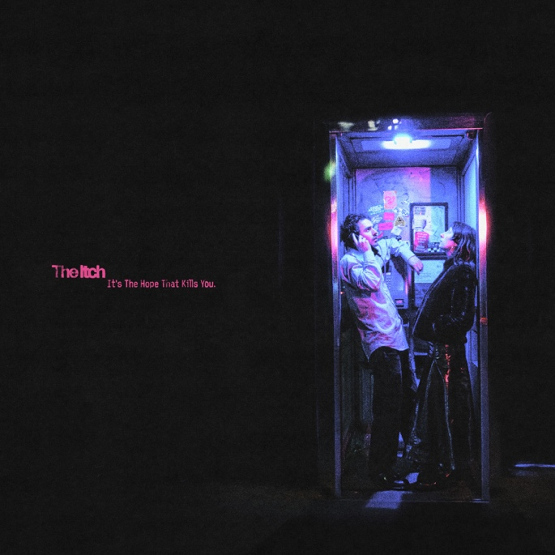

DISCOVER THE ITCH
Website | Instagram | YouTube | Spotify

For more info contact Warren Higgins
warren@chuffmedia.com

