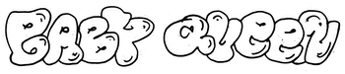

**RELEASES NEW SINGLE ‘DOVER BEACH’**

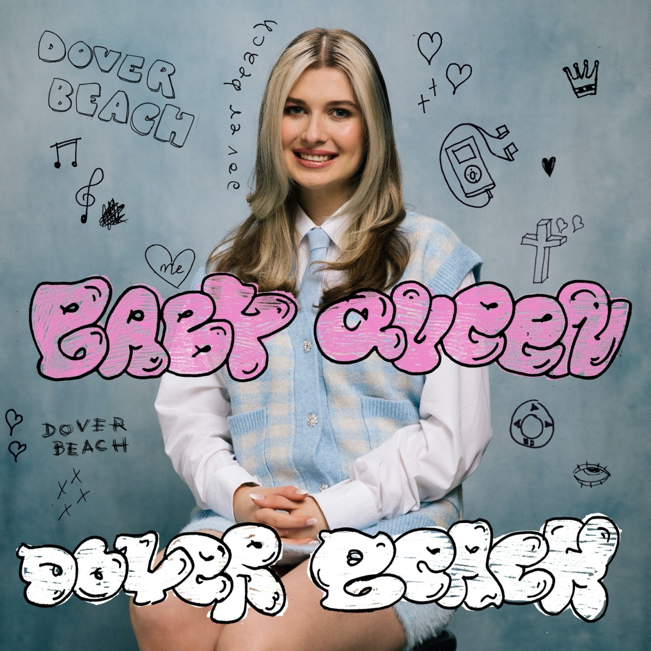

**\*ANNOUNCES DEBUT HEADLINE SHOW \***

**OMEARA 9TH NOVEMBER**

LISTEN HERE   
WATCH VIDEO HERE

PRESS IMAGE [HERE](https://we.tl/t-HQ6cRtRomE) (credit Clark Franklyn)

Pop’s new anti-hero **Baby Queen** releases her new single ‘Dover Beach’ on April 14th on Polydor Records. The track follows ‘These Drugs’ and her highly-praised single ‘Raw Thoughts’ which was Greg James Radio 1 Breakfast Show 'Tune of the Week'. Already racking up the accolades, Baby Queen was also hailed Radio 1's Future Artist for March.

The 23-year-old South Africa-born, London-based artist (real name Bella Latham) arrived in the pop sphere barely a year ago but has already carved her name deep into its fabric with her crooked sceptre. Since her first release ‘Internet Religion’ last summer she has dropped a steady slew of singles that place her at the forefront of a musical movement.

Her latest ‘Dover Beach’- a widescreen smash with flecks of The 1975 and optimistic dream-pop like M83 - chronicles the time in October 2020 when she headed to a place she had long dreamt of visiting. Bella says, *"In school I was obsessed with this poem called 'Dover Beach' by Matthew Arnold and I always wanted to visit the Dover cliffs, so I went there alone on a writing trip in October last year. I actually wrote the melody and lyrics of this song while I was sitting on the beach. It's about being infatuated with somebody and seeing them everywhere you look. I was kind of pissed that I went to look at the beach, all I could think about was this person, hence the lyric "you stole the view of Dover Beach." It's another internal struggle with my own insecurities and a sort of acceptance of the fact that I can't escape my daydreams of this person, even if I go to a different place."*

While debut EP *Medicine* paired alt-pop sensibilities with scathing, stark social commentary, the new era of Baby Queen’s story is more inward looking. *“That was the introduction to the essay, where I said all my points and beliefs,”* she says of the tracks that make up *Medicine*. *“Now I have the freedom to write love songs without something thinking I’m vapid and shallow!”*

Behind Baby Queen’s opening, socio-critical musical moment lay a bruising, exhilarating backstory. Now that we know how she feels about the world, she’s ready to tell us how she feels about herself. *“I feel like my instinct is to take something disturbing and painful and make it sound really fucking beautiful and happy,”* she says. The songs she’s writing with that mantra will make her a proudly rare jewel in contemporary pop’s crown.

Baby Queen will play her debut headline show at London’s Omeara on 9th November 2021. Tickets go on general sale from 9am this Friday with Live Nation/Ticketmaster pre-sale tickets available now.

**For more info please contact** [**Warren@chuffmedia.com**](mailto:Warren@chuffmedia.com) **on 07762 130510**