SHARES NEW SINGLE + VIDEO
‘DON’T ASK’
LISTEN / WATCH HERE

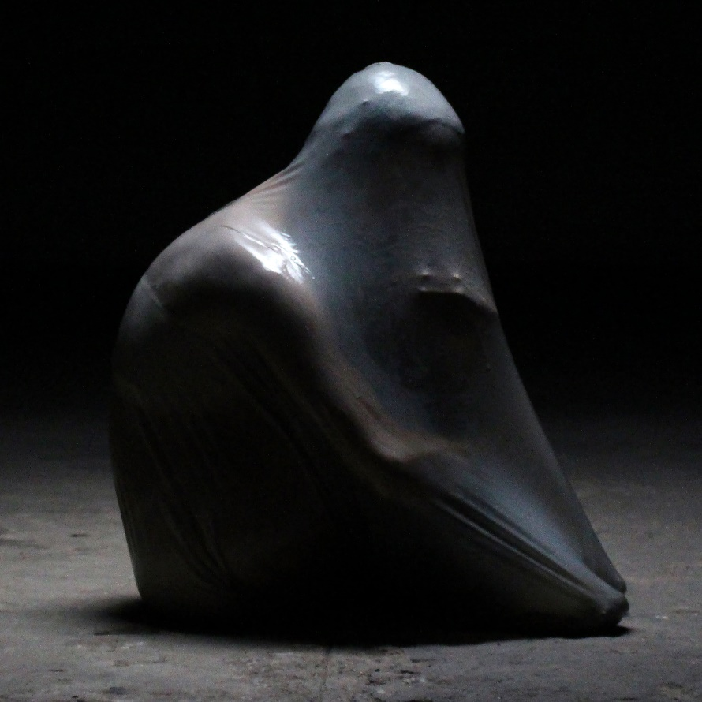
DON'T ASK ARTWORK (credit: Maisy Banks)
“The most commanding new artist statement we’ve heard all year” i-D
“Word is already out on this pop voyager, a daring voice carving out her own niche” CLASH
“Absolutely melting with confidence and style” DIY
“The London-based artist has crafted a sound that is distinctly her own” THE FORTY-FIVE

KAETO today (February 23d) releases her new single ‘Don’t Ask’ via Polydor Records. The emerging London-based artist is fast carving a space for herself with her unique genre-spanning sound that blends elements of trip-hop, dance and electronic music with punk, alt-pop and more. ‘Don’t Ask’ comes with a video directed by Kaeto and her creative collaborator Maisy Banks and was produced by Max Rad. Watch it HERE
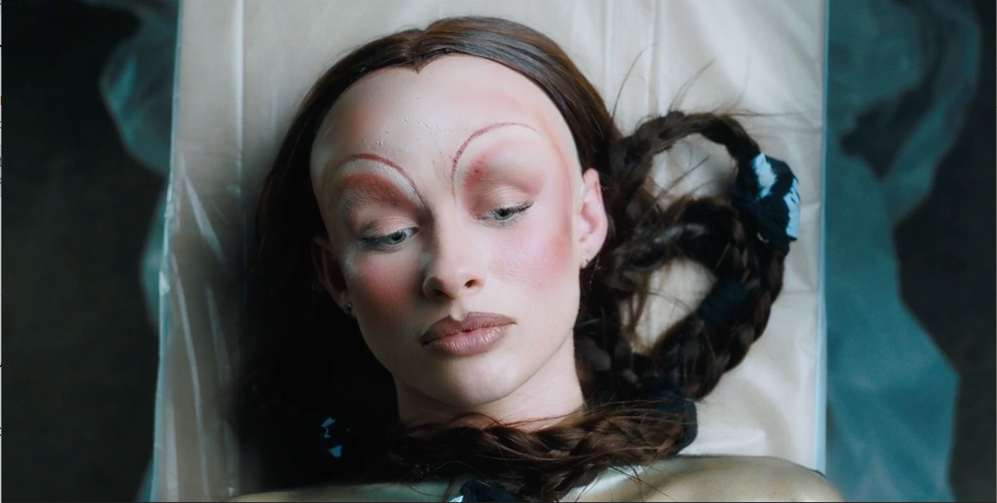
“In this song I am writing about my relationship with myself”, Kaeto says. “Maisy and I directed the video. The video is a celebration of our skin and the beautiful human body. Liv Lockwood is the incredible choreographer that we worked with. She has an amazing brain and she really understood what we were trying to create. The choreography perfectly encapsulates the internal struggle we experience that is reflected in the song and I loved the use of the symbols of teeth, the mouth, hair and the tongue.”

KAETO first attracted attention with her startling debut ‘Good Morning’. After signing to Polydor last summer, she released ‘No Body’ which i-D declared “may be the most commanding new artist statement we’ve heard all year”, following it up with the hypnotic ‘Little Me’ which further revealed a mesmerising new talent.
It was back in 2019 that Kaeto first entered the studio with outside producers and began building a sound that would be all her own, but the route she’s taken since is a mark of her maverick and inventive approach to music. One such diversion was enrolling in Clown School, a move designed to throw herself into something creative and spontaneous and shake off the mundanity of modern life. It's why Kaeto’s music has such a free-spirited, loose-limbed sense of adventure about it. “I’m so unashamed of myself,” she says, “but music is where I go to explore these things.”
KAETO has been captivating audiences with her stunning live performances, including a recent residency at Laylow as well as supporting Haim, Lauren Mayberry and Eliza. Watch this space for details of where to catch KAETO next.
LEAD PRESS PHOTO (Credit: Maisy Banks)

FOLLOW KAETO
Instagram | Youtube |TikTok

For more on info contact warren@chuffmedia.com

