FLETCHER SHARES NEW TRACK “DOING BETTER” FROM HER FORTHCOMING ALBUM IN SEARCH OF THE ANTIDOTE

ACCLAIMED SINGER/SONGWRITER'S SOPHOMORE LP OUT MARCH 22

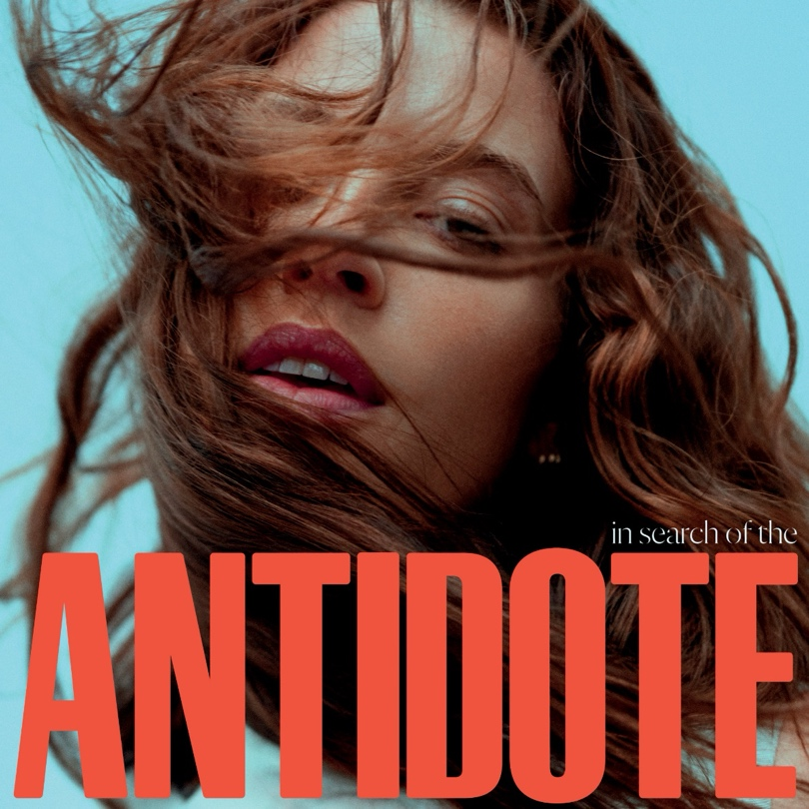
Download hi-res album art, HERE.

Today, acclaimed singer-songwriter FLETCHER shares “Doing Better” – a new track from her highly anticipated new album In Search Of The Antidote out March 22 on EMI/Capitol Records which is available for pre-order now. Listen to “Doing Better” HERE and watch the lyric video HERE.

A song informed by the darker side of living in the limelight, the explosively fun “Doing Better” arrives as a tell-all account of the whiplash of fame. “When I put out ‘Becky’s So Hot’it got quite a reaction, but in a lot of ways that attention didn’t feel good,” recalls FLETCHER. “I wrote ‘Doing Better’ as a way to explore my ego and call myself out, but also to tell the truth about what I was feeling at the time.”

The follow-up to her critically-lauded debut album Girl Of My Dreams — a 2022 LP that entered the Billboard 200 at No. 15 — In Search Of The Antidote delves deeper into the ultra-vivid storytelling and unfiltered introspection that have long defined FLETCHER’s boundary-pushing brand of pop. The album sees FLETCHER exploring such complex themes as identity, insecurity, ego, and self-fulfillment with distinct production and powerful vocal delivery.

“Over the years, I’ve looked for the antidote in so many things: women, the road, the stage, fans, spirituality and self-reflection. Making this album was an excavation, a deep dive where I asked myself what would truly heal me, and my ultimate realization was that love is the antidote. From the Finding Fletcher EP to you ruined new york city for me to THE S(EX) TAPES to Girl Of My Dreams, love has always been my muse. But before now, I don’t think I’d ever really looked at love through all the different lenses and angles and discovered all its infinite manifestations. That’s what this album is about for me.”

FLETCHER collaborated closely with GRAMMY® winning producer/songwriter Jennifer Decilveo to produce the album alongside a lineup of hitmakers including Aldae, Jon Bellion, Julia Michaels, Monsters & Strangerz, and Michael Pollack who are known for their Diamond-certified hits with the likes of Justin Bieber and Miley Cyrus (whoFLETCHER performed alongside in an internet-breaking performance in 2023). “Doing Better” follows her gut-punching single and video “Lead Me On” which was featured as the cover of New Music Daily on Apple Music.

Since her debut, FLETCHER has sold nearly 200,000 tickets worldwide with her headline tours across North America, Australia and Europe. This spring, she’ll kick off her year with performances at Lollapalooza South America in Brazil, Chile, and Argentina in March ahead of her much-anticipated runs in Europe, UK and Australia.

UK Dates below
May 01 Birmingham O2 Academy
May 02 Manchester Victoria Warehouse Academy
May 03 Glasgow O2 Academy
May 09 Newcastle City Hall
May 10 Bristol O2 Academy
May 12 London Eventim Apollo
May 13 London Eventim Apollo

FOLLOW FLETCHER
Facebook / Instagram / Twitter / Website / YouTube

About FLETCHER
Praised by leading outlets like Rolling Stone, TIME, Interview Magazine, and more, acclaimed singer-songwriter FLETCHER hails from Asbury Park, New Jersey, where she cultivated her passion for music and her unforgettably candid storytelling. In 2019 she released her widely lauded debut EP you ruined new york city for me, featuring her breakthrough hit “Undrunk” — a track that spent several weeks on the Billboard Hot 100, scored the No.1 spot on Spotify’s Viral Chart, and emerged as the fastest-rising song at pop radio from a new artist in the past five years. Released in September 2020, FLETCHER’s EP THE S(EX) TAPES hit No. 1 on iTunes across all genres and included the hit single “Bitter,” which has amassed over 200 million global streams. FLETCHER’s debut album Girl Of My Dreams arrived in September 2022 and delivered the smash single “Becky’s So Hot,” which hit No. 3 on the iTunes chart across all genres and landed on Billboard’s Hot Rock and Alternative Songs chart. The album earned raves from the likes of Rolling Stone, Billboard, Alternative Press, Vulture, and many others while her music has surpassed two billion combined streams worldwide. In support of the LP, FLETCHER performed on “The Tonight Show Starring Jimmy Fallon” and set out on sold-out headline tours across North America, Australia, and Europe with nearly 200K tickets sold to date. FLETCHER kicked off 2023 with an internet-breaking performance alongside Miley Cyrus on NBC’s “New Year’s Eve Party,” won the 2023 GLAAD Media Award for Outstanding Music Artist and garnered nominations from the MTV Video Music Awards and MTV Europe Music Awards. A fast-rising cultural force, she also appeared as herself in the third season of The L Word: Generation Q on Showtime, launched her own “FLETCHER & Friends” festival in her hometown of Asbury Park, and raised over $200K for GLAAD as part of her hugely popular Meet Her At The Bar: Pride Month Experience— a series of pop-ups in support ofwomen-owned queer bars across America. FLETCHER will begin her global headline tour of the UK, Europe and Australia tour this spring with performances at Lollapalooza South America in Brazil, Chile and Argentina in March. FLETCHER’s sophomore album In Search Of The Antidote will be released March 22 on Capitol Records.

For more information and press enquiries please contact
Jenny Entwistle
Jenny@chuffmedia.com

