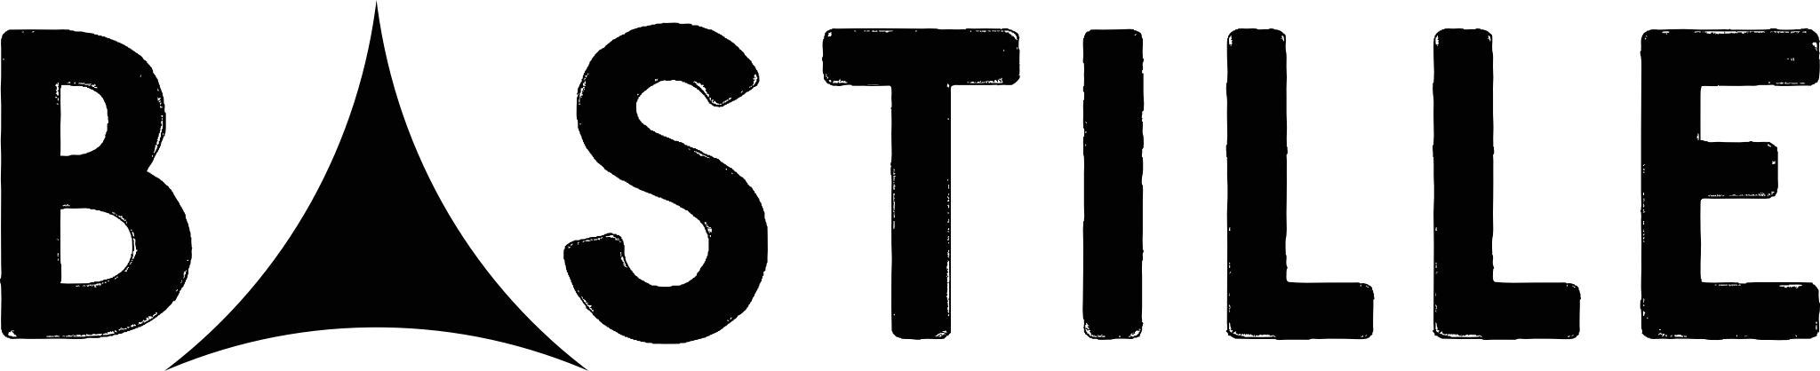

RELEASE NEW SINGLE - “DISTORTED LIGHT BEAM”

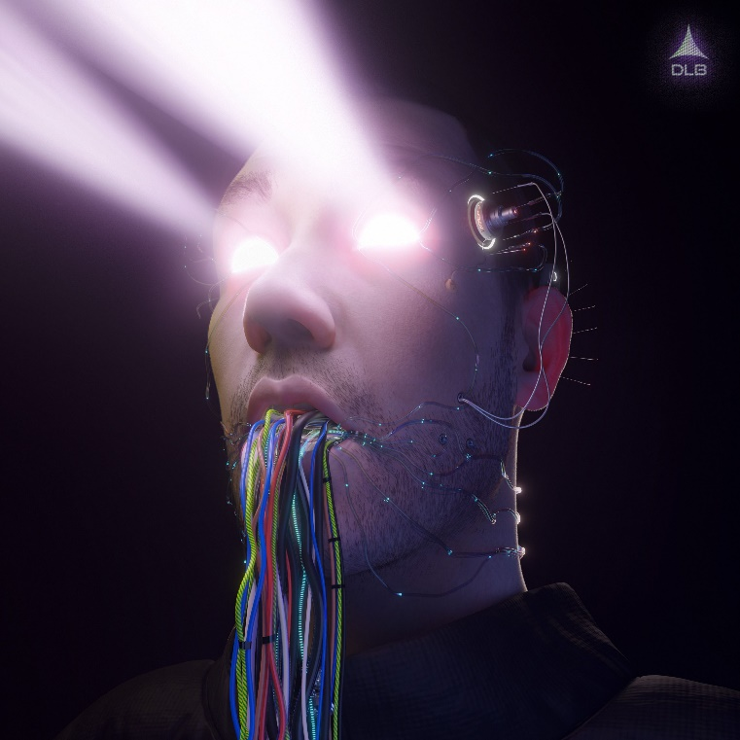

THE FIRST TRACK FROM THE BAND’S FORTHCOMING NEW ALBUM RELEASED LATER THIS YEAR

LISTEN/ WATCH HERE

“Everything is becoming science fiction… the new currency of an ever-expanding future.”
J.G. Ballard

Bastille have always reflected on their surroundings in their art, but how to make sense of a world where fake news has agency and our reality is increasingly lived online? A world where we can be whoever we want to be from behind the glare of a screen, creating avatars that transcend our inadequacies and gloss over the disappointments that real life throws at us.

21st Century boredom has accelerated the need to create fantasies, compounded further by the recent pandemic. From flattering filters on Instagram to inhabiting the virtualscapes of the gamer’s universe, both offer us an infinite freedom and the ability to thrive more so than real life itself.

On new single “Distorted Light Beam”, co-written and co-produced with Ryan Tedder alongside the band’s long-time collaborator Mark Crew, the multi-award winning British band reflect on how we are all changing, and the ways in which we can manipulate our realities to fit a narrative that better suits us. Call it dystopian, utopian or simply call it the future... This isn’t a song that sits in judgement so much as recognises the paradigmatic shift taking place…. “When I’m dreaming tonight, I can do anything,” sings Dan “When I’m dreaming tonight, I can go anywhere… When I’m dreaming tonight, I can be anyone…”

Dan says, “For us Distorted Light Beam soundtracks dancing through some twisted, euphoric futuristic club space. It’s a song about limitless possibilities - which isn’t something any of us actually have in real life right now, so it’s been fun to explore that idea while experimenting with new sounds in our music.”

You don’t predict the future. You imagine it…
futureinc.world

About Bastille

Distorted Light Beam, a gleaming, metallic rush of retro-futuristic pop, marks a new chapter for the multi-platinum selling band, one that revolutionises the Bastille sound, and is the first release from the band’s forthcoming fourth studio album due out later this year. Set in the future, the video for the track sees newly developed immersive technology, Futurescape created by pioneering global tech entity Future Inc transform life as we know it, and alongside the band features, Remmie Milner from BAFTA winning series, Save Me. Watch here

The four-piece have been experimenting and augmenting the Bastille sound since the release of their last album Doom Days in 2019, the conclusion of an unofficial trilogy. Last year they released the Goosebumps’ EP, featuring Graham Coxon on “What You Gonna Do???” and US producer Kenny Beats on the title track as they continued to pen songs that seek to understand and offer escape from the modern human condition

Doom Days received huge critical acclaim and charted in the top 5 in both the UK and U.S, the only UK band to have achieved this chart landmark alongside The Beatles and Queen in 2019. The record found the band at their most lyrically provocative, most accomplished, and most vital and charts the course of one night in search of distraction from the surrounding apocalypse (sound familiar?) During the course of 2019 the four-piece continued to cement their reputation as one of the world’s most captivating live bands having played an extensive two month-long sold-out U.S and UK tour. At the beginning of 2020 Bastille received their sixth Brit nomination and their second nomination for British Group.

In January 2021, Bastille were the subject of ReOrchestrated, a documentary film that provided a revelatory and bracingly honest new look into the band’s journey so far, framed through their ReOrchestrated shows and diving into themes of motivation, anxiety and imposter syndrome.

This summer Bastille ReOrchestrated headline both Latitude and Standon Calling with a further two sold out shows at Hampton Court Palace Festival in August – dates below.

With over 11 million records sold, 6 UK top 40 singles and 1.5 billion video views, Bastille continue to be one of the world’s most streamed bands.

Summer festival dates
Standon Calling 23rd July
Latitude Festival 25th July
Hampton Court Palace Festival 17th & 18th August

Socials
Instagram: https://Bastille.lnk.to/DDPreOrderIN
Facebook: https://Bastille.lnk.to/DDPreOrderFP
Twitter: https://Bastille.lnk.to/DDPreOrderTW

ReOrchestrated documentary
https://www.amazon.co.uk/Bastille-ReOrchestrated/dp/B08VW2VFSZ

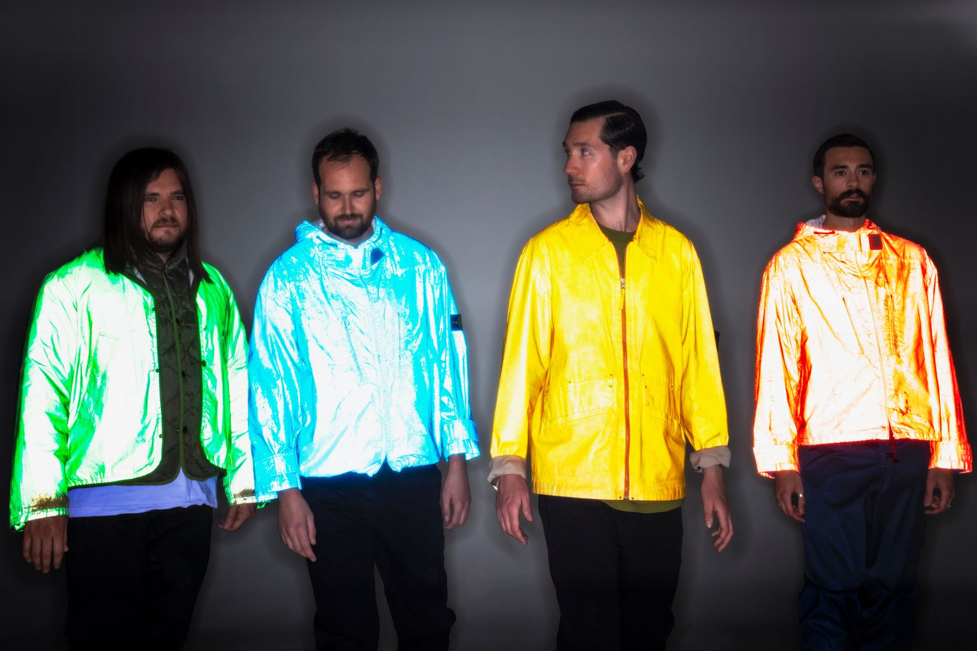

For more information and press enquiries please contact

Jenny Entwistle
Jenny@chuffmedia.com

