HOLLY HUMBERSTONE

UNVEILS NEW SINGLE

“DIE HAPPY”

WATCH THE VISUALISER HERE
DIRECTED BY SILKEN WEINBERG

PLAYING HEADLINE SHOWS AND SUPPORTING SAM FENDER IN AUSTRALIA THIS WINTER

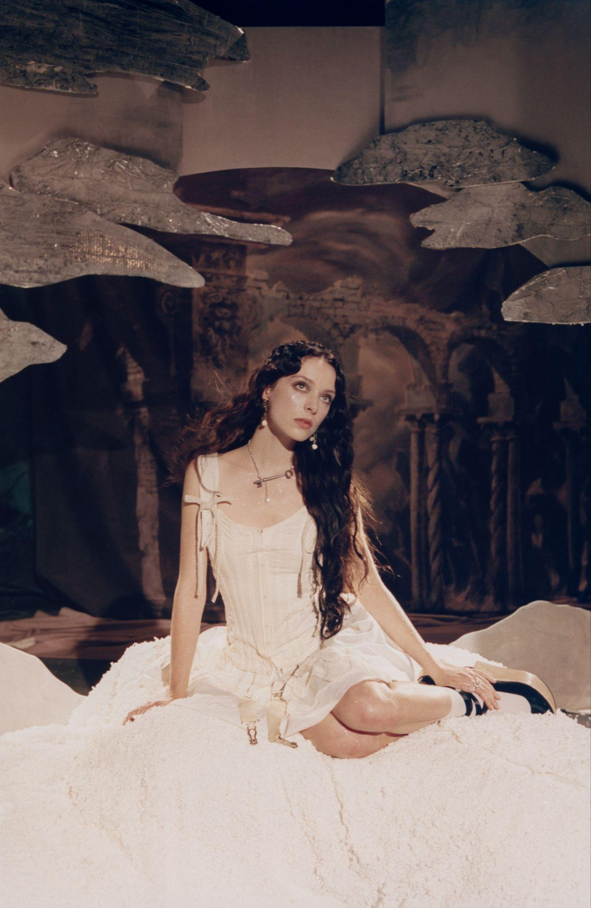

Holly Humberstone returns with “Die Happy”, a gothic love song that feels like stepping into a dark fairytale, where passion is both enchanting and dangerous. The visualiser, directed by Silken Weinberg (Ethel Cain), unearths a new season for one of the UK’s most spellbinding songwriters and performers.
Since emerging with her breakthrough EP Falling Asleep At The Wheel five years ago, Holly has carved out a world that is cinematic, visceral, and unflinchingly intimate. Her vivid storytelling has carried her from the haunted rooms of her family home in Grantham to the stages of Glastonbury, Lollapalooza, and Wembley Stadium supporting Taylor Swift last year. Holly has become one of the UK’s most vital young artists, an extraordinary storyteller and a voice of her generation, able to capture private emotions with searing clarity and transform them into universally loved songs.
“Die Happy” plunges deeper into that world and shows the intoxicating pull of a love so consuming it could undo you.
“I wrote Die Happy thinking about a fairytale at night, somewhere between driving fast with the windows down and wandering through a crumbling old house. I took inspiration from The Bloody Chamber and Dracula and I wanted to show the feeling of throwing yourself into love fully and recklessly. There is danger in love.”
LISTEN TO DIE HAPPY
WATCH DIE HAPPY
Turning 25 has been a milestone for Holly and a moment of stepping out of girlhood and into womanhood. Holly found herself grounded in a new sense of belonging. Where Paint My Bedroom Black captured turbulence and dislocation, this new chapter reflects deeper stability and agency, while understanding that pleasure and pain exist side by side. “In order to feel extreme happiness, you have to know extreme sadness,” says Holly.
From winning the BRIT Rising Star in 2022 having only released two EP’s and an Ivor Novello nomination for "Haunted House”, to releasing her top #3 critically acclaimed debut album Paint My Bedroom Black in 2023, Holly has become known for her unflinching honesty and ability to articulate the quiet turbulence of young adulthood. Selling out Brixton Academy and Eventim Apollo, to headline tours in North America, Holly will join Sam Fender on his Australian tour this winter, with a run of headline dates, inviting fans to listen to new music for the first time in two years.
Atmospheric and cinematic, “Die Happy” stitches Holly’s signature intimacy and is a striking new season from one of the most luminous voices of her generation.
Artwork
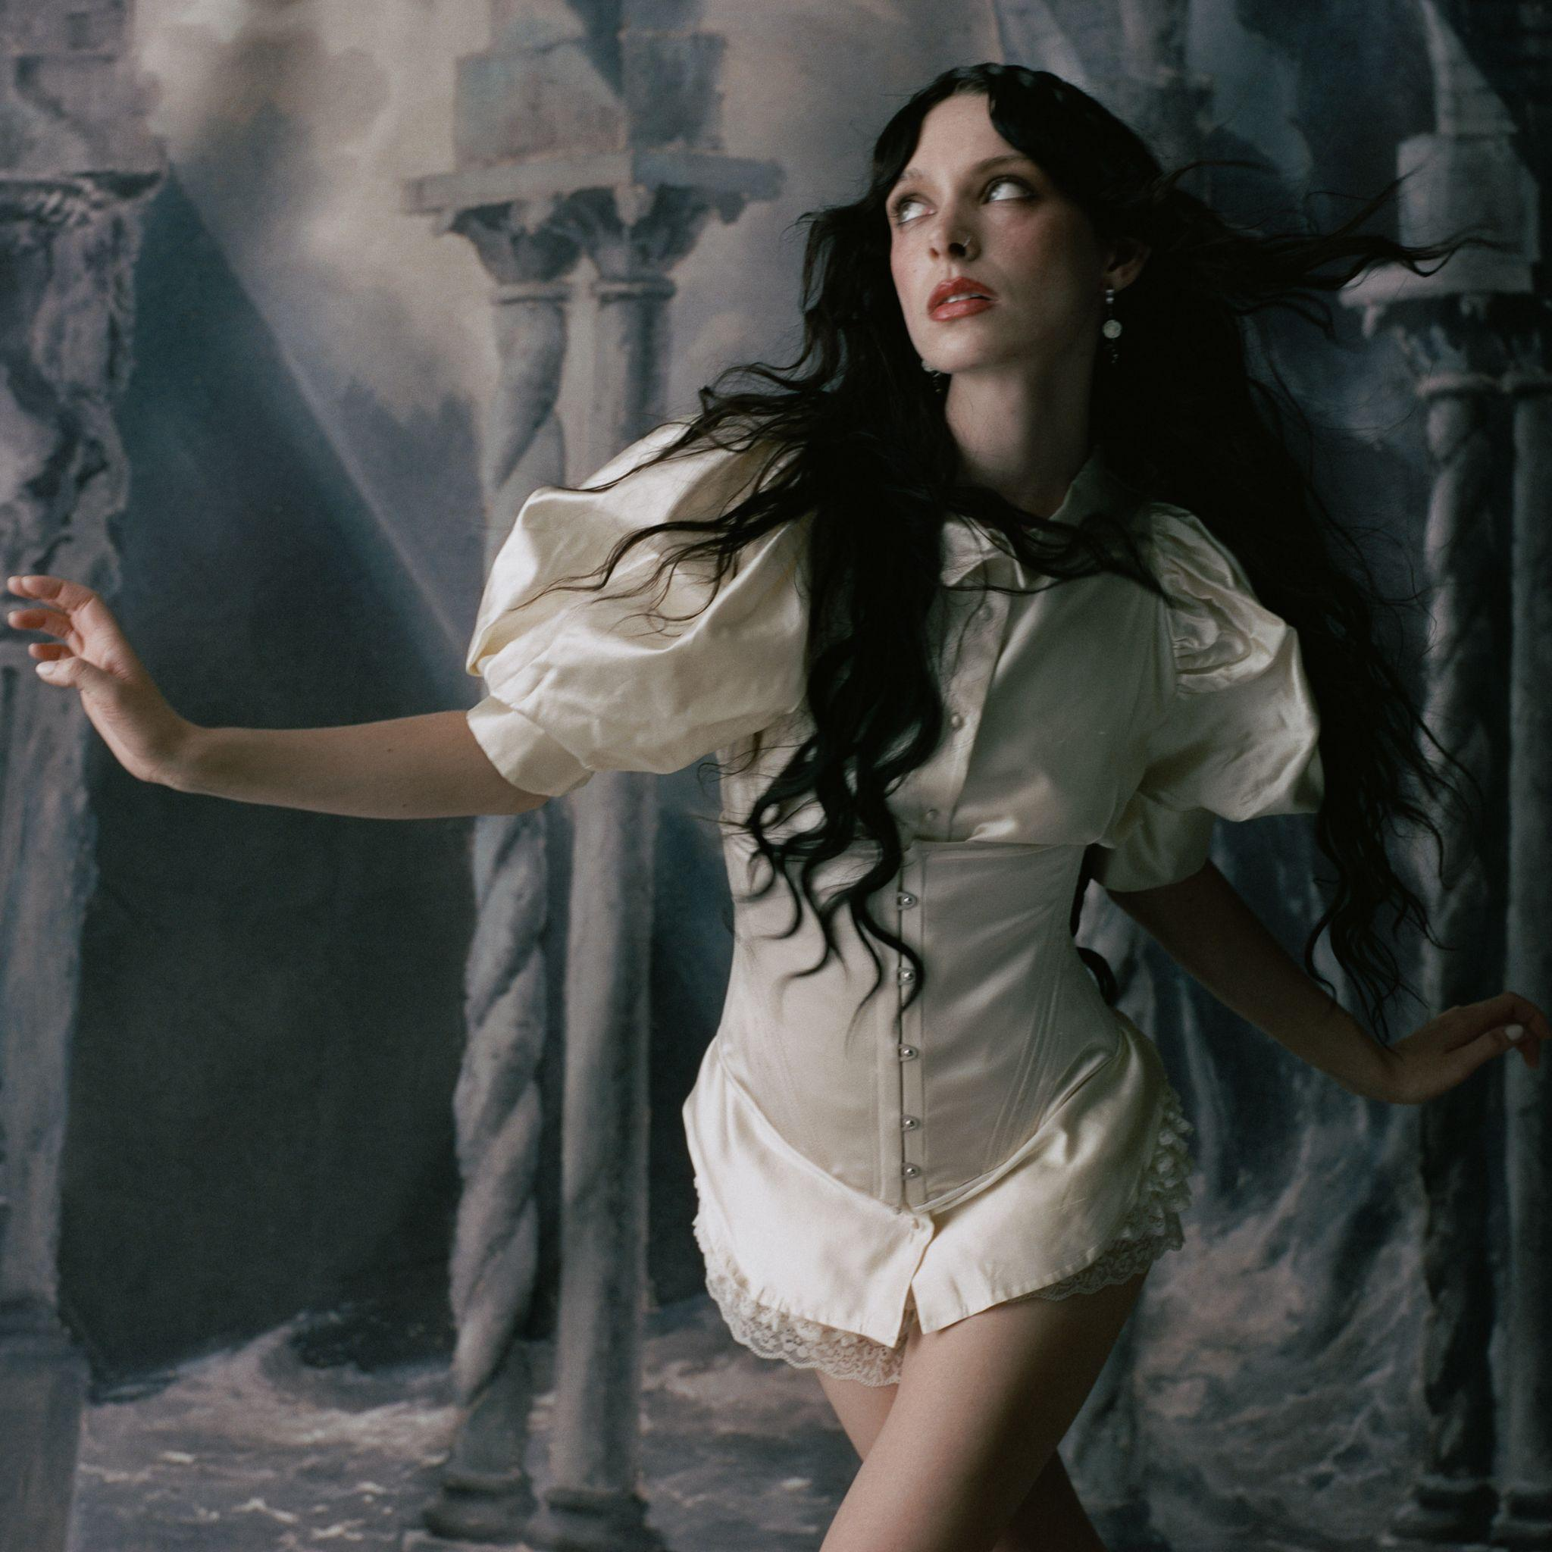

Follow Holly Humberstone:
YouTube/ Instagram / Twitter / Facebook / Spotify /
Apple/ / TikTok

For more information and press enquiries please contact

Jenny Entwistle
Jenny@chuffmedia.com

