HOLLY HUMBERSTONE

RELEASES NEW SINGLE AND ALBUM TITLE TRACK
“CRUEL WORLD”

WATCH THE OFFICIAL VIDEO, OUT 3PM GMT
DIRECTED BY SILKEN WEINBERG

HIGHLY ANTICIPATED SECOND ALBUM CRUEL WORLD
TO BE RELEASED ON 10 APRIL 2026

SOLD OUT OUT-STORES UK TOUR AND SHEPHERDS BUSH EMPIRE HEADLINE ON 2 APRIL 2026

SET TO PLAY MAD COOL, GOVERNORS BALL, COACHELLA AND MORE

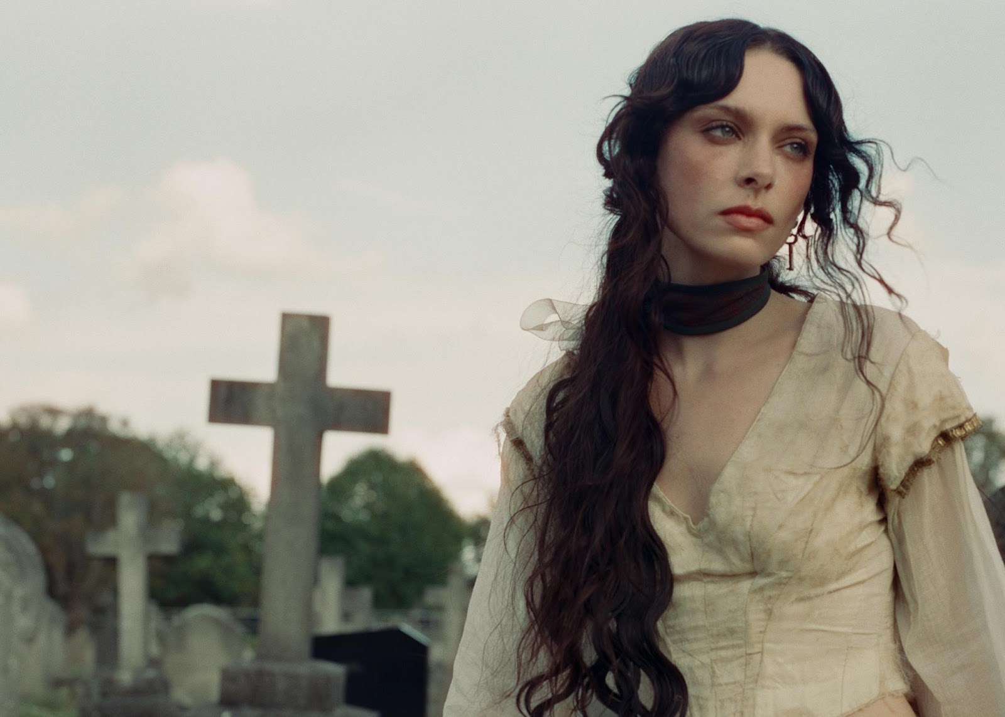

Download image and artwork - credit Silken Weinberg

““Cruel World” comes from the euphoria and pain of long-distance. Your perception of the world around you can be completely distorted without that one person in it. There’s no fun in going out solo when the only place you want to be is wherever they are. Loving someone that much is always going to hurt a little. This is the dichotomy of pain and pleasure. Love is so painful at its core and this is the throughline of my record. This is my favourite song I’ve ever written!” - Holly Humberstone

Today, Holly Humberstone shares the title track from her highly anticipated second album Cruel World, to be released on 10 April 2026. The song captures the emotional centre of the record, the dichotomy between pain and pleasure, and addresses the euphoria and pain of long-distance love. Directed by Silken Weinberg (Ethel Cain), the video takes place on a Victorian theatre set, following Holly as she quietly attempts to sabotage the unfolding production. The release follows a huge start to 2026 for Holly, who has just completed her European headline tour, performed recent single “To Love Somebody” on The Tonight Show Starring Jimmy Fallon, and attended both London and Paris Fashion Week as her creative world continues to expand beyond music.
WATCH CRUEL WORLD
LISTEN TO CRUEL WORLD
Renowned for her forensic songwriting ability — nominated for an Ivor Novello for her debut EP and winning the BRIT Rising Star in 2022 — Holly has grown into a global force, whose lucid storytelling resonates far beyond her own walls. Entering Cruel World, Holly escapes into a dark fairytale world of her own making, where childhood relics, monsters and memory collide. Last month, Holly released “To Love Somebody”, accompanied by an enchanting video directed again by creative director Silken Weinberg (Ethel Cain). Inspired by Victorian theatre, Brothers Grimm and Nosferatu, “To Love Somebody” is a visceral opening statement for the 26-year-old. Love now, for Holly, is both grounding and destabilising. “The record explores love as beautiful and inherently painful,” she says. Gothic-leaning songs like BBC Radio 1 Hottest Record “Die Happy” also explore devotion, danger and desire.
The past two have been defined by repair, belonging, and rediscovering talismans to her past, moments that were forgotten when Holly was catapulted into the public sphere at just 20-years-old. Where her top 3 debut album Paint My Bedroom Black was marked by turbulence and longing, Cruel World is anchored in stability and recollection. Visually, Holly has built a world with her sister Eleri and creative director Silken Weinberg, inspired by childhood trinkets unearthed while leaving the Haunted House she grew up in. From ballet shoes, to Alice in Wonderland books, and films like Edward Scissorhands and James and the Giant Peach, sifting through her girlhood belongings reframed the ghosts of her past into something playful and magical.
WATCH AND LISTEN “TO LOVE SOMEBODY”
PRE-ORDER CRUEL WORLD
Holly Humberstone’s Cruel World era is unfolding on stages around the world, following a sold-out European headline run and a series of UK out-store shows and underplays this month. With headline dates across the UK and USA already selling out — including London’s O2 Shepherd’s Bush Empire on 2 April — Holly’s momentum continues internationally with major festival appearances at Coachella, Governors Ball, Mad Cool and more this summer. Over the past few years, Holly has already sold out Brixton Academy and Eventim Apollo, to headline tours in North America, as well as supporting Taylor Swift at Wembley and joining Sam Fender on his Australian tour last year.
Holly’s story began with Falling Asleep At The Wheel, the breakthrough EP that revealed a young woman translating her haunted childhood home and three-sister household into vivid, unforgettable songs like “Vanilla,” “Overkill” and “Deep End.” The intimacy and precision of her lyrics marked her as a diarist of the small details that make up big emotions. That voice quickly carried her from her gothic family home to the international stage: performing “London Is Lonely” live to millions at the BRIT Awards in 2022, supporting Olivia Rodrigo and Girl in Red across North America, and releasing her acclaimed debut album Paint My Bedroom Black in 2023, written partly in hotel rooms while living the dream she had imagined as a girl.
Cruel World was written with a new discipline through daily studio sessions with collaborator Rob Milton and draws deeply on love - romantic, platonic, and feminine. Raised among strong women, Holly speaks to the way girls are taught to see one another as competition, unlearning that instinct and reclaiming solidarity as survival.
LISTEN TO DIE HAPPY
ALBUM ARTWORK
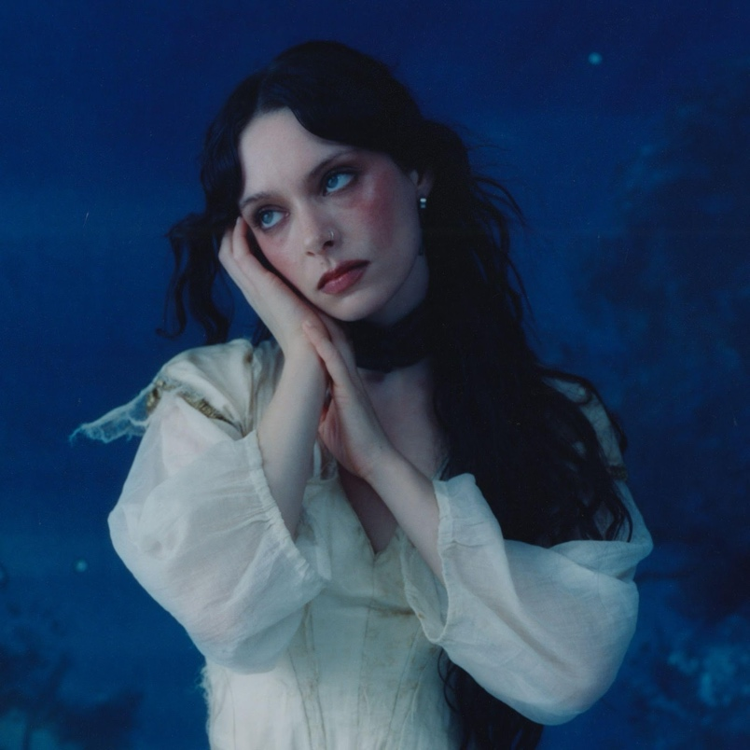
TOUR DATES
20 March – Liverpool, Rough Trade SOLD OUT (IN-STORE)
21 March – Nottingham, The Level (OUTSTORE)
22 March – Oxford, O2 Academy 1 (OUTSTORE)
24 March – Birmingham, O2 Academy 2 (OUTSTORE)
25 March – Brighton, Chalk (OUTSTORE)
26 March – Kingston, Circuit SOLD OUT (OUTSTORE)
29 March – Glasgow, Old Fruitmarket SOLD OUT
30 March – Manchester, New Century Hall SOLD OUT
01April – Bristol, Electric SOLD OUT
02 April – London, O2 Shepherds Bush Empire SOLD OUT

Follow Holly Humberstone:
YouTube/ Instagram / Twitter / Facebook / Spotify /
Apple/ / TikTok

For more information and press enquiries please contact

Jenny Entwistle
Jenny@chuffmedia.com

