**BILLIE MARTEN**

**SHARES NEW SINGLE**

[**“CROWN”**](https://billiemarten.lnk.to/crownPR)

**OUT NOW ON FICTION**

**FOLLOWING A SOLD-OUT HEADLINE SHOW AT THE BARBICAN CENTRE WITH HER ENSEMBLE**

**SUPPORTING BEN HOWARD ON HIS UK TOUR**

**WITH THREE SHOWS AT EVENTIM APOLLO ON 22 OCT 23 OCT & 3 NOV**

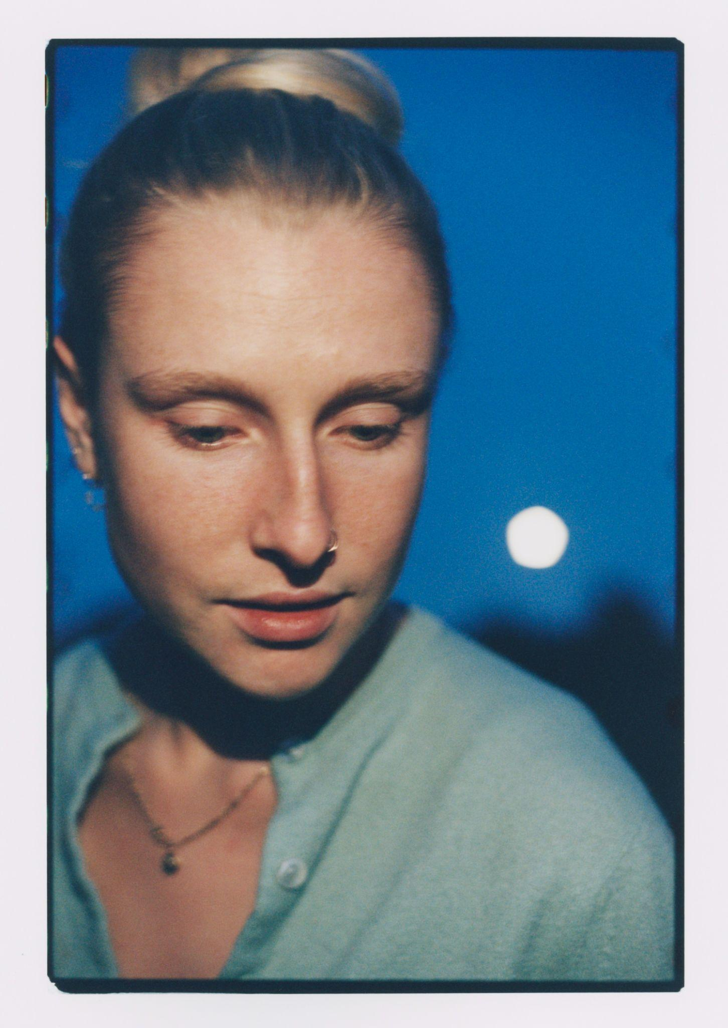

*Photo credit: Katie Silvester*

*“A sublime talent”*  - **Rolling Stone UK**

Last week, [**Billie Marten**](https://www.billiemarten.com/) headlined a sold-out show at the Barbican Centre alongside free-form string group, [**Her Ensemble**](https://www.herensemble.org/), playing remarkable orchestral versions of songs from her four critically acclaimed albums. It was no mean feat for the British singer-songwriter, who has become known for thoughtful live moments and singular songwriting and storytelling.

Today, Billie shares a recorded version of fan favourite, “[Crown](https://billiemarten.lnk.to/crownPR)”. Billie says of “Crown”, *"I wrote this in my garden last summer while staring at my cat sitting peacefully in the shade. It’s a song of longing, of accepting who you are, a truthful interlude"*.

The song was recorded this summer with **Philip Weinrobe** (Adrianne Lenker, Cass McCombs, Tomberlin) in Brooklyn, NY. *“We made this song in what felt like an instant, elbow to elbow, circled up, delicately listening to each other breathe, and sing, and play. Honestly magical. I wish you could have been there. Thank god we recorded it,"* says Weinrobe. *“Immaculate players came together to make a completely live recording - the only overdubs on this were Núria Graham’s harmonies and Mauro Refosco (David Byrne) on his triangle,”* Billie continues.

Getting back to her happy place and finding “nerve” of the song, Billie travelled to NYC after playing the legendary **Newport Folk Festival**, and started work on her next record, which follows 2023’s critically acclaimed album, ***Drop Cherries***.

[**LISTEN TO CROWN**](https://billiemarten.lnk.to/crownPR)

*“It’s often the case that each record has to be a new ‘statement’ for the artist, a re-branding, a progression. But my statement is always the same - I’m simply searching for clarity,”* says Billie in her first-person biography for *Drop Cherries.* The record is a series of vignettes highlighting different pieces of a relationship, while trying to fit them together. Billie and director **Joe Wheatley**, alongside producer and engineer **Dom Monks**, executed an entirely live, one-take performance of four songs to create [*Drop Cherries*: The Film](https://youtu.be/BZoemhwOzEA?si=7sMtIE-G5B0WbYJU). *Drop Cherries* achieved the highest week one album sales of her releases to date, as well as getting an A-List single at BBC 6 Music; Billie was invited to perform at a BBC Radio 1 piano session and appearing on Fearne Cotton’s Happy Place podcast. It proved that Billie should trust her instincts entirely.

Originally from Yorkshire, Billie’s music is rooted in English folk tradition, nature and love. From her debut in 2016 *Writing of Blues and Yellows* to *Feeding Seahorses by Hand* in 2019*,* a great young songwriter emerged; with both sweetness and grit, humour and solemnity. The eerily beautiful “Vanilla Baby”, which now has over 32 million Spotify streams, showcases what fans have come to love from Billie Marten: clever portrayals of the messiness of womanhood and resilience in her lyricism: *“How can I be, vanilla baby?”*. On her 2021 critically adored album, *Flora Fauna,* Marten experimented with alt-rock production, creating a mature and immediate sound: “*Creature of mine, be good to m*e”, sings Billie, pictured covered in mud on the album artwork, co-created by longtime collaborator Katie Silvester

After selling over 5,000 tickets on the *Drop Cherries* world tour, Billie will join Ben Howard on his UK tour this month, performing three nights at the Eventim Apollo. *“I’ve at last learned to stop thinking about what others want to hear and finally started to trust my own instincts. I love music more than anything in this world, and I consider myself a music fan much more than an artist,”* says Billie.

**TOUR DATES**

**Supporting Ben Howard**

Sun 13th Oct - Usher Hall, Edinburgh

Mon 14th Oct - O2 Academy, Leeds

Tue 15th Oct - O2 City Hall, Newcastle

Thu 17th Oct - Brighton Centre, Brighton

Fri 18th Oct - Bournemouth International Centre, Bournemouth

Sat 19th Oct - Swansea Arena, Swansea

Mon 21st Oct - Manchester Warehouse - Aviva Studios, Manchester

Tue 22nd Oct - Eventim Apollo, London

Wed 23rd Oct - Eventim Apollo, London

Thu 31st Oct - The Civic Hall, Wolverhampton

Fri 1st Nov - Pavilions, Plymouth

Sun 3rd Nov - Eventim Apollo, London

Connect with Billie Marten

[Spotify](https://open.spotify.com/artist/02YLJJnWC7YQVixkjEBRn7?si=iKVNduJRQpS9ooycOTE16w) | [Apple Music](https://music.apple.com/us/artist/billie-marten/879538438) | [YouTube](https://www.youtube.com/channel/UC7B-nApg76kClvW-YBYezQQ) | [Instagram](https://www.instagram.com/billiemarten/) | [TikTok](https://www.tiktok.com/@billiemartenofficial) | [Facebook](https://www.facebook.com/billiemarten) | [X](https://x.com/BillieMarten) | [Website](https://www.billiemarten.com/) | [Soundcloud](https://soundcloud.com/billie-marten)

**For more information and press enquiries please contact**

**Jenny Entwistle**

[**Jenny@chuffmedia.com**](mailto:Jenny@chuffmedia.com)