ONLY THE POETS SHARE ROUSING
NEW SINGLE & VIDEO FOR ‘CRASH’ - LISTEN/WATCH HERE
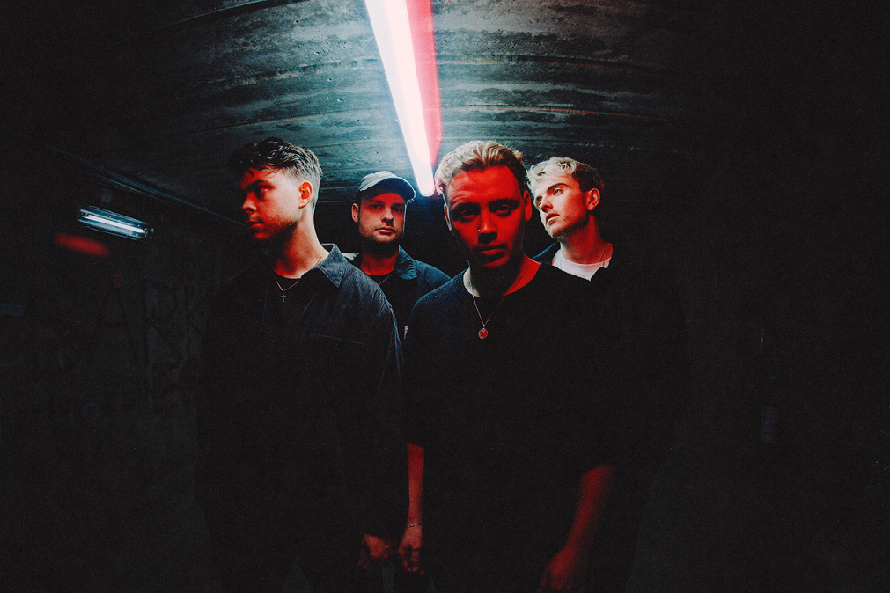
“Their respect and appreciation for their fans feels genuine, and it’s never more apparent than when they share the room together” – CLASH
“It was banger after banger…You'll be itching to see their next show” – GIGWISE
Today, indie-pop upstarts Only The Poets share sleek new single ‘Crash’. Fusing propulsive drums and driving guitar with an undercurrent of synth-pop elements, Only The Poets’ stadium-sized ambition steps into the spotlight. Co-written with Olly Burden (The Prodigy) and Tylr Rydr (Ashnikko, Girli, Cassyette) and produced by King Ed (Baby Queen, Years & Years), ‘Crash’ fully caters for Only The Poets’ frenzied live fanbase, ticking off air-punch inducing choruses and rousing melodies from the crowd-pleasing checklist. LISTEN HERE
Tommy says, “Crash is all about battling with your own emotions. The times when you feel everything is going great in your life, but somehow you latch onto the negatives, like it’s too good to be true. We wanted the track to have elements of calm and chaos to reflect the concept. King Ed brought the song’s conception and meaning to life during the production process; he allowed us to encapsulate our vision of those moments of calm through sparse and electronic-inspired verses, before being plunged into short bursts of band-focussed chaos through the song’s most energetic moments. Dan Grech finished the process by bringing punch and clarity with his amazing mix.”
The Reading four-piece, comprising Tommy Longhurst, bassist Andy “Roo” Burge, guitarist Clem Cherry and drummer Marcus Yates, have established themselves in just a few short years as one of the UK’s biggest emerging live acts. Unsigned until recently, the band’s DIY ethos saw them build things from the ground up, from playing student house parties, pub circuits and small venues to selling out 1,600-capacity venues in the UK and across Europe last year.
Their recent single Jump, a rousing call to arms set to widescreen, galloping riffs, blends sparkling indie-pop and the everyman swagger of Bruce Springsteen and Sam Fender, while fan-favourite track Even Hell is a celebration of the transformative power of music full of chiming guitars, impassioned vocals and irresistible harmonies, transporting you right into the thick of a festival crowd.
Hot on the heels of a massive run on the continent in support of Lewis Capaldi earlier in 2023, Only The Poets have just wrapped their spring European tour, taking in cities such as Vienna, Warsaw, Prague, Berlin and Amsterdam and culminating in a triumphant sold-out slot at Shepherd’s Bush Empire. They will also support indie-pop stalwarts Bastille at their Dreamland show in Margate on the 1st July, as well as being confirmed for a BBC Introducing stage this summer. See the full list of their live dates below.
Bridging the gap between artist and fan as a priority, the band offered reduced ticket prices for fans who financially struggle to attend their shows, as well as organising an intimate set at Camden Assembly for their most dedicated fans the night before their headline Shepherd’s Bush show last month. With a hugely successful tour under their belt and another live favourite track to add to their arsenal, Only The Poets’ exciting reputation is building unstoppable momentum as we head into festival season 2023 and beyond.
Catch Only The Poets live this summer:
18th June: - PINKPOP Festival - Landgraaf, Netherlands
1st July: – Bastille support - Dreamland Margate
9th July: – TRNSMT Festival – Glasgow, Scotland
15th July: – FIB Benicassim Festival - Benicassim
12th August: – FEST Festival – Chorzow, Poland
22nd July: – Lollapalouza – Paris, France
8th September: Lewis Capaldi Support – Barcelona, Spain
10th September: Lollapalooza – Berlin, Germany
11th September: Headline Show – Netherlands
12th September: Lewis Capaldi Support – Munich, Germany
13th September: Lewis Capaldi Support – Stuttgart, Germany

DON’T MISS A THING: OTP // INSTA // TWITTER // FB
For more information and press enquiries please contact
Jenny Entwistle
Jenny@chuffmedia.com

