
SPORTS TEAM RELEASE NEW SINGLE ‘CONDENSATION’
SECOND TRACK TO BE REVEALED FROM THIRD ALBUM
‘BOYS THESE DAYS’
SET FOR RELEASE MAY 23RD 2025
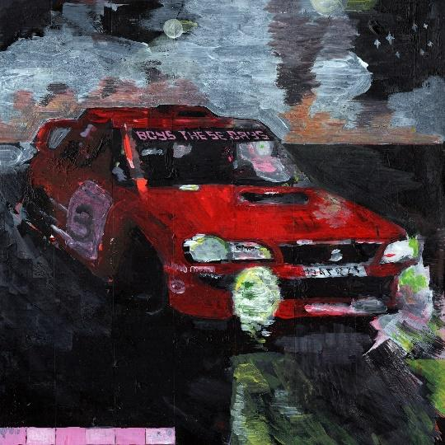
Download ‘Boys These Days’ Artwork
“Like a scratchcard summer, everyone’s a winner, everyone’s a winner and the pleasure’s all mine… It’s a cold snap coming… I q-q-q-quiver… so crush me like a cigarette Pressed into a plastic ash tray”

SPORTS TEAM today (September 13th) release new single ‘Condensation’. Displaying classic Sports Team at their confident best, it is the second track to be revealed from the Mercury-nominated six-piece’s hotly anticipated third album 'Boys These Days' which is set for release May 23rd via Distiller Records and Bright Antenna. Riding hot on the heels of shimmering comeback single ‘I’m In Love (Subaru)’, ‘Condensation’ propels SPORTS TEAM into rock’n’roll’s fast lane with its swaggering riffs and undeniable hip-moving powers.

Condensation’ is destined to be a live favourite with Sports Team’s fervent audience. Talking about the new single, lyricist Rob Knaggs says, ‘It’s a song about sweat. We had two years away from playing live and wanted to capture the physicality of being in a packed room with people you love. At a gig or anywhere else.’

The song is released alongside a brilliant video which was written and directed by Rob Knaggs and Ben Mack of Sports Team, which Knaggs describes simply, “It’s a video about sweat.”

SPORTS TEAM marked their return in July with the release of “I’m In Love (Subaru)”, revealing a dramatic shift in gears in their songwriting. Carpooling with the likes of Prefab Sprout, Trust-era Elvis Costello, city-pop icon Mariya Takeuchi and Bryan Ferry, it showcases the band at their brightest and most beguiling yet.
Its release came alongside news of forthcoming new album ‘Boys These Days’ which boasts some of the Sports Team's most dynamic musical performances to date and features hand painted artwork by Rob Knaggs. While its Top 3 predecessors, Deep Down Happy (No.2 in 2020) and Gulp! (No.3 in 2022), were recorded between bouts of intensive touring, the record not only follows the London-based band’s longest absence from a stage, and a switch of label (they signed to London-based Distiller at the end of 2023, who now represent them globally alongside Bright Antenna, the band's longstanding US label partner) but it was created via a series of near hermetically sealed sessions in Bergen, Norway with producer Matthias Tellez (Girl in Red, CMAT).

Following an exhilarating underplay show at London’s Omeara which sold out in less than 3 minutes, SPORTS TEAM will play of a 10-date nationwide UK tour this autumn, kicking off in Manchester on November 14th and culminating in a show at London’s O2 Forum on November 24th.

Tour dates are:

14th November – Manchester, New Century
15th November – Birmingham, The Castle & Falcon
16th November - Liverpool, Arts Club
18th November – Sheffield, Foundry
19th November - Glasgow, SWG3
20th November – Newcastle Upon Tyne, Boiler Shop
22nd November – Nottingham, Rescue Rooms
23rd November – Leeds, The Wardrobe
24th November – Bristol, The Trinity Centre
25th November – London, O2 Forum Kentish Town

‘Boys These Days’ is available to pre-order on CD, vinyl and cassette as well as a number of exclusive limited edition formats including a box set, a signed test pressing and picture disc vinyl.
Pre-save BOYS THESE DAYS ALBUM

Sports Team are Alex Rice (vocals), Robert Knaggs (lyrics, backing vocals, rhythm guitar), Henry Young (lead guitar, lap steel), Oli Dewdney (bass), Al Greenwood (drums) and Ben Mack (synths, piano & percussion).


DOWNLOAD PRESS PHOTO HERE (Photo Credit: Bartek Szmigulski)
CONNECT WITH SPORTS TEAM
Instagram | tiktok | facebook | X | youtube | website
For more info contact Warren warren@chuffmedia.com

