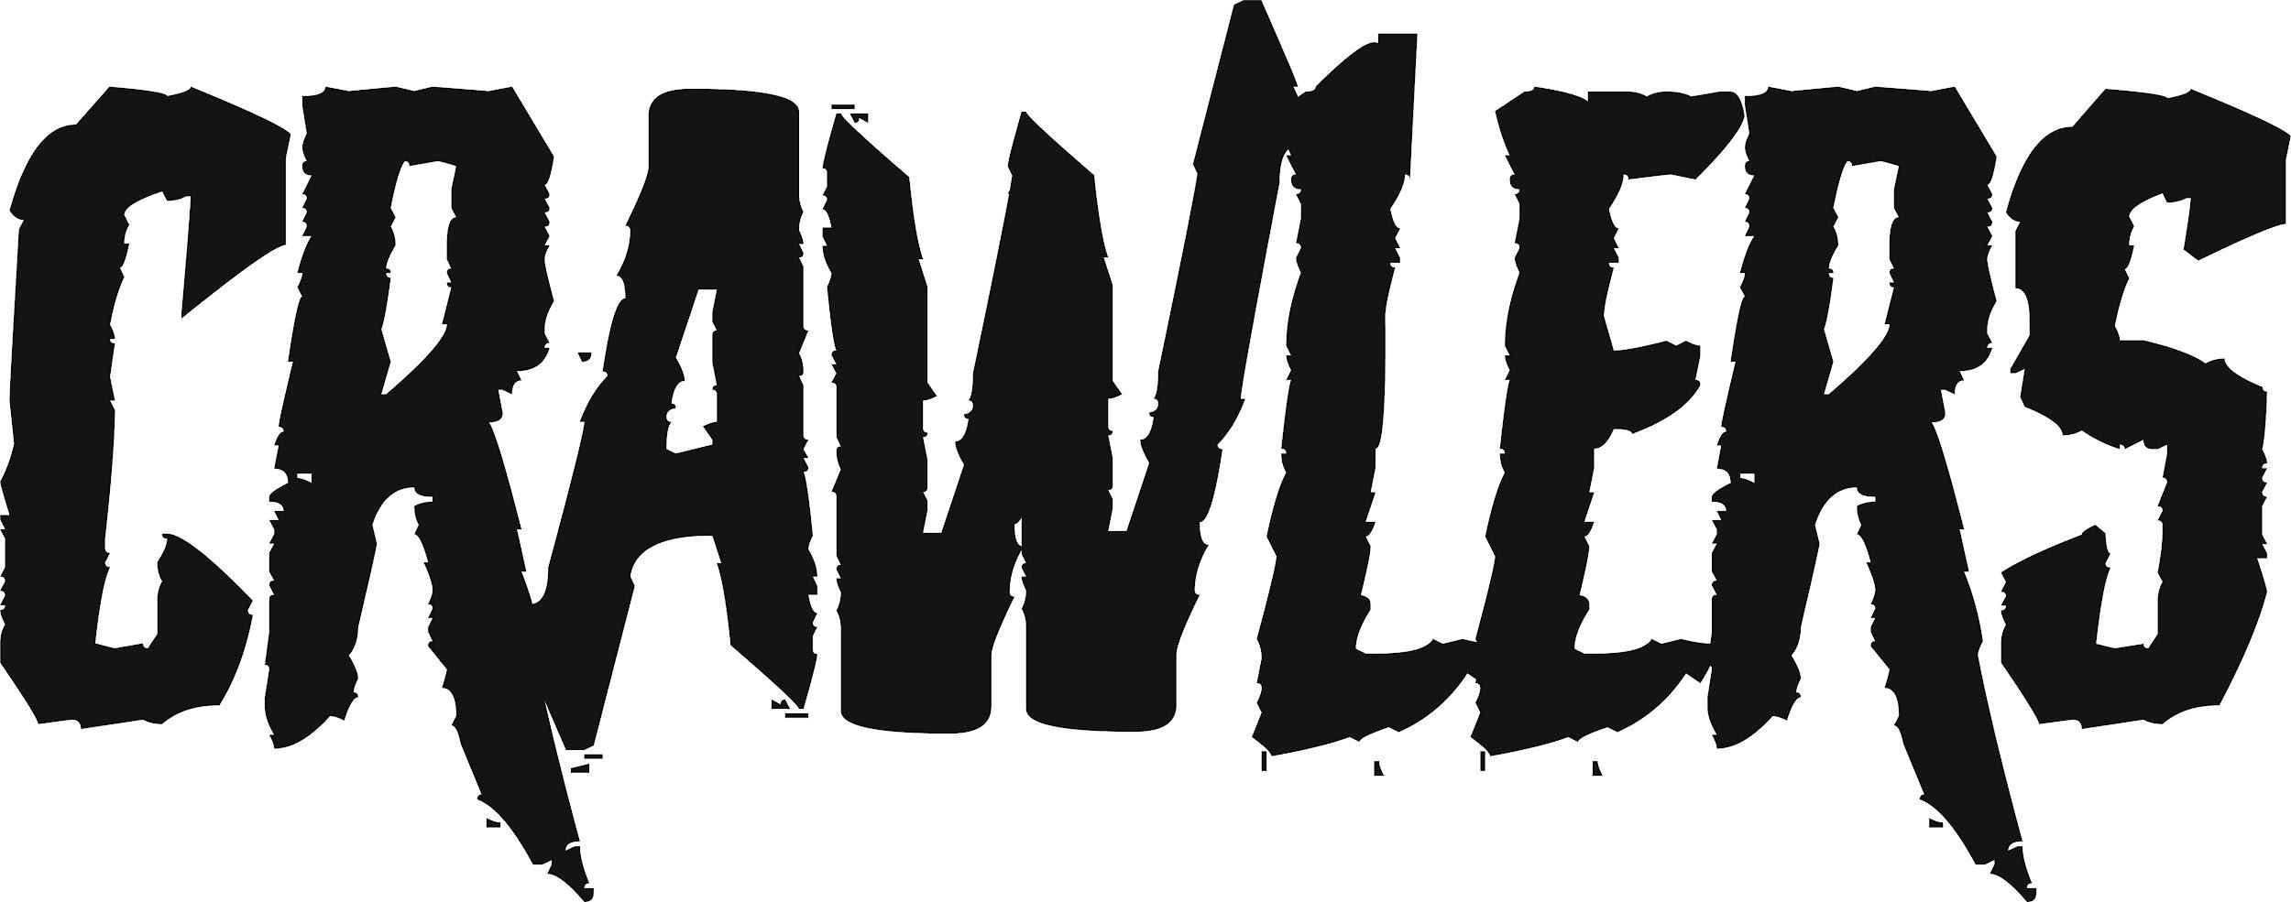
‘Come Over (Again)’
New Polydor signings enjoying success with hit single
Listen HERE
Watch HERE

Liverpool-based four-piece CRAWLERS, who recently signed to Polydor Records, are enjoying success with their hit single ‘Come Over (Again)’ which has already racked up over 15.5 million streams on Spotify and one million views on YouTube.
Over the last year, CRAWLERS have built a reputation as one of the hottest and most exciting new bands in the UK. The band have gained themselves an impressive loyal following, with a string of single releases leading into their debut EP - released through Modern Sky/Lab Records in October - clocking up over 30 million combined streams. The EP was produced by Pete Robertson and mixed by Tom Roach at Coastal Studios.
CRAWLERS debut tour in March/April has completely sold out, with the quartet playing to over 1,000 fans in their hometown alone.
The UK & Ireland dates are:
Mar 24th Liverpool Arts Club
Mar 25th Liverpool Arts Club
Apr 1st Leeds Brudenell Social Club
Apr 2nd Glasgow Room 2
Apr 7th London Camden Assembly
Apr 8th London Camden Assembly
Apr 9th Manchester YES
Apr 10th Birmingham Hare & Hounds

Apr 15th Belfast Oh Ye Centre
Apr 16th Dublin The Academy 2

CRAWLERS are Holly Minto (vocals & trumpet), Amy Woodall (lead guitar), Liv Kettle (bass guitar) and Harry Breen (drums).

Connect with CRAWLERS:
INSTAGRAM
TWITTER
FACEBOOK

For more information and press enquiries please contact
Jenny Entwistle
Jenny@chuffmedia.com

