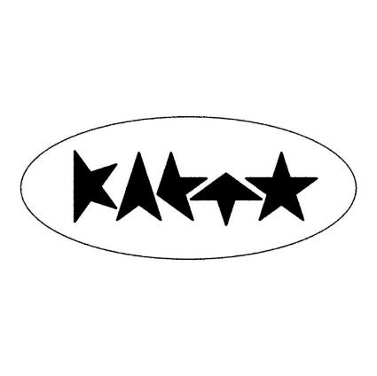
KAETO SHARES NEW SINGLE + VIDEO
‘CARRY YOU’
LISTEN / WATCH
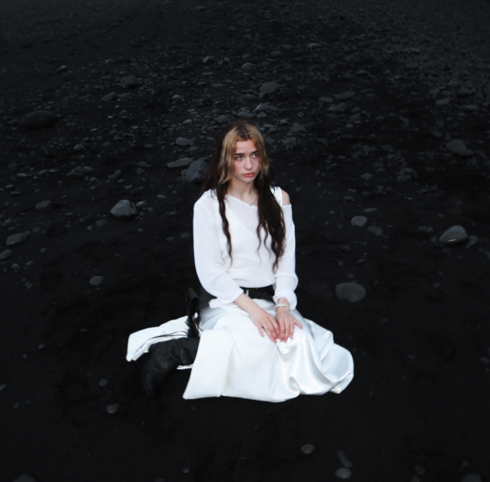
DOWNLOAD CARRY YOU ARTWORK
FROM FORTHCOMING DEBUT MIXTAPE ‘INTRO’
SET FOR RELEASE SEPTEMBER 20TH
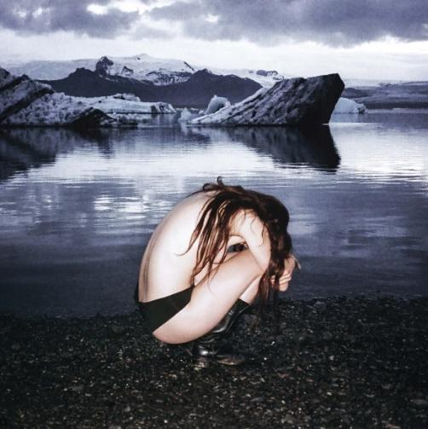
DOWNLOAD INTRO ARTWORK
PRE-ORDER INTRO HERE
Hotly tipped pop voyager KAETO today (Aug 9th) shares new single ‘CARRY YOU’ alongside a self-produced video shot in Iceland. The track is the latest taste to be offered from KAETO’s forthcoming debut mixtape INTRO, set for release on September 20th via Polydor Records, ahead of the London-based musician opening for The Last Dinner Party on their UK tour.
‘CARRY YOU’ is a captivating blend of early 90s grooves and trip-hop atmospherics, an exhilarating whirl of criss-crossing beats, yearning vocals and stirring melodicism from an artist on the cusp of a big breakthrough. It is one of 8 tracks that will feature on KAETO’s debut project ‘INTRO’ alongside her recent singles ‘U R MINE’ and ‘HERO’.
The mixtape was written and produced by KAETO and Mathias Wang (aka Junkmail). Many of the songs on INTRO were written while the pair were in Seville, which Kaeto describes as “such an inspiring place to work and one of my favourite places on earth.”
Speaking about ‘CARRY YOU’ Kaeto says, “This song is about the heaviness of loving a person and how much loving someone or something can feel like a grey contradiction; comforting and exhausting. There have been many different versions of the chorus lyrics of this song and I felt that this was because the feeling that I was trying to capture is one that I struggle to understand in my own life. Love is a confusing necessity and I love the way in which it creates impact and heaviness in my life. It feels very human. I often feel very moved and quite sad about time passing. It is something I reflect on a lot and so this song is an expression of that feeling”
‘CARRY YOU’ is accompanied by a video which, as with previous videos for U R MINE and HERO, Kaeto created with her group of friends. She elaborates, “Maisy, Reuben, Dan and myself shot this video in Iceland. One of the most incredible places I have been. We had brought a speaker but unfortunately it died so we had to be creative in order to have playback. The song is actually playing out of a secret phone belonging to Maisy hidden in my boot.” Watch it HERE
KAETO has been captivating audiences with her mesmerising live performances, opening as special guest for Haim, Lauren Mayberry, Eliza and Bleachers and will support The Last Dinner Party on their UK tour in October.
About KAETO
The emerging London-based artist is fast carving a space for herself with her unique genre-spanning sound that blends elements of trip-hop, dance and electronic music with punk, alt-pop and more.
KAETO first attracted attention with her startling debut ‘Good Morning’. After signing with Polydor last summer, she released ‘No Body’, which i-D declared “the most commanding artist statement we’ve heard all year”. CLASH remarked “word is already out on this pop voyager, a daring voice carving out her own niche”, while DIY described her as “absolutely melting with confidence and style”. Following it up with the hypnotic ‘Little Me’, THE FORTY-FIVE recently tipped KAETO for big things, saying “The London-based artist has crafted a sound that is distinctly her own”.
It was back in 2019 that Kaeto first entered the studio with outside producers and began building a sound that would be all her own, but the route she’s taken since is a mark of her maverick and inventive approach to music. One such diversion was enrolling in Clown School, a move designed to throw herself into something creative and spontaneous and shake off the mundanity of modern life. It's why Kaeto’s music has such a free-spirited, loose-limbed sense of adventure about it. “I’m so unashamed of myself,” she says, “but music is where I go to explore these things.”



DOWNLOAD PRESS PHOTO (credit: Maisy Banks)

FOLLOW KAETO
Instagram | Youtube |TikTok

For more on info contact warren@chuffmedia.com

