5 SECONDS OF SUMMER’S

CALUM HOOD

SHARES NEW SOLO SINGLE ‘CALL ME WHEN YOU KNOW BETTER’

TAKEN FROM LONG-AWAITED DEBUT SOLO ALBUM
ORDER chaos ORDER

DUE FOR RELEASE ON JUNE 13TH


Download hi-res press images HERE
Credit: Sarah Eiseman

Acclaimed musician Calum Hood continues his solo era today, with the release of new single ‘Call Me When You Know Better’ alongside the official video. The single is taken from his recently announced debut solo album ORDER chaos ORDER set for release on June 13th via Island EMI.

ORDER chaos ORDER, is available to pre-order here. ‘Call Me When You Know Better’ is out now and available here. The accompanying video is out now and available here.

‘Call Me When You Know Better’ acted not only as the sonic breakthrough when making the album, welding digital and organic sounds together to create the sonic skeleton of what would become

ORDER chaos ORDER, but also became a representation of the erratic noise in Calum’s mind, the chaos of contradicting thoughts, reflections, regrets, self pity and beyond. The single follows ‘Don’t Forget You Love Me’, which was released in March alongside the announcement of the album, serving as the album’s emotional cornerstone and introducing listeners to the raw honesty and sonic depth that define it.

On the single, Calum says, “‘Call Me When You Know Better’ is a love letter in the form of an apology. For maybe not being the best lover or friend to the people who mean the most to me. Thoughts contradicting one another, talking over each other and stretching reality. It’s a reflection on mistakes made, perpetual regret and self pity.”

Having spent the past 14 years touring the world and releasing music as one fourth of global phenomenon 5 Seconds of Summer, the dazzling and brooding ORDER chaos ORDER sees Hood strike out alone for the first time, and emerge not just as a solo musician, but as the introspective storyteller he was always meant to be. The result of a deeply personal creative journey, the album captures the strength it takes to look inward and to move forward through pain.

Crafted primarily alongside Jackson Phillips, aka Day Wave, with key contributions from David Burris (Lauren Spencer Smith, ITZY) and TMS (Lewis Capaldi, Ed Sheeran), ORDER chaos ORDER is heady, raw, tender indie that is unflinchingly sincere, buoyed by hints of a coiled intensity within - a record that showcases the 29-year-old musician’s mastery of nuance and emotional depth, with melodies that reveal new layers with each listen, deepening further with every play and often leading to moments of quiet revelation.

While ORDER chaos ORDER marks a new beginning, it is also a reckoning with Hood’s past. Calum says: "There are things I’ve never been able to sing about in the band—my upbringing, my family, the places life has taken me. This album is about laying those things to rest and allowing listeners to connect in their own way."

ORDER chaos ORDER will be released on June 13th and is available to pre-order here. ‘Call Me When You Know Better’ is out now and available here.

ORDER chaos ORDER tracklist
- Don’t Forget You Love Me
- Call Me When You Know Better
- Sweetdreams
- I Wanted To Stay
- Sunsetter
- All My Affection
- Endless Ways
- Streetwise
- Dark Circles
- Three Of Swords

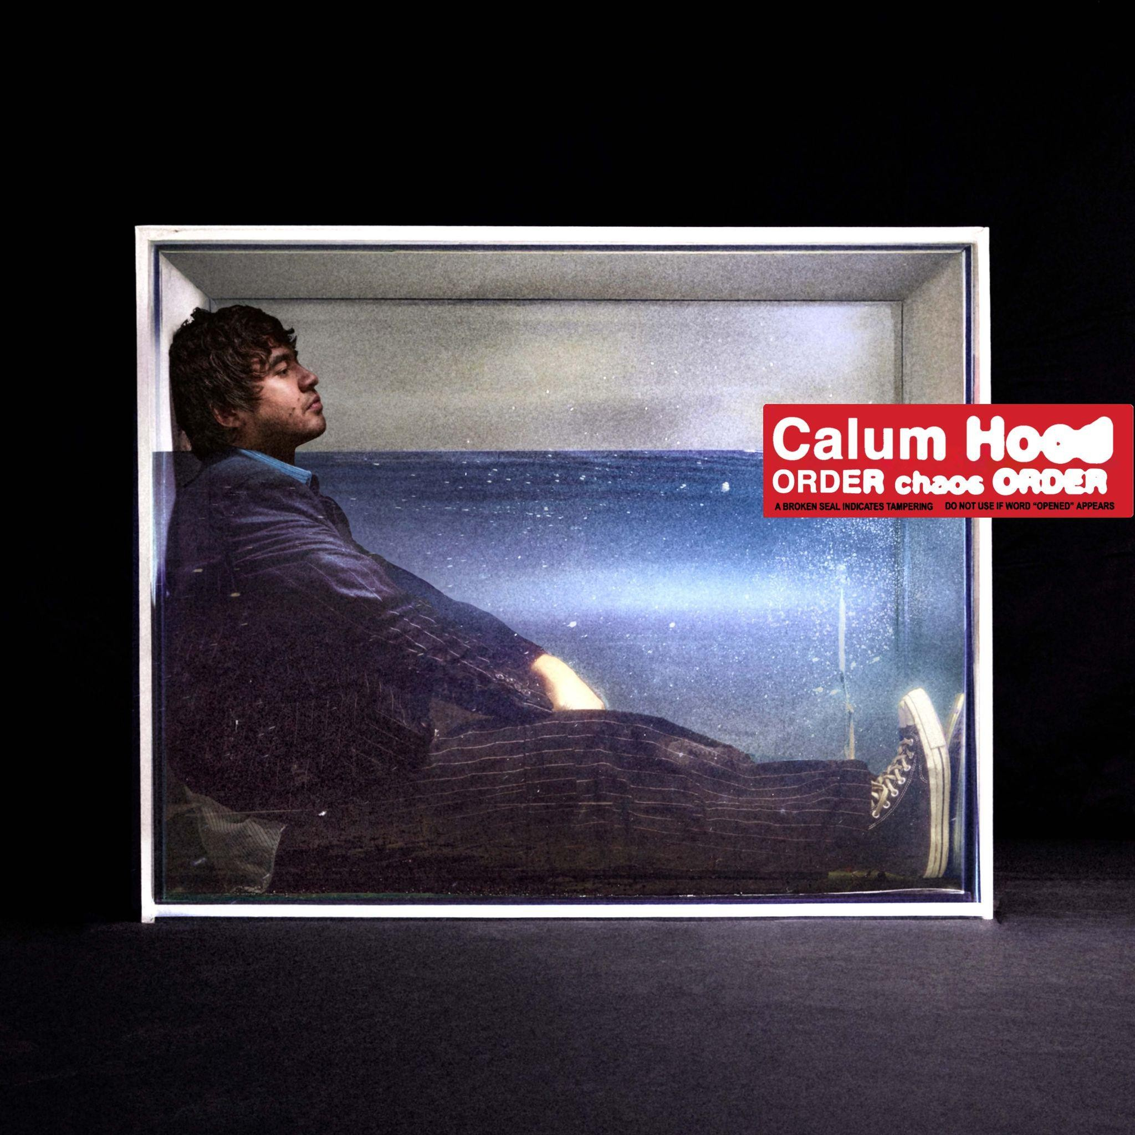
Download album assets HERE

Connect with Calum Hood
Instagram / X / TikTok

For more information, please contact

Jenny Entwistle
jenny@chuffmedia.com

