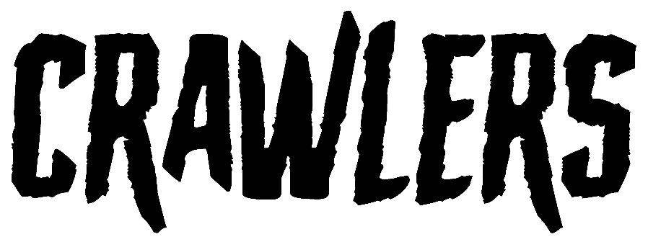
CHASE THE THRILL OF ROMANCE ON NEW SINGLE
‘CALL IT LOVE’
TAKEN FROM CRAWLERS’ EAGERLY AWAITED DEBUT ALBUM
‘THE MESS WE SEEM TO MAKE’
SET FOR RELEASE FEB 16th 2024
LISTEN HERE

CRAWLERS today share their new single ‘Call It Love’ via Polydor Records. As they continue to grow their reputation as one of the most exhilarating bands to come out of Liverpool in recent years, this new single perfectly showcases their 90’s grunge sound with a contemporary edge.
“Call It Love romanticises the desire to love someone despite it being a toxic situation. You call a relationship love because you feel like that’s what you deserve, but that doesn’t mean that that’s what it actually is” says lead singer Holly Minto of the track.
‘Call It Love’ offers another taste of what to expect from the hotly tipped quartet’s debut album ‘The Mess We Seem To Make’ which was recently announced for release on February 16th 2024. It follows CRAWLERS electrifying last single ‘Would You Come To My Funeral’ which launched as Radio 1’s ‘Hottest Record in the World’ in September.
Speaking about ‘The Mess We Seem To Make’, singer Holly Minto says, “This album debut comes from us honing our craft, being vulnerable with each other, finding our sound and saying exactly what we wanted to. I think that's a lot of what the Crawlers sound is, being honest with each other about how to get the correct emotions out - trying, failing, and pushing each other to keep playing and writing to the limits.”
True to their word ‘The Mess You Seem To Make’ takes on a whole range of challenging topics; trauma, sexual politics, mental health, the general goings on in a young person’s life. Across the record, feelings of loneliness, insecurity and toxic forms of dependence are held up to the light and examined in close context.
It digs deeper into what fans already know and love about Crawlers’ eclectic alt-rock sound and builds on the relationship of trust they have with producer Pete Robertson and engineer Tom Roach at Liverpool’s Coastal Studios, crafting anthemic rock songs where each member's playing personality can truly thrive. Rather than forcing themselves in any one sonic direction, they maintained the free-wheeling spirit of 2022’s mixtape ‘Loud Without Noise’, producing a striking debut which cements their status as the UK’s next big crossover alternative act.
‘The Mess We Seem To Make’ features 12 tracks and will be available on various formats including Deluxe CD, white vinyl, blue splatter vinyl and silver glitter cassette.
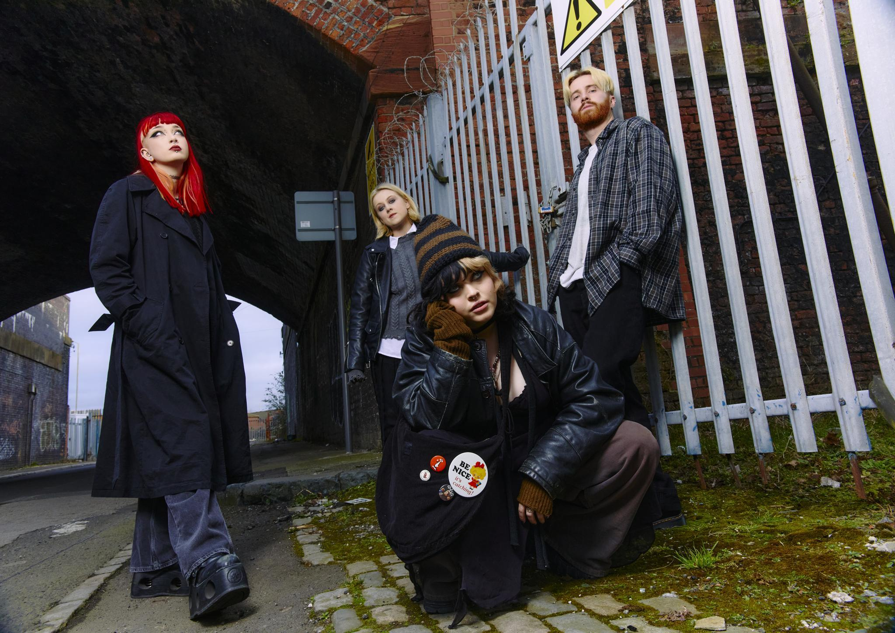
Credit: Claryn Chong
ABOUT CRAWLERS
To become a great rock band, you often need to begin with a certain alchemy. There needs to be talent, determination, a solid friendship which can withstand the rigours of creative difference or public critique. But you also need a sizable dose of ambition, the kind of unapologetic belief that your voice is one which needs to be heard. Such was already the case for Crawlers way back in 2018, where Amy Woodall, Liv May and Holly Minto were at uni together in Liverpool. Having formed in 2018, the band spent their first few formative years gigging around the Liverpool scene. Amy, Holly and Liv were already polishing their grunge-rock sound when they recruited drummer Harry Breen. Newly solidified as a four, their formidable live reputation has already encouraged the kind of organic fanbase that will help them become the UK’s next big crossover alternative act. Over the years, each new release has sealed CRAWLERS reputation as one of the UK’s most exciting young bands, with last years’ debut mixtape “Loud Without Noise” cementing their global status through helping them to achieve a huge 80+million streams to date.
CRAWLERS are Holly Minto (she/they), Amy Woodall (she/her), Liv May (she/they) and Harry Breen (he/him).
Connect with CRAWLERS
INSTAGRAM | TWITTER | FACEBOOK

For more information and press enquiries please contact

Jenny Entwistle
Jenny@chuffmedia.com

