BIG SPECIAL share new track 'BUTCHER'S BIN'

Biggest UK headline show to date at London's The Forum on sale now

Touring in South America with Placebo through March

Debut album POSTINDUSTRIAL HOMETOWN BLUES out 10th May via SO Recordings

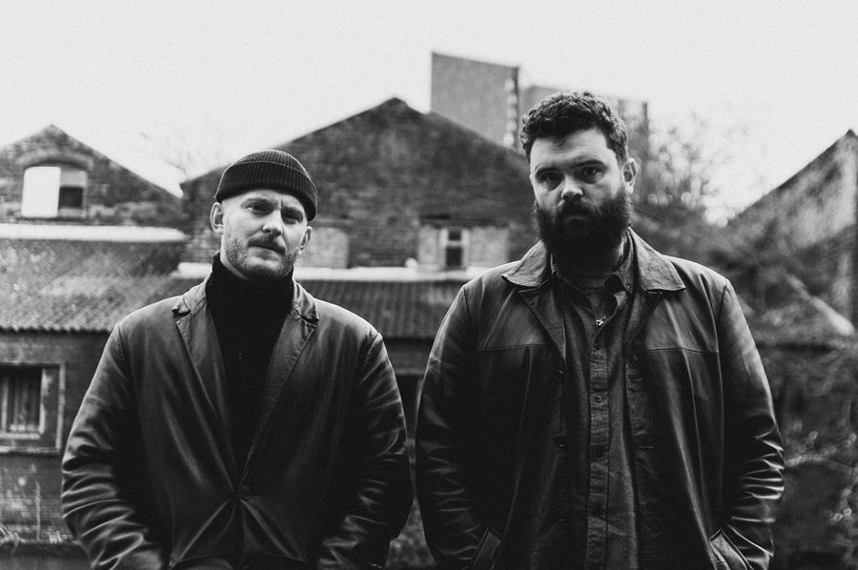
BIG SPECIAL | Photo credit: Isaac Watson | Download image here

BIG SPECIAL are today sharing new track 'BUTCHER'S BIN'. Built on top of buzzing synths, it follows lead single 'DUST OFF / START AGAIN' which currently sits on the BBC 6 Music playlist.

Taken from their highly-anticipated debut album POSTINDUSTRIAL HOMETOWN BLUES which is set for release on 10th May via SO Recordings, 'BUTCHER'S BIN' arrives with news of the band's biggest London headline show to date at The Forum in November, as well as a tour in support of Placebo through South America in March.
Lead singer Joe Hicklin had the following to say about new song 'BUTCHER'S BIN':

"BUTCHER'S BIN is about class awareness and the realisation that the working classes are used as nothing but a commodity and set against each other at every turn, their existence trivialised and struggles denied; the off cuts tossed to feed the rabid hounds of neoliberalism. The song is about all of this from the perspective of declining mental health whilst trying to make a living as an artist and to break through in a time and place where a life In art is seen as a luxury granted to those of a higher social class or a fruitless pursuit for idealistic fools."

Continuing about the album he says:

“POSTINDUSTRIAL HOMETOWN BLUES is an album about depression. It's about the different shapes it takes; personal, social, generational... and it's about coming face to face with those ghosts and what we do or how we feel when that happens. The album offers no answers, it is just an honest expression of a working-class experience in modern England through the eyes of ill mental health, a pursuit of art and political disenchantment; a story of rumination, realisation and reaction. POSTINDUSTRIAL HOMETOWN BLUES is about learning that we are connected by our common struggles and though dark and rageful, the album holds a quiet sentiment of love and hope. It's about laughing at the face of the void, recognising its oppressive weight, holding hands and moving forward.”

Pre-order debut album POSTINDUSTRIAL HOMETOWN BLUES here. Listen to ‘BUTCHER'S BIN' on streaming services here and watch the video below.

BIG SPECIAL 2024 UK TOUR DATES

Tickets on sale now here.

03 Apr - Clwb Ifor Bach, Cardiff, UK (DIY Now & Next tour)
04 Apr - Bullingdon, Oxford, UK (DIY Now & Next tour)
05 Apr - Yellow Arch Studio, Sheffield, UK (DIY Now & Next tour)
06 Apr - Green Door Store, Brighton, UK (DIY Now & Next tour)
07 Apr - Joiners, Southampton, UK (DIY Now & Next tour)
12 Apr – New Century Hall, Manchester, UK (supp. Antony Szmierek)
13 Apr – Lafayette, London, UK (supp. Antony Szmierek)
07 May – District, Liverpool, UK
08 May – The Key Club, Leeds, UK
09 May – XOYO, Birmingham, UK
10 May – King Tuts, Glasgow, UK
12 May – Strange Brew, Bristol, UK
16 May – Jazz Café, London, UK - SOLD OUT
17 May – Horatio’s, Brighton, UK (The Great Escape 2024)
18 May – Deaf Institute, Manchester, UK
20 May – Kasbah Club, Limerick, Ireland
21 May – Workman’s Cellar, Dublin, Ireland
22 May – Ulster Sports Bar, Belfast, Norther Ireland

26 May – Bearded Theory Festival, Derbyshire, UK
28 Jul – Latitude Festival, Suffolk, UK
15 - 18 Aug - Green Man Festival, Bannau Brycheiniog, UK
23 Aug – Reading Festival, Reading, UK
24 Aug – Leeds Festival, Leeds, UK
29 Aug - 01 Sep - End Of The Road Festival, Dorset, UK
30 Nov - O2 Forum, Kentish Town, London, UK

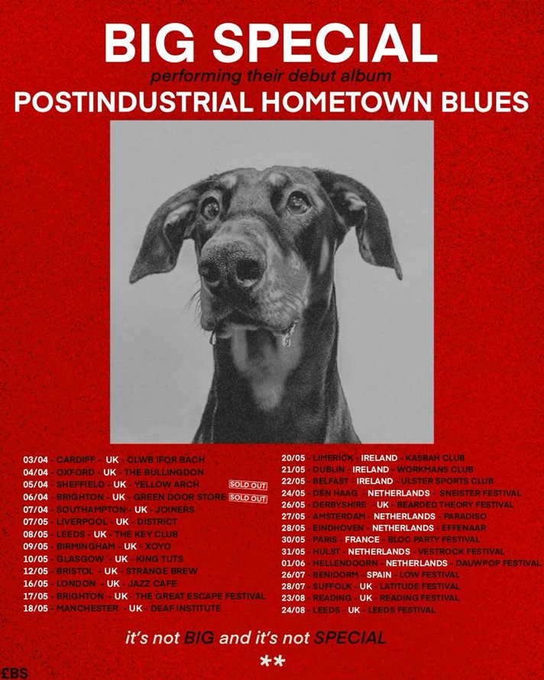

BIG SPECIAL - 2024 live poster | Download image here

More about BIG SPECIAL and debut album POSTINDUSTRIAL HOMETOWN BLUES

Words are not to be taken for granted. Especially when they’re being bellowed, full blast, by a broad-shouldered poet with the brimstone fire of a preacher and the honesty and wisdom of a layman, over ground-shaking live beats and between anthemic blasts of melody and rousing riffage.

Words matter. History matters. People matter. And BIG SPECIAL matter.

For BIG SPECIAL - Joe Hicklin (vocals) and Callum Moloney (drums) - their sound is one that comes from vital, frustrated young working-class voices that don’t always get heard on the scale they should do. It’s a frustration that comes to the fore through a voice that is at times coarse and raw, but sensitive, desperate and soulful at others. Hicklin's brimstone-fired voice marches from guttural punk barks and serrated spoken word to soaring soul and back again, arriving siphoned from their forebears, crushed under the weight of history, and retooled for a new generation. It’s wrought, raw and angry at a world lacking options, the thinning of the common understanding between the social classes of England, exasperation at repeating cycles, and the feeling that you’re watching your own life unfold from the outside.

These are songs that channel that voice you hear when you look in the mirror and see your true self – fight songs for a world gone wrong.

Download the band's latest biography here.

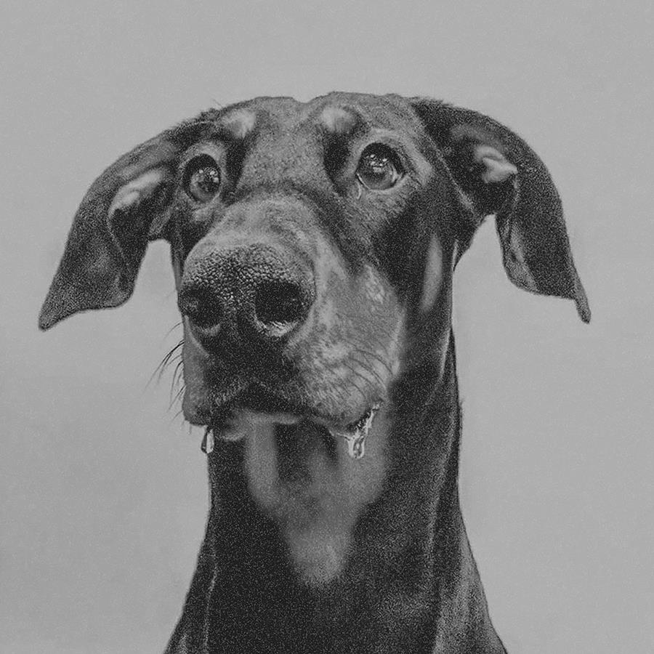

BIG SPECIAL - POSTINDUSTRIAL HOMETOWN BLUES album artwork |
Download image here

BIG SPECIAL - POSTINDUSTRIAL HOMETOWN BLUES tracklisting

1. BLACK COUNTRY GOTHIC
2. I MOCK JOGGERS
3. DESPERATE BREAKFAST
4. SHITHOUSE
5. THIS HERE AIN’T WATER
6. MY SHAPE (BLOCKING THE LIGHT)
7. BLACK DOG / WHITE HORSE
8. BROADCAST: TIME AWAY
9. iLL.
10. MONGREL
11. BUTCHER’S BIN
12. DUST OFF / START AGAIN
13. TREES
14. FOR THE BIRDS
15. DiG!

Follow BIG SPECIAL
Website | Facebook | Instagram | Spotify | Twitter | YouTube

For more information & media enquiries, please contact Warren
warren@chuffmedia.com

