Another Sky Release ‘Burn The Way’

Follows Singles ‘Psychopath’ And ‘A Feeling’

+ Show at London’s Lafayette On 8th November On Sale Now

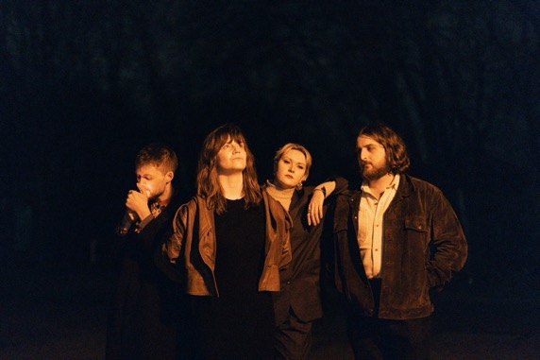
Download
Credit Darina

Another Sky’s return earlier this year heralded an exhilarating step forward for the South London quartet. After a three-year absence from the spotlight, the band’s long-awaited single “Psychopath” was a far more punchy and direct rock song than anything from their 2020 debut record, “I Slept On The Floor”. The band then followed up with ‘A Feeling’, another huge creative step forward for the band which received strong support across BBC Radio 1 and 6 Music. Melding richly textured percussion and rhythm sections with squalling, Soundgarden-esque guitars and the furious vocals of Catrin Vincent, Another Sky are fully embracing their electrifying new era.

Continuing the ferocious sentiments and instrumentation of the previous two singles, today they release new track ‘Burn The Way’.

Listen To ‘Burn The Way’

Vocalist Catrin Vincent says of the track -

“Burn The Way was written after a conversation with someone in denial about climate change. It’s about the feeling of being powerless and having to run from someone’s behaviour before you take on their reality.

As much as anger is a difficult, complicated emotion, it’s sometimes the first step towards survival.

Climate change is coming for everyone. No one can wait it out in the trees. Sometimes anger burns the way.

We also wrote it after supporting Biffy Clyro which completely gave us a new perspective on live performance. We played it a few times on our last tour and it’s the first time we’ve had a mosh pit at any of our shows.”

Burn The Way Artwork –

In their three-year absence, the band (Vincent, Jack Gilbert, Naomi Le Dune & Max Doohan) have not only been writing and producing new music but have built a brand-new studio from scratch in the crypt of a Church. More info to follow on that new music soon.
The news of their return came with an announcement of their signing to Republic Records in the US. “Who knew a song in 5/4 timing [‘Psychopath’] would get you signed to a US major label?” quips Vincent. The band continues to work with Fiction Records in the rest of the world.

Live Dates –

8th November Lafayette, London

For more on info contact warren@chuffmedia.com

